Contents

2 Introduction 1

3 Zybo Board Set-Up 1

3.1 Introduction 1

3.2 Board Configurations 4

3.2.1 Power Supply Configuration 4

3.2.2 Boot Mode Configuration 5

4 Vivado Introduction and Set-Up 6

4.1 Introduction 6

4.2 Vivado 6

4.3 Board Files 7

4.4 Hardware Description Language 9

4.5 Development Flow and Toolchains 10

4.6 Vivado SDK 11

5 Hardware Development 11

5.1 Introduction 11

5.2 First Projects - 11

5.2.1 Simple Half Adder 11

5.2.2 Hello World 18

5.2.3 SDK 22

5.3 Conclusion 24

6 Hardware Implementations 25

6.1 Introduction 25

6.2 SIMON32/64 27

6.3 Cipher Details 28

6.3.1 Specifications: 28

6.3.2 Round Function: 28

6.3.3 Key Expansion: 30

6.3.4 Core Module 31

6.4 Cipher Models 32

6.4.1 SIMON_Iterative_model 32

6.4.2 SIMON_Pipelined_model 32

6.4.3 SIMON_Mixed_model 32

6.4.4 SIMON_Decrypt_model 32

7 Cipher Simulation and Validation 33

7.1 Introduction 33

7.2 Anticipated inputs and outputs 33

7.3 Controller Logic 33

7.3.1 Test Vectors 34

7.4 Debugging 36

7.5 Conclusion 36

# Introduction

# Zybo Board Set-Up

## Zybo Board

The Diligent Zybo Z7 development board, as shown in Figure 3‑1, provides the platform for developing the hardware for this project.

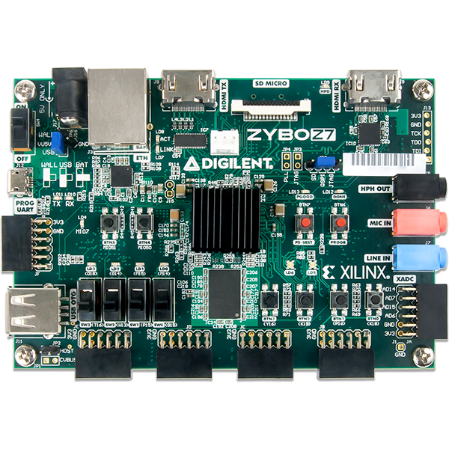

Figure 3‑1: The Zybo Zynq -7000 Development Board

The Zybo Z7 is part of the Xilinx Zynq-7000 family, based on the Xilinx All Programmable System-on-Chip (AP Soc) architecture. It tightly integrates a 667 MHz dual-core ARM Cortex-A9 processor with Xilinx 7-series Field Progrmmable Gate Array (FPGA). The main features of the Zybo board include:

* Zynq-7000 FPGA/SoC containing a Dual-core ARM Cortex A9 processor integrated with programmable FPGA fabric
* On-board JTAG programming and UART to USB convertor
* FPGA reprogrammable logic cells containing 4400 slices (4 LUTs and 8 flip-flops)
* 450 MHz internal clock
* High-bandwidth peripheral controllers: 1G Ethernet, USB 2.0, SDIO
* Low-bandwidth peripheral controllers: SPI, UART, CAN, I2C
* On-Board programming from JTAG, Quad-SPI flash, and microSD card
* 240 KB Block RAM
* 512 MB DDR3
* SPI Flash

## Zynq-7000

Taken from the Diligent reference manual, Figure 3‑2 shows the distinct subsystems on the Zynq-700, the programmable logic (PL) and the processing system (PS). The figure demonstrates interface between each other and some peripherals. This allows programmes written in software to access the cipher core architectures through the Zynq processor. The programmable logic consists of the FPGA and is reprogrammable, while the Zynq processing system is hardened in Silicon and is accessed through software. The figure also reveals the Advanced eXtensible Interface (AXI) ports, part of the ARM architecture and used to provide parallel, high-performance communication between the two sub-systems. Custom IP’s created in PL can be accessed from the processor by this ARM AXI interface. Also seen in the image, are the UART and GPIO I/O controller interfaces. UART1 will provide the interface for used to transmit the data needed to program the board and the GPIO will provide the interface for receiving signal from the switches and any other I/O.

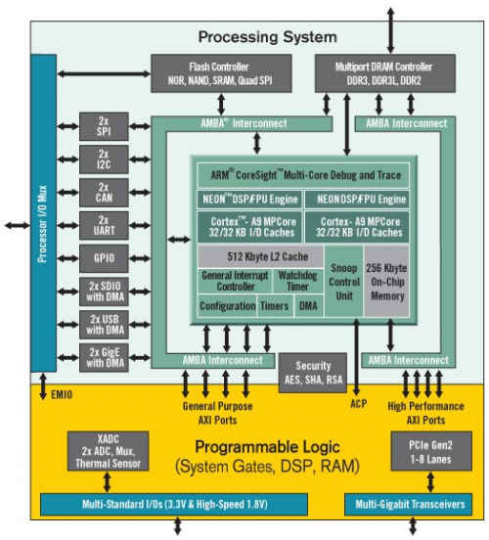

Figure ‑ Zynq-7000 Processing System (PS) and Programmable Logic (PL) Interface

## Physical Requirements

The physical requirements needed to begin developing custom applications for the board used to complete the project are as follows:

- A physical Zybo Zynq-7000 development board (manufactured by Diligent)

- A USB - Micro USB cable

- A PC with USB port

Note: An external power source may also be used to power the board

## Board Configurations

The board comes with two main board configurations to consider, boot mode configuration and power supply configuration.

### Power Supply Configuration

The board's power can be supplied from the USB-JTAG-UART port or from an external power source depending on the positioning of the jumper found near the power switch (shown in Figure 3‑3). The three valid power supply configurations are USB, wall wart with barrel jack, and battery pack as detailed on the board below the supply jumper. Figure 3‑4 further details the circuitry of the three power supply configurations. For this project powering the board via the USB connected to the computer is sufficient. It is worthwhile to note that there were power supply issues with the original board that was used for this project. These power supplies were temporarily resolved by upgrading the A USB - Micro USB cable but persisted for more intensive applications. An external power supply of 1.5V batteries were used which caused the board to stop working. The minimum voltage required is 3.6V as detailed by the Diligent reference manual is 3.6V, indicating that there were underlying power issues with the board. These power issues were resolved with the replacement of the board.

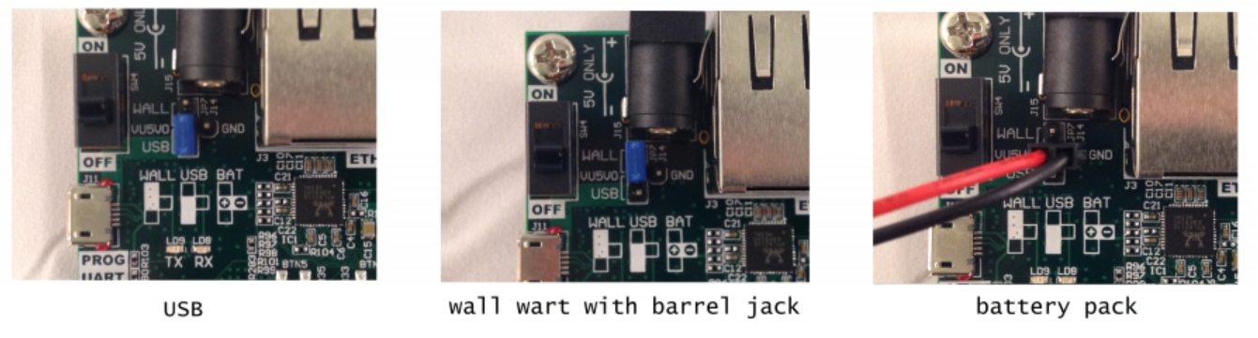

Figure ‑ Power Supply Configurations

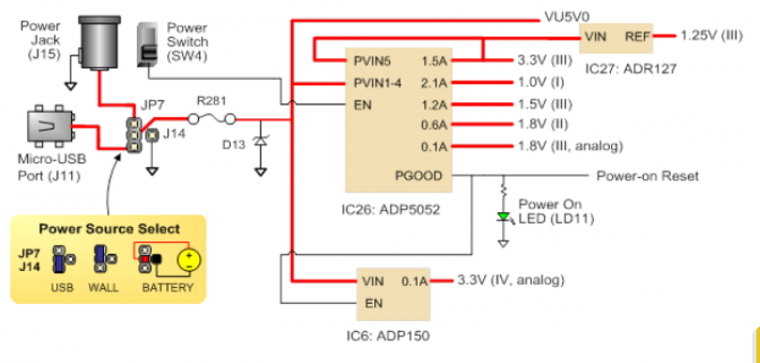

Figure ‑ Power Supply Circuitry

### Boot Mode Configuration

The boot mode configures the state of the Zynq configuration pins after the power is turned on. The jumper to configure the mode is located in the top right hand corner of the board as shown in figure Figure 3‑5. There are three different boot modes: microSD, QSPI Flash, and JTAG. MicroSD supports booting from a microSD card inserted into connector J4, QSPI Flash supports booting from the onboard 128-Mbit Quad-SPI (QSPI) serial Flash while when in JTAG boot mode the processor will wait until software is loaded by a host computer. Upon load completion, the software can be executed and debugged. For this project the JTAG boot mode is selected as shown in image .. to allow the software to interact with the processing system and programmable logic.

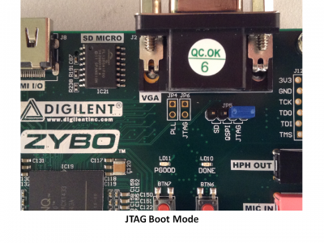

Figure ‑ Boot mode configuration

# Vivado Design Suite and SDK Introduction and Set-Up

## Introduction

For this project, development is complete using the Windows Operating System on a personal computer. The software used for development was a fully licensed version of the Vivado Design Suite and Vivado Software Development Kit. A free web pack version of the Vivado IDE and SDK can be found for download on the Xilinx website. For this project Vivado 18.2 was used which includes the SDK in its download. The latest version was not selected due to severely increased memory requirements.

## Vivado Design Suite

Vivado Design Suite is a software design suite produced by Xilinx for design, high-level synthesis, and analysis of HDL projects. Vivado’s Integrated Development Environment (IDE) provides a graphical and Tcl-based development flow providing several useful features for development, including a comprehensive process control flow Project Manager, an electronic system level (ESL) interactive IP and Block Design Integrator, simulation tools, Register Transfer Level (RTL) analysis, synthesis tools, implementation design analysis, debug tools and bitstream writing services. Some of these tools are depicted in the Vivado’s default window shown in Figure 4‑1.

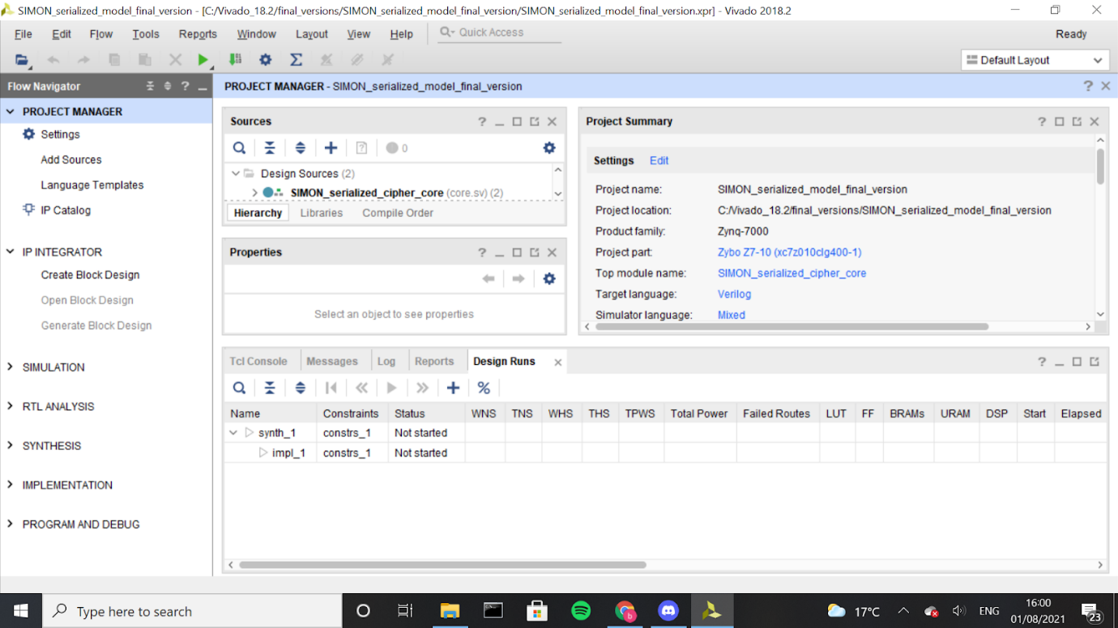

Figure ‑ Vivado Design Suite IDE

## Toolset

The following is a brief introduction to some of these tools used for development that will be further explored in subsequent chapters during implementation:

* **Project Manager:** Allows for quick access to the project settings and adding design, simulations, and constraint sources. Also provides language templates and an IP catalogue of the Xilinx IP’s available for use in the designs.
* **IP Integrator:** Tool for creating and updating custom block designs.
* **Simulation:** Used for validation checking to ensure that the output of the design is error-free prior to programming the device.
* **RTL Analysis:** Presents a schematic view of the design, outlining how the tool is interpreting their code
* **Synthesis:** Provides the tools to transform the RTL design into a gate-level netlist representation along with post-synthesis reports
* **Implementation:** Implements the steps necessary to place and route the gate-level representation onto the device, providing post-implementation reports.
* **Program and Debug:** Provides tools to generate a .bit bitstream file from the implemented design that can later be flashed to the device.

Extending on the toolset in the flow navigator, some additional tools that will be applied through the

DISCUSS IP INTEGRATOR , HARDWARE EXPORT ETC, PAGE 12 IN MICHael.. MAYBE IN A FUTURE SECTION

Develop Hardware IP: An IP (intelectual property) is block of logic or data used in making the programmable logic. They fall into one of three categories: hard cores IP’s used for physical manifestations, firm core Ip’s used for flexible placement and robust and soft core IP’s for HDL language. The cipher cores will be designs as soft core IP’s

## Status Information

Vivado provides useful information on the status of the project, locate at the bottom of the Project Manager window as shown in Figure 4‑2. It consists of several useful tools for debugging a project.

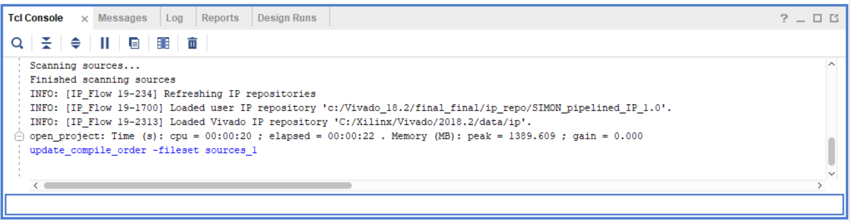

Figure 4‑2 Vivado Status Information

* **Tcl Console:** Allows for commands to be run directly through the console and provides some error messaging
* **Messages:** Provides a variety of messaging on the status of the design ranging from general information to errors
* **Log:** Displays the latest simulation, synthesis, and implementation information output
* **Reports:** Easy access tool for the many reports, including power, timing, and area utilization that Vivado provides
* **Design Runs:** Run setting can be edited and new runs created using this tool

## Board Files

Board files are used to define specific hardware details and to provide different interfaces on the board. Without these board files these details and interfaces would need to be manually configured. The manufacturer of the board, Diligent, provides these board files for free via their website [reference]. Ensure the correct board and the latest version is chosen. Once the *.zip* file has been downloaded and extracted the contents needs to be copied into the correct repository. Locate Xilinx installation folder and traverse through the directories as follows:

*Xilinx\Vivado\2018.2\data\boards\board_files*

Located in this folder are the board files of the pre-installed board models. Paste the Zybo board file into this folder. The updated *board_files* directory should look as seen in Figure 4‑3

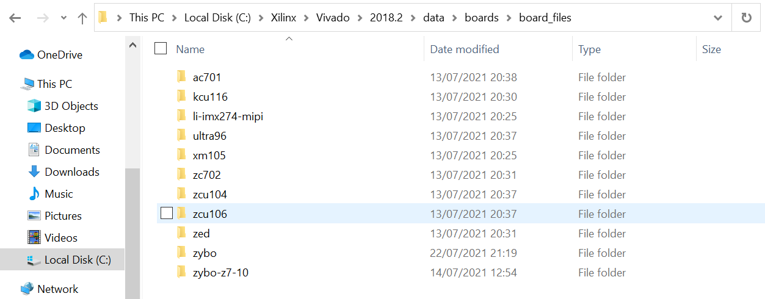

Figure ‑ Updated board files including the Zybo board

Verification of correct board file installation can be achieved by carrying out the following steps:

* Open Vivado
* Select *Create Project*
* Follow the prompts to create a new RTL project
* When the *Default Part* window is reached, select the *Boards* tab
* The Zybo board should appear as one of the available board models as seen highlighted in Figure 4‑4

This confirms correct installation of the board files. These will form the initial steps of creating any new project and will be further discussed in the subsequent section.

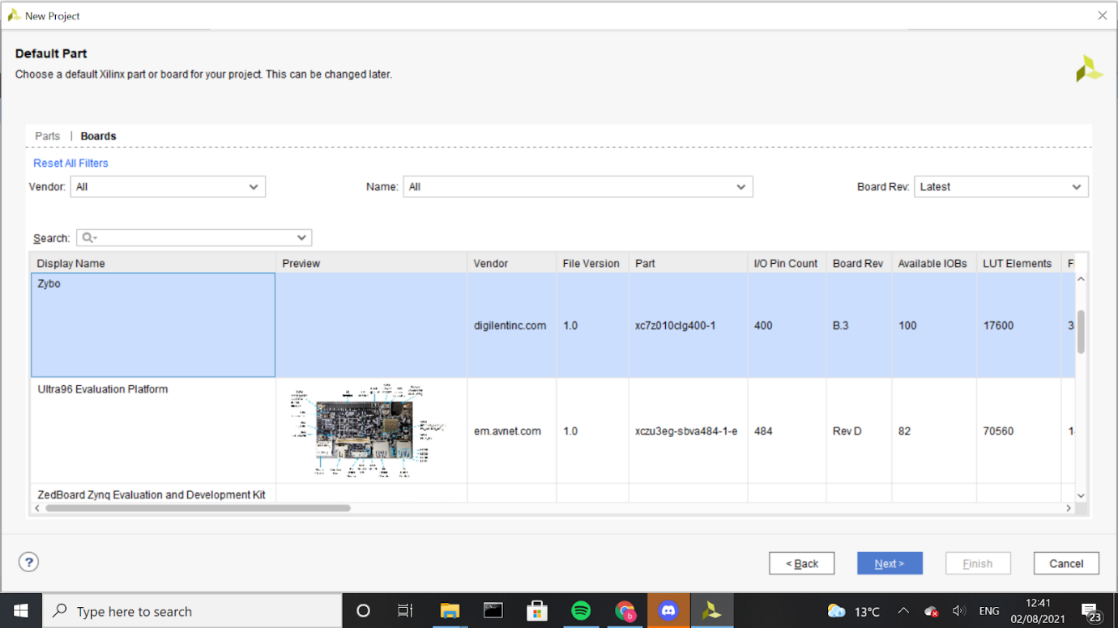

Figure ‑ Zybo board listed following board file inclusion

## Hardware Description Language

The programmable logic FPGA will be programmed using a hardware description language before it is synthesised, implemented, and programmed onto the board. Vivado supports the HDL languages Verilog, SystemVerilog and VHDL. Verilog and VHDL are both general purpose digital design languages while SystemVerilog is an enhanced version of Verilog to provide assisted design and verification for more complex designs. Each language has their own subtle advantages, and any would be sufficient for the completion of this project. SystemVerilog was chosen for the completion of this project due to previous experience working in Verilog added to the richer benefits of SystemVerilog over Verilog for assisted design.

## Vivado SDK

The Xilinx Software Development Kit (SDK) is the IDE used to create embedded software applications on the Zynq-7000 processor. Based on Eclipse, the SDK provides all the tools needed to create, develop, debug, and run embedded software applications. Some useful features include:

* Project Management tools used for project creation, update, and general configuration settings in keeping with standard Eclipse
* Feature rich C/C++ code editor
* Template applications for rapid development
* Application build and Makefile generation using the built-in GCC compiler
* Board Support Packages (BSP) to provide the support needed place the device bare-meta drivers into memory
* Hardware Definition File (*.hdl*) file initialization. The hardware definition is passed to the SDK in a single *.hdl* file, extracted from the hardware build. The SDK used this file to extract register maps, processor and peripheral configurations and creates a comprehensive board support package and API.
* Tools to interact with the hardware in the Programmable Logic.
* A debug view perspective comprising of all the widely expected tools including variable inspection, breakpoint management and core register viewers.
* A performance perspective, providing graphical performance modelling tools that allow continuous display of results such as speed, memory, resources from within the processing system or at the interface between the processing system and the programmable logic
* Flash programming of the bitstream imported from Vivado onto the device’s programmable logic

These features are used throughout the project and will be further examined in subsequent sections. Figure 4‑5 shows the project editor GUI and Project explorer interface of Vivado SDK

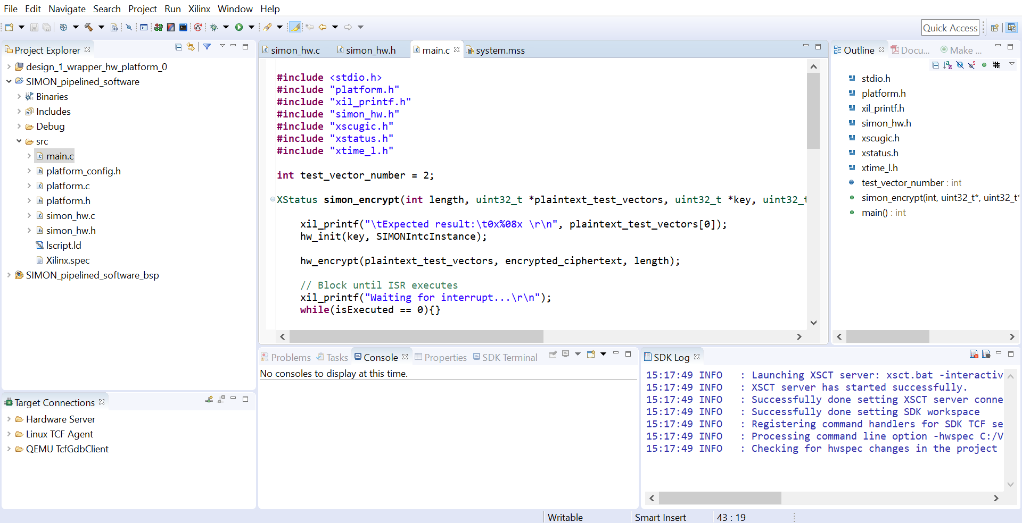

Figure ‑ Vivado SDK IDE

# Development Flow and First Projects

## Development Flow

MAYBE CHANGE THE HARDWARE ONLY TO INCLUDE PROGRAMMING DEVICE

This project will implement several different implementations of SIMON32/64. These implementations will either compose of a hardware only or a hardware/ software co-design. The hardware-only implementations, written in SystemVerilog will be created in the Vivado Design Suite. The design flow will consist of RTL development and simulation using signal waveforms and testbenches which is summarised in Figure 5‑1. 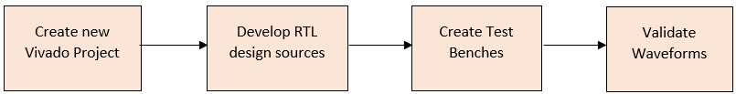

Figure ‑ Summary of hardware creation and validation workflow

The hardware and software co-design will encompass the main project goals is an extension of the hardware only implementation. The initial steps of RTL design and simulation are repeated. After the simulation has been verified, the hardware must be packaged and exported as .bit file to the SDK to interact with the software. This is achieved by creating a visual representation of the system connectivity, known as a block design. The block design is then run for synthesis and implementation, before the bitstream and exported hardware to the SDK. The workflow is summarised in Figure 5‑2

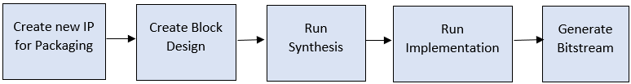

Figure ‑ Summary of Bitstream Generation workflow

The block design will provide the mapping between the programmable logic and the processing system. To establish a successful connection, the cipher core must be packaged in a newly created IP and integrated into the design, as seen in the first step of Figure 5‑2. This IP will interact with the processing system using the AXI interconnect protocol. Interface connection configurations of this new IP must be defined. Vivado provides a large amount of automation to assist with this. It also automates a large amount of the IP packaging process that wraps up the design, constraints and I/O’s into a block that is easily customised, modified and integrated. The IP is ready to be added to the IP repository and added into the block design. Once integrated, the block must be appropriately connected to the other blocks and the design validated. A summary of the IP creation design flow is summarised in Figure 5‑3.

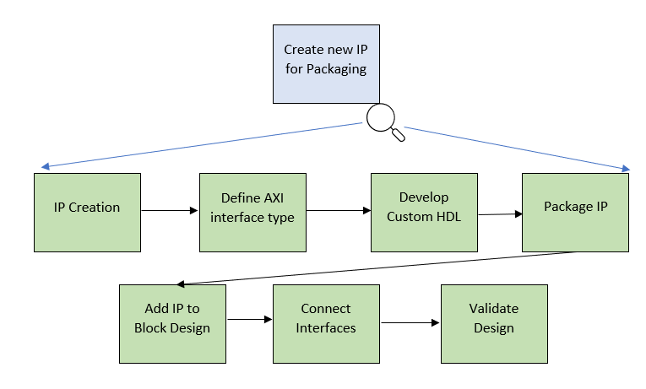

Figure ‑ IP Creation and Packaging Workflow

## Vivado SDK is used to access the exported hardware through software. Launching the SDK should automatically include the hardware. Create a new project and develop the software as required. Once complete, the board is ready to be programmed and the software ran. The usual steps are taken to debug errors using the tools available in Vivado SDK. A summary of the software development workflow is shown in Figure 5‑4.

## 

Figure ‑ Summary of Software Development Workflow

## First Projects

Once the initial setup is complete, the first goal major goal of the project is to create a fully working SIMON32/64 hardware encryption module. Prior to developing the cipher modules, it is useful to create some simple projects to become accustomed to the development flow and some of the useful features provided by Vivado. Creating a simple project also confirms that the software, board, board files, etc are interfacing correctly. To achieve this, two simple projects were made; a simple half adder for RTL implementation and deployment and a “Hello World” programme to test the connection between the processing system and the programmable logic. This will also form the basis of creating all future project implementations.

### Simple Half Adder

**Add Design Sources**

The first step in implementing the SIMON cipher is to create the required cipher module code written in SystemVerilog before it is programmed on the board. For this demonstration, a simple half adder module will be created to illustrate the process, before the more complex cipher is implemented. The following are the steps to create a new Vivado project:

* Open the Vivado Design Suite
* Under the *Quick Start* tab, select *Create Project*
* Appropriately name the project in the desired directory
* Create a new RTL project and select the ZYBO board that was included in the board_file directory as described previously
* It is unnecessary to add design sources or constraints at this time
* Click *Finish* to finalise project creation

The new Vivado project is now ready for development. It can be reopened at any time by selecting the *.xpr* file in the project directory. There are three options to add SystemVerilog source code to implement the hardware design. Select *File* -> *Add Sources*, locate *add sources* in the project manager section of the flow navigator, or click the “*+”* in the source wizard that will appear in the default display after creating a project. In the source browser there are three available top-level categories of design that can be added:

* Design Sources: Contains the HDL describing the hardware
* Constraint Sources: Contains the synthesis, I/O, timing, and location constraints of the design
* Simulation Sources: Contains HDL testbenches and any other files needed to simulate the design

Select *Add or Create Design Sources*. In the next window, select *Create File* and name the file *half_adder*, ensuring the HDL language selected is SystemVerilog. Select *Finish* to create the file. A window will appear allowing the user to define the module name and I/O ports. These can be added later, and the window can be left without changing the module definition. The window should appear as shown in Figure 5‑5.

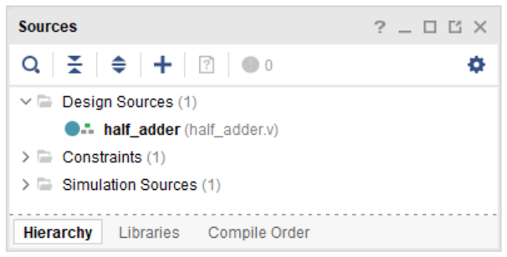

Figure ‑ Sources browser post adding design source

To open the file, double click on it in the sources tab. Add the following source code that denies a half adder.

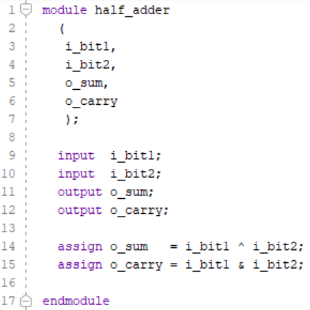

**Verification**

To simulate that the half adder is working as expected, it is useful to run a simulation. This is achieved by applying different input stimulus to the design at different times to check if the RTL code behaves the intended way in the form of a testbench. Using the same process as creating a new design source, create a new SystemVerilog simulation source, naming it *half_adder_tb* and adding the following source code:

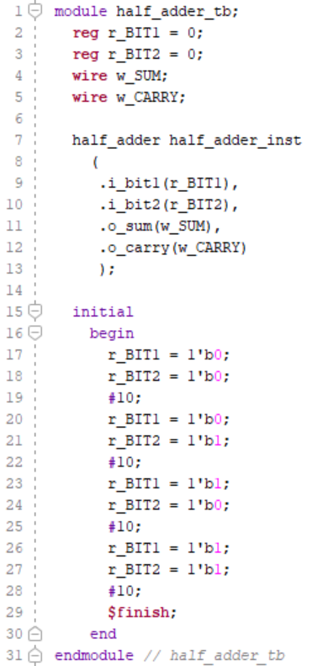

Save both files. To run the simulation and view the produced waveform, select *Run Simulation* -> *Run Behavioural Simulation* from the flow navigator. The waveform shown in Figure 5‑6 is produced which corresponds to the required truth table of the half adder shown in Figure 5‑7

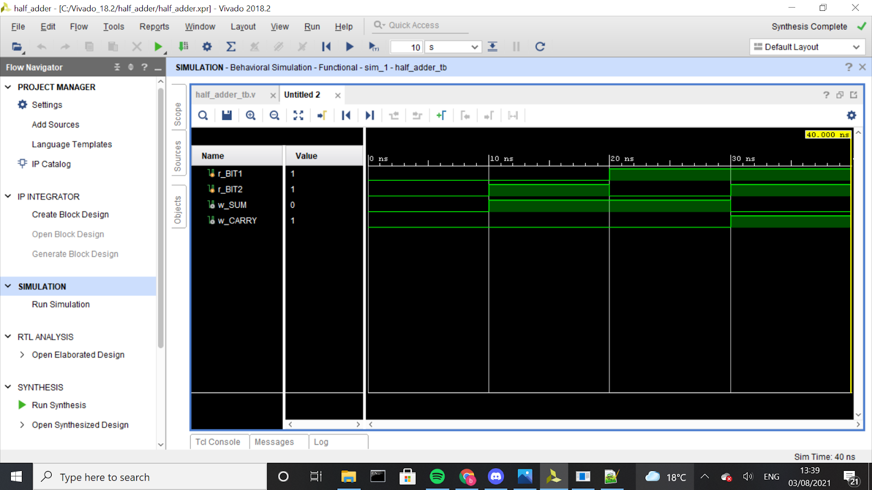

Figure ‑ Half Adder Waveform Simulation

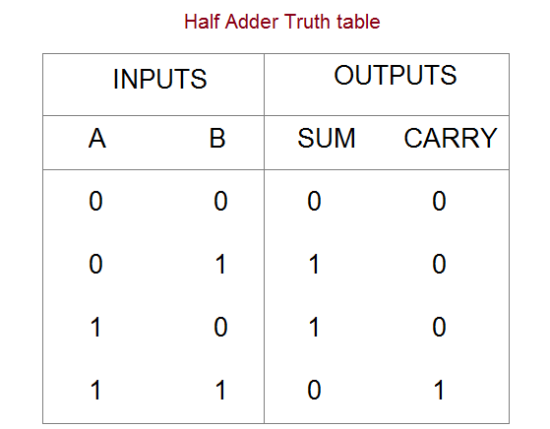

Figure ‑ Half Adder Truth Table

**Program Board**

After verification is complete, the next step is to program the board. The I/O constraints are added via an *.xdc* (Xilinx Design Constraints) file. This file provides a description of how the top-level ports of the design are routed to physical I/O. Diligent provides a master template file for the Zybo board, found on their website, which can be edited to incorporate the design. Add a *.xdc* constraint file *half_adder_constraints* and copy the contents of the ZYBO’s master .xdc file. For this example, switches will provide the input and LED’s the output. Uncomment the lines that configure switches 0 and 1 and define the ports to have inputs as described by the half_adder module, i_bit1 and i_bit2 in this case.



The same procedure is used to assign the output of the module to the LED’s 0 and 1.



The next step is to select the *run synthesis*, followed by *run implementation* found in the flow navigator (refer to section 4.3 for details as to what these steps achieve). Select *Generate Bitstream* under the program and debug dropdown in the flow navigator. Note that for a more streamlined implementation in future implementations, selecting *Generate Bitstream* will automatically run synthesis and implementation. This can take a few minutes to complete. Once the bitstream has been written, connect the board to the computer and switch it on. Vivado should automatically detect the presence of the board by displaying a green banner with the option to *Open Target*. If not, expand the *Program and Debug* tab and select *Open Target* in the *Open Hardware Manager*. Select *Auto Detect* and click *Program Device* to program the board. The green *DONE* LED should turn on indicating successful programming and the functionality can now be verified using the switches and LEDS

INCLUDE IMAGE.

### Hello World

**Create Block Design**

To create software for Zynq a new project needs to be created in the normal way. Before any software is written the processing system must be configured. Create a block design by selecting *Create Block Design* in the flow navigator. The newly opened empty block design diagram provides a visual representation of the system connectivity. Select the “+” icon and search for *ZYNQ7 Processing SYSTEM* to add the processing system IP.

**Run Block Automation**

Vivado provides a useful *Run Block Automation* feature that should pop up after the processing system has been added. This allows automatic configuration of certain aspects of the IP. As there is only one IP in the block, there is little configuring required but this tool becomes useful when interconnecting multiple blocks in more complex designs. Run the block automation the default settings. This connects the DDR and FIXED_IO to the processing system and the block should currently look like Figure 5‑8 Zynq processor after block automation

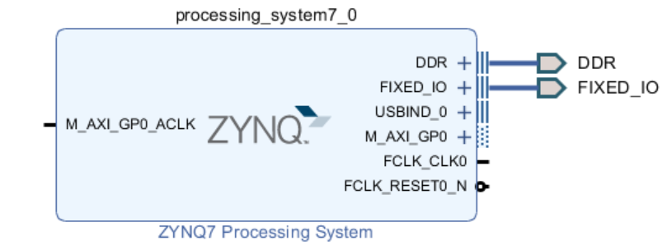

Figure ‑ Zynq processor after block automation

The AXI GPIO clock source must next be tied to a valid source. For this project, the FCLK inside the processing system is used. Click the FCLK_CLK0 output port and drag it to the input M_AXI_GP0_ACLK port.

**Validate Design**

To validate the block design and check for any errors select the check mark at the top of the window or press F6.

**Re-Customize IP**

Note that that some of the I/O peripherals and AXI I/O ports in the processing system can be disabled. Double click on the processing system IP opens the Zynq block design as shown in Figure 5‑9. This window can be used to re-customize the IP.

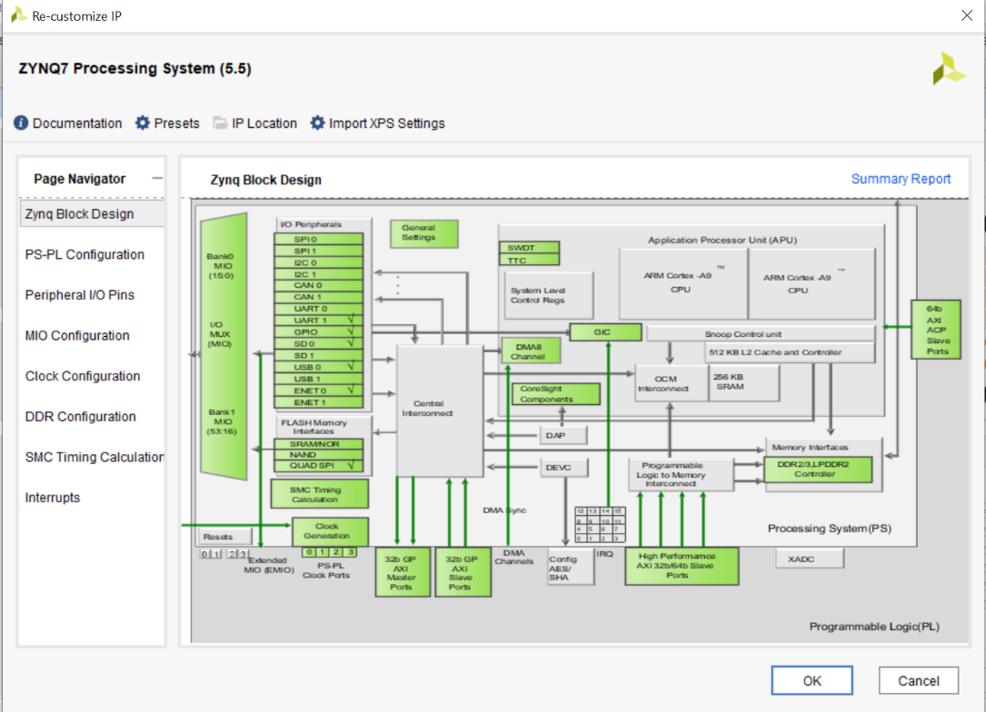

Figure ‑ Zynq Processing System Block Design

The dark grey parts represent the PL of the Zynq chip while light grey parts constitute the processing system PS. The modules in the green can be cut out by configuration, while the modules in the grey part are fixed and cannot be omitted. UART1 is needed to program the board but GPIO, USB, SD, and the timer can all be disabled.

**Generate Block Design**

Select “Generate Block Design” under the IP Integrator section of the flow navigator and ensure the “Out of context per IP” synthesis option is selected as seen in Figure 5‑10. This will perform “out-of-context” synthesis and implementation of the IP. “Out-of-context” synthesis and implementation will be discussed further in section 8.1.4.

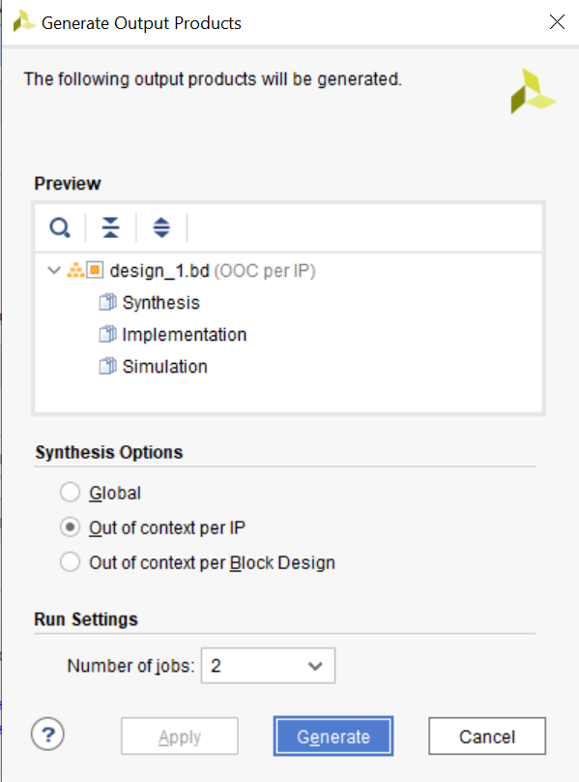

Figure ‑ Generating Output Products

**Create HDL Wrapper**

The synthesiser requires a top module HDL file. Creating a HDL wrapper for the block, translates the block design into source code that can be read by the synthesiser. Right click on the design in the sources tab and select *Create HDL Wrapper.* Ensure *Let Vivado manage wrapper and auto-updated* is checked so that any future changes to the design are automatically updated.

**Export Hardware**

Once the top-level RTL wrapper has been created, the bitstream can be generated as normal. Finally, the outputted bitstream can be packaged and exported to the SDK by selecting *File* -> *Export* -> *Export Hardware* and ensuring *Include bitstream* is checked. A fully placed and routed representation of the Zynq Processing System is exported for software development. To launch the Xilinx SDK, select *File* -> *Launch SDK*.

**Software Development**

Figure 5‑11 depicts the layout of the SDK once launched. The hardware wrapper is automatically imported. The hardware platform specifications of the wrapper are displayed including information on the addresses and types of the cells in the processor and any included IP’s.

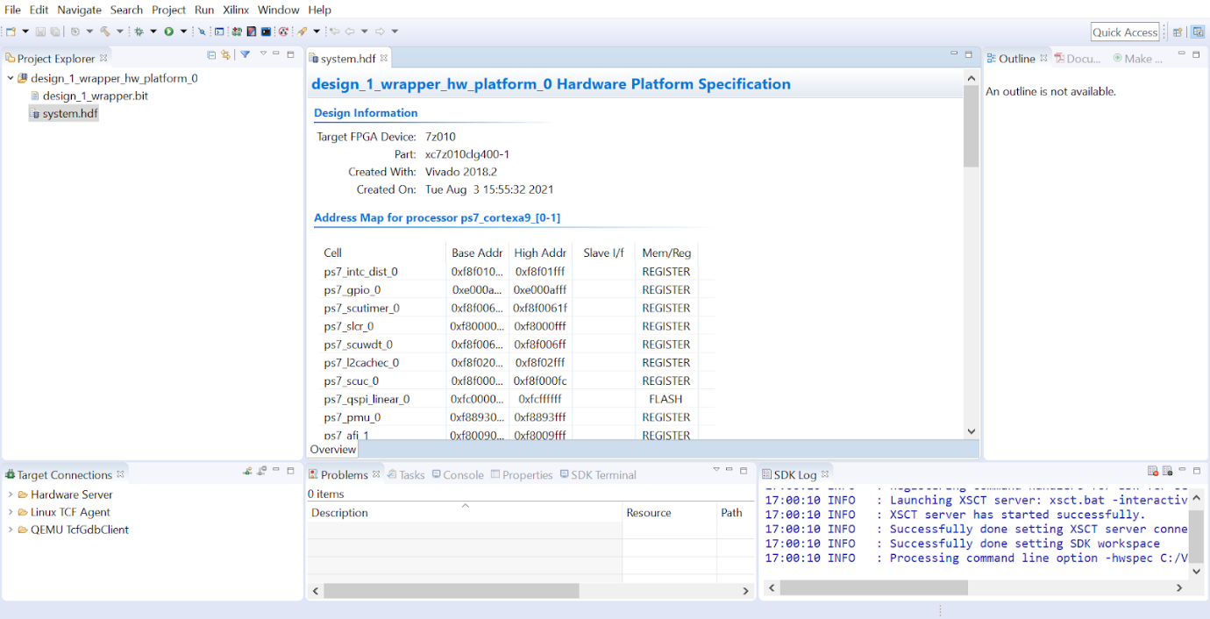

Figure ‑ Vivado SDK

To begin software development, create a new software application by selecting *File -> New -> Application Project*. Appropriately name the project. Click *next*, select the *hello world* template, and click *finish*. An application project for software development is created as well as a Board Support Package (BSP). The BSP creates a collection of drivers customised to the hardware description as well as the libraries used. The *helloworld.c* source code is located in the application project’s *src* directory. Add custom print statements if desired, as seen in 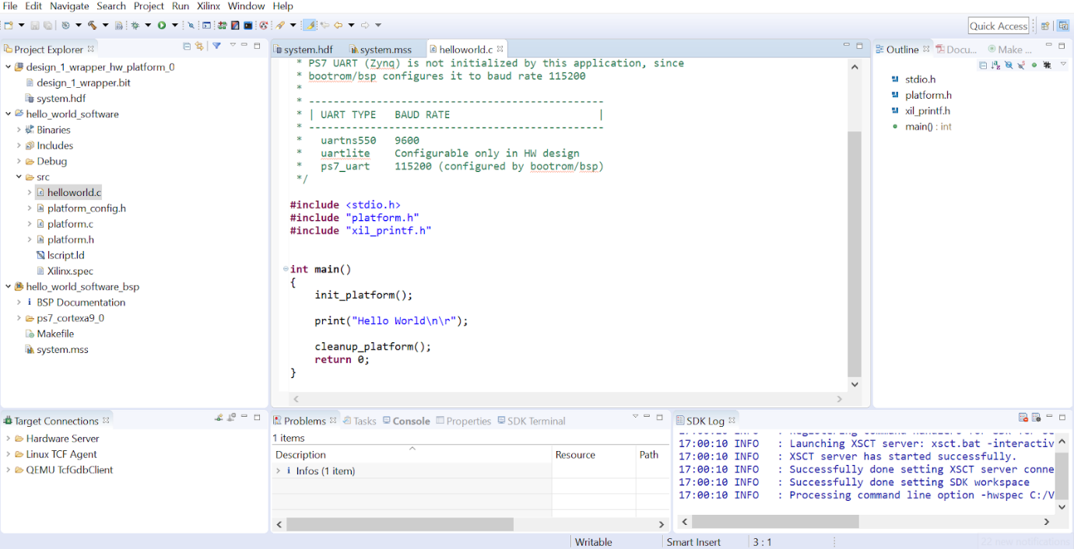

Figure ‑ helloworld.c source code

Saving the project will automatically build it and any errors will appear in the “*Problems*” and “Console panes at the bottom of the screen. The FPGA is programmed by connecting the board to the machine and selecting *Xilinx* -> *Program FPGA*. Once the bitstream has been flashed to the FPGA a green LED will appear on the board indicating successful programming. A serial port can be set up via the *SDK terminal* tab or through a terminal emulator. For this project, the free open-source terminal emulator, PuTTY was used. Open PuTTY and select *Serial* on the left-hand side of the dialog box as show. This window is used to control the serial port number connected to the UART port, which may be different according to different machines. Use the USB cable that comes with the system to connect the UART port of the development board to the computer. The COM port number can be obtained by opening *Device Manager* -> *Ports* information and finding the COM port corresponding to the *USB Serial Port*. Ensure the baud rate is set to 115200 to match the Baud rate transferred across the communication channel. Open the terminal connection by selecting *Session* on the left side of the dialog box, select the *Seiral* radio-button on the right side and clicking O*pen* as seen in Figure 5‑13*.*

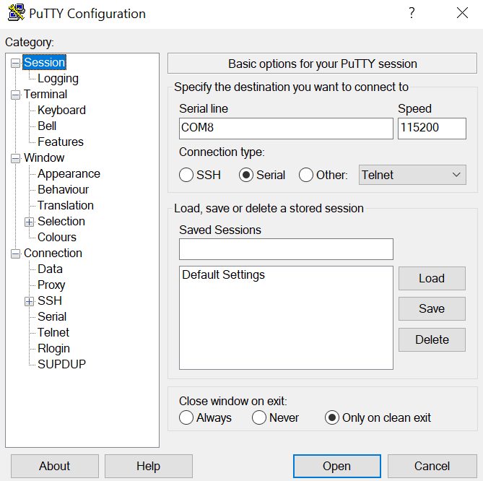

Figure ‑ PuTTY terminal emulator configurations

To run the application, right click on the application project and select *Run As..* -> *Launch on Hardware (System Debugger)*

If the process is successful, “Hello World”, plus any custom print statements should appear on the PuTTY console as seen in Figure 5‑14

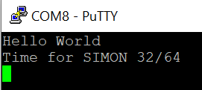

Figure ‑ Terminal Output

**Conclusion**

The description of the design workflow required for the development of the different implementations of the cipher core. Furthermore, the two basic projects demonstrate core features of Vivado and Vivado SDK that will be used throughout. These will both be used as valuable references. The next step is to incorporate the cipher itself into this established workflow.

# Hardware Implementations

## Introduction

This chapter details the processes involved for hardware development of the cipher core modules for encryption in hardware. The motivation for implementing SIMON32/64 is its extremely lightweight realisations suitable to resource constrained IoT devices, as discussed in the main research paper. Multiple models will be designed, and their performances compared. The models implemented are as followed:

* **Iterative model:** This iterative or round based model will perform one round function and key expansion for every clock cycle and the intermediate values stored in a single register as seen in the model architecture in Figure 6‑1. The ciphertext will be produced after 32 clock cycles (plus additional for read and load functions). This model provides the best area resource utilizations.

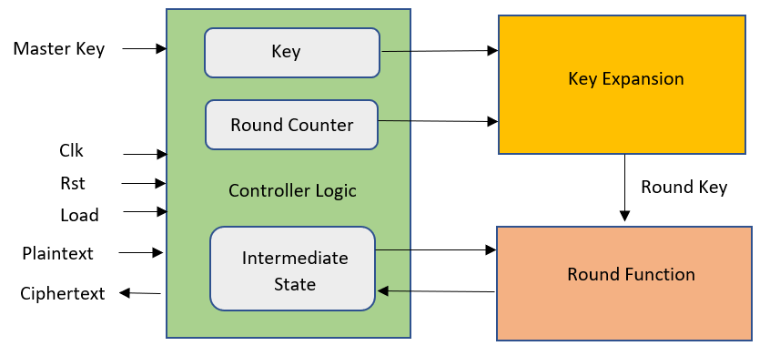

Figure ‑ Iterative Model Architecture

* **Pipelined mode:** The pipelined model or full bit unrolling creates a memory register between every consecutive round to store intermediate values of key and ciphertext unrolling. 32 key scheduling and round modules are required to process the stored values in each of the intermediate registers. As the pipelined model performs multiple tasks per clock cycle, it provides a higher throughput and produces ciphertext every clock cycle. A diagram of the pipelined architecture is given in Figure 6‑2. From the diagram, it is clear that the key expansion and round function modules can be reused for the fully unrolled model.

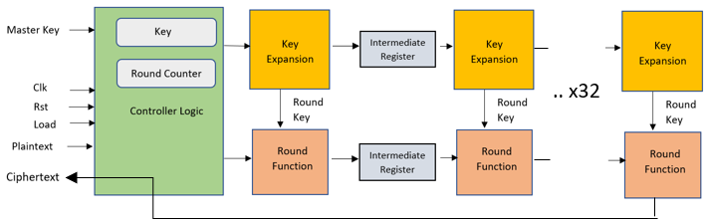

Figure ‑ Pipelined Model Architecture

* **Mixed Models**: Iterative/ pipelined hybrid models are created by changing the number of rounds executed in parallel. A fully unrolled model executes 32 rounds per stage to an iterative model’s 1. By only partially unrolling and processing 2, 4, 8, or 16 rounds per stage can provide a robust trade-off between throughput and area. A diagram of the mixed model architecture is given in Figure 6‑3. Once again, the key expansion and round function modules are reused.

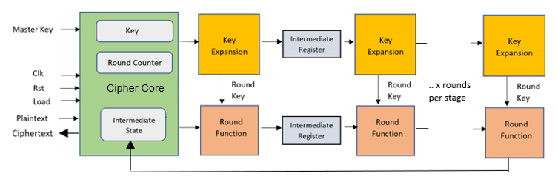

Figure ‑ Mixed Model Architecture

* **Decrypt Model:** Due to the nature of a Feistel based structure, the process of decryption is very similar to encryption. The ciphertext is used as input and the number of rounds is the same. The round function is the inverse of the round function used for encryption. The key concept to consider when implementing a decrypt mode is prior key expansion. The key must be expanded in the same way as for encryption and thus cannot be done in parallel to the round function. The 32 sub-keys must be expanded before the inverse round function can begin. After the key has been expanded, decryption can occur as iterative, pipelined, or mixed models as usual. For the decryption implementation, a mixed model is selected. By the reasons discussed, there is very little additional architecture needed to incorporate a decrypt mode. There will be an additional input to determine the encryption/ decryption mode.

A requirement of the designs is the minimum usage of hardware resources, in accordance with the application of an IoT device. The iterative, pipelined, and mixed models provide direct trade offs in some of these resources, which will be analysed in the results section.

This chapter will:

* Review the theory of the SIMON32/64 cipher
* Analyse the implementation core and submodule RTL creation of the previously discussed models of the cipher

## SIMON32/64

The SIMON family of ciphers was designed and published by the NSA in 2013. The abstract of the paper stated that “The aim of SIMON is to fill the need for secure, flexible, and analysable lightweight block ciphers.” These features are apparent from the cipher structure:

**Security:** For the purposes of this project, it is assumed that SIMON is secure from brute force attacks. It is noted in the paper, that cipher does not provide security by itself and must be combined with cryptographic protocols. It is also noted by the creators of the cipher that the security of the cipher should depend on the size of the key. Specifications of key sizes ranging from 64 to 256 are given for SIMON. These security considerations are not the focus of the project but must be considered for practical applications.

**Flexibility**: The creators of SIMON provide reasoning as to how flexibility is provided on a range of implementations and across a range of platforms. For this project, a range of implementations will be implemented and analysed. SIMON is implemented on an FPGA SoC in this project, but it should also have excellent realisations on a wide spectrum of platforms such as ASIC’s or in software. Furthermore, as SIMON is a Feistel network, the same circuitry can be utilised for decryption, effectively halving the amount required.

**Analysis**: SIMON is amenable to analysis using existing techniques.

## Cipher Details

The following subsections deals with specific cipher details that will be needed for implementation

### Specifications:

There are 10 different size configurations of SIMON. SIMON 32/64 has the following specifications:

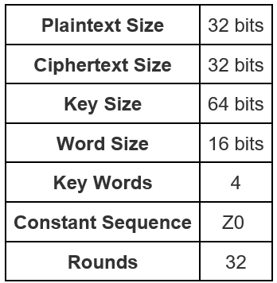

### Round Function

The round function is given by the Feistel map:

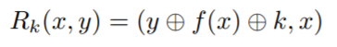

where f is the round function and k is the corresponding key for the round. The plaintext block is broken into halves and used as the initial arguments for x and y. The map is executed for 32 rounds and the concatenation of the final values of x and y is the outputted ciphertext. The round function is specified as follows:

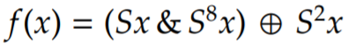

consists of the following operations:

* bitwise XOR, ⊕
* bitwise AND, &
* left circular shift, Sj, by j bits

All three of these operations are resource friendly. A visuall representation of the round function is given by Figure 6‑4.

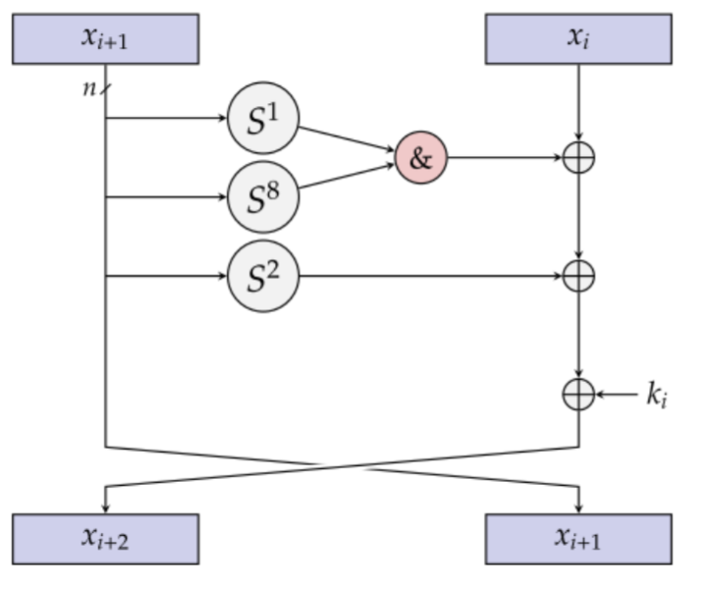

Figure ‑ Round Function

The SystemVerilog sound code used for the round function is created in the module *round_function*. It is reused for the models *SIMON_iterative_model,**SIMON_pipelined_model and SIMON_mixed_model. SIMON_decrypt_model*only differs from the other model by using the inverse round function. This will be further discussed in section 6.3.4. Figure 6‑5 shows the round function module declaration and the defined input and output ports.

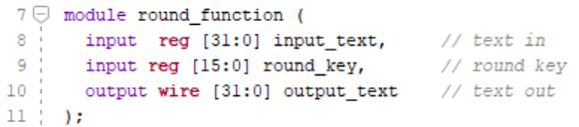

Figure ‑ Round function module definition

The elaborated design for the round function is shown in Figure 6‑5. It is produces using Vivado’s *Open Elaborated Design* tool under *RTL Analysis* in the flow navigator. The figure depicts the XOR, AND and shift operations (black arrows) of the round function.

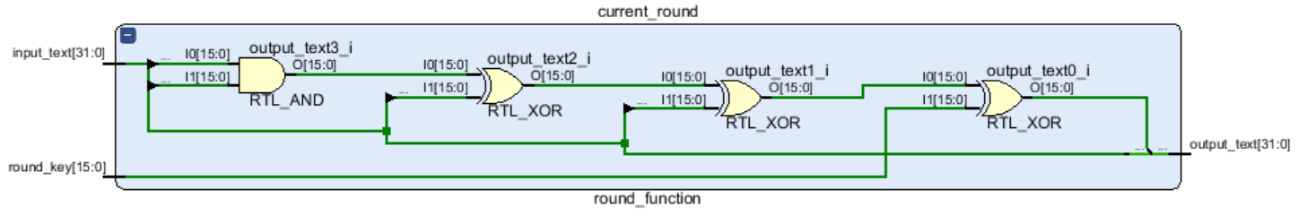

Figure ‑ Round function elaborated design

### Key Expansion:

The initial key expansion breaks the 64-bit key into 4 words of length 16. The subsequent keys produce keys given by the equation



where *kx* is the *xth* sub-key, *c* is a constant, and (*zj)i* is the *ith* bit of the round constant *j.* A flow chart depiction of the key expansion is given by Figure 6‑6

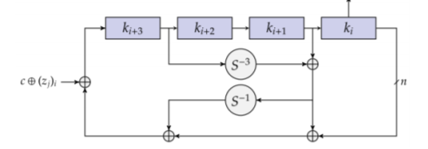

Figure ‑ Key Expansion

The *key_expansion* module is reused in all models, including the *decrypt_mode*. In keeping with the use of simple, robust hardware, it reuses the operations right circular shift, and XOR operations. The previous 4 16-bit sub-keys and the round counter are provided as input into the module to produce a new 16-bit subkey appended to the previous three sub-keys, as shown in the module definition in Figure 6‑8.

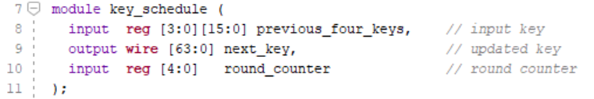

Figure ‑ Key schedule module definition

As seen in the key expansion function, local parameters z and c are used. These are constants, chosen by the cipher creators in such a way to eliminate slides properties and circular shift symmetries. They are declared as local parameters in SystemVerilog:

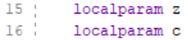

The elaborated design as produced by Vivado is given in Figure 6‑9. It depicts the XOR and shift operations (black arrows) of the key schedule.

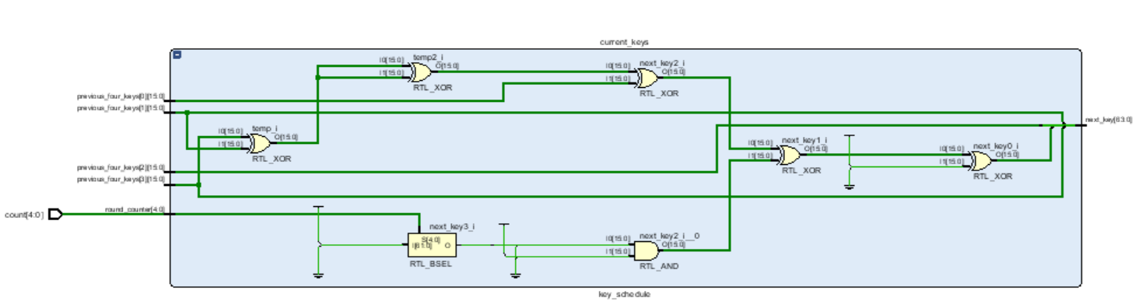

Figure ‑ Key Schedule Elaborated Design

### Core Module

Each implementation needs a top-level RTL cipher core module to control how that data is transferred into the *key_schedule* and *round_function* modules. A clock and reset port are fundamental building blocks to any circuit to allow different blocks to synchronize with each other. The input port *load*, loads the plaintext and key vectors into memory registers and the 5-bit *count* keeps track of the round number. This module definition is shown in Figure 6‑10 is consistent for all modules, excluding the *decrypt_model,* which includes an additional *decrypt_mode* input signal. These signals will be determined by some control system This will either be from a SystemVerilog testbench or driver. Details of testbench control will be provided in section 7 and driver control in section..

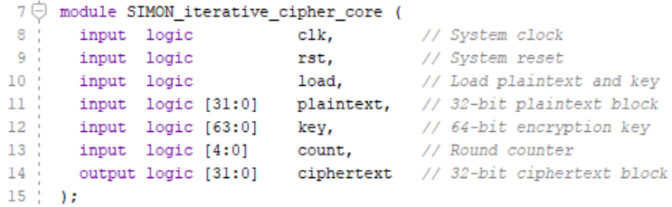

Figure ‑ Core Module Definition

Another common concept of the core module is the actions performed under different signals of *rst* and *load.* Their actions are given by the truth table in Figure 6‑12.

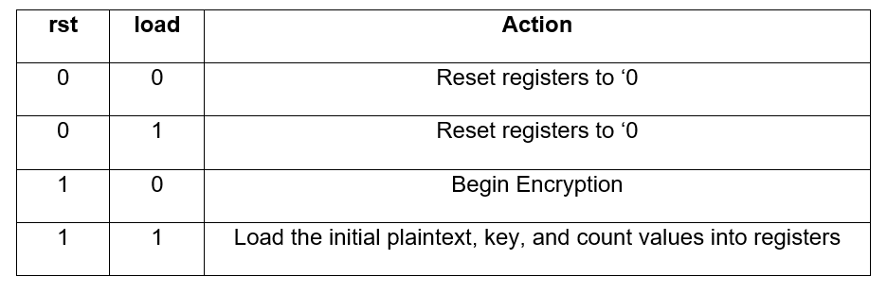

Figure ‑ Reset and load truth tables

The reset and plaintext, key, and count load SystemVerilog is given by Figure 6‑12. The continuation of the else statement on line 30 will describe how the key and round registers are updated for each model during encryption and will be different for each model.

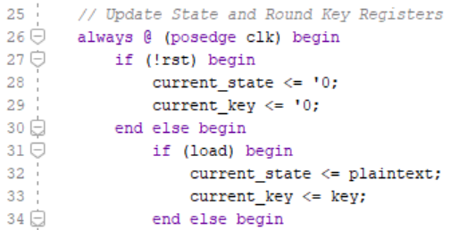

Figure ‑ SystemVerilof reset and load

Unlike the round_function and key_schedule modules, the core module will differ for all models. Each will involve some instantiation of the round and key sub-modules. For example, the instantiation of the *round_function* module in the iterative model is given in Figure 6‑11. Further details will be discussed in the corresponding section.

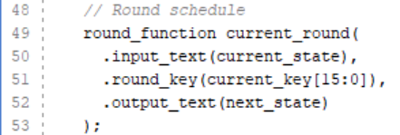

Figure ‑ Round function instantiation

Figure 6‑13 shows an example of the elaborated design of the cipher core. The key, count, clk, plaintext, load, rst and ciphertext ports are included. The round function and key schedule modules are also shown as well as a combination of MUX’s to control data flow.

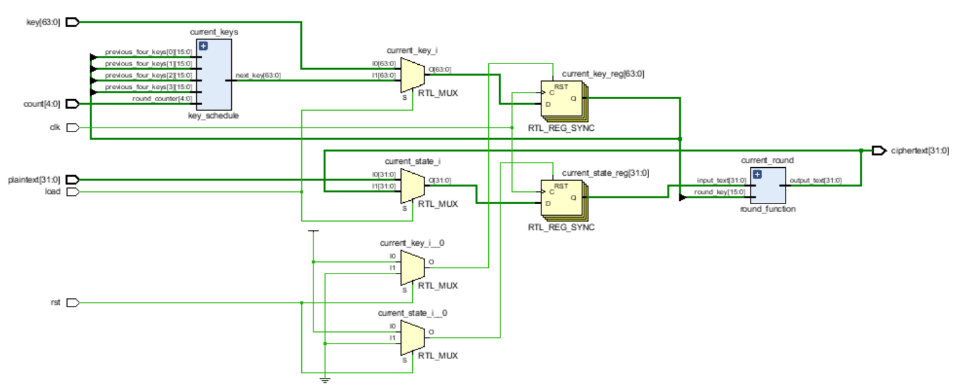

Figure ‑ Cipher core elaborated design

## Cipher Models

The following sub-sections details model specific implementation considerations. These considerations will be how the intermediate states of the core are updated and how the key-schedule and round functions are instantiated.

### SIMON_Iterative_model

The iterative model will contain one register *current_state* and one register *current_key* to store the intermediate values. A single *key_schedule* and *round_function* module is instantiated, and the outputs are wired to the corresponding single intermediate register and updated every clock cycle. The code snippets that provide this functionality are given in Figure 6‑15.

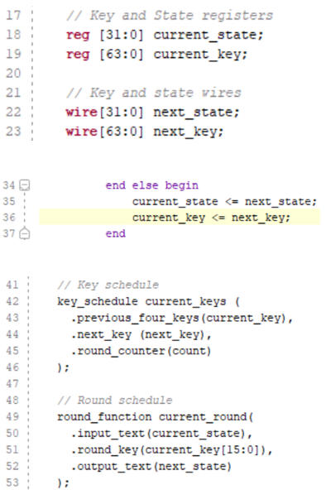

Figure ‑ Iterative Model Core Important Snippets

### SIMON_Pipelined_model

The pipelined core creates 32 round modules and 32 key schedule modules. This is achieved using the Generate construct in SystemVerilog, which creates the modules using a for loop. The key and round functions modules for each unrolled section are instantiated concurrently in a module called *pipe_section.* The code snippets for this functionality are given in Figure 6‑16.

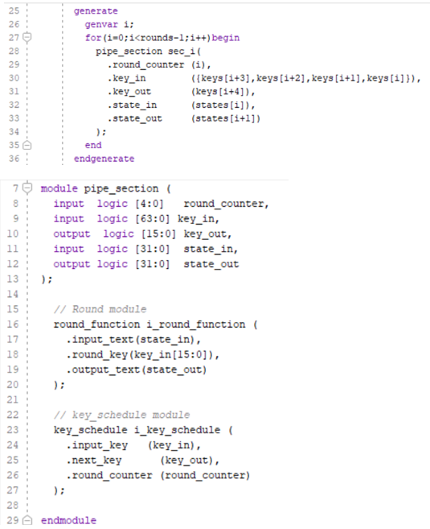

Figure ‑ Pipe section generation code snippets

33 intermediate round and key registers are created to store the intermediate values between the modules, the extra single registers used for initial values. The intermediate registers are wired to be the output of one module and the input to the following. There is no need for any update of registers, as the cipher is encrypted after one clock cycle. Therefore, the else statement that updates the registers between clock cycles in the iterative model is not required in the pipelined model. The intermediate registers are shown in the code snippet in Figure 6‑17.

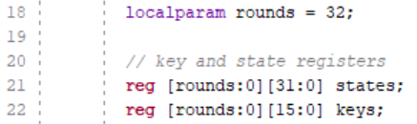

Figure ‑ Pipelined model intermediate registers

### SIMON_Mixed_model

The mixed model is a hybrid of the iterative and pipelined modules.

**Pipelined Similarities**

The piped section module from the pipelined module will be reused for the mixed module. Instead of the for loop in the generate construct creating 32 sections, the number of pipe sections is given by the desired number of rounds to be unrolled, specified by a parameter called *mixed_size.*

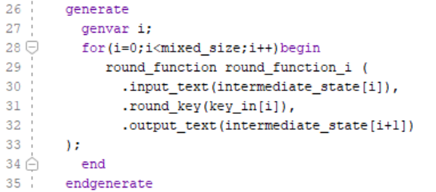

**Iterative Similarities**

A single intermediate state register is created to store the text value after every clock cycle, identical to the iterative model. The value of this intermediate state is also updated in the same way as the iterative model. The difference in this case is that the intermediate state will only need to be updated 32/*mixed_count* times.

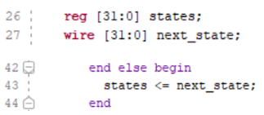

**Pre-Key Expansion**

The approach taken in this model was to pre-expand the key on the first clock cycle. The motivation behind this was to provide some comparison analysis between the models. The advantage of prior key-expansion is that decryption can be performed at any point after this. It comes with the cost of additional area requirements, due to the 28 (The master key contains the first 4 sub-keys) key_shedule modules required to provide the expansion. Once again, the modules are created using the Generate construct and wired accordingly as

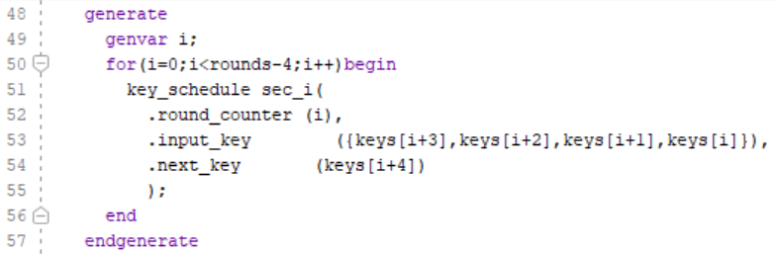

### SIMON_Decrypt_model

As previously discussed in section 6.3.4, the decrypt model will have an additional input signal *decrypt_mode* that determines if decrypt is enabled, or the regular encrypt is performed. If decrypt mode is disabled, regular encryption will take place using the mixed model. As described in that section, the key is pre-expanded in this implementation. If decrypt mode is enabled, the pre-expanded key is inputted into the pipe section in reverse. The pipe section contains two different round functions: the regular function and its inverse. The function chosen is determined by the decrypt mode.

## Conclusion

The implementations of the SIMON32/64 cipher core are now finished. ..

# Cipher Simulation and Validation

## Introduction

In the previous chapter, the RTL cipher cores, and submodules have been designed and implemented and are ready for simulation to verify that they are functioning as required. This is achieved by creating the controller logic in the form of a SystemVerilog testbench, supplying test vectors simulation sources using *.mem* file simulation sources and running a behavioural simulation to produce a waveform simulation. Like the hardware implementations, the testbenches will have a large amount of modulation in their designs that can be reused across all implementations. The test vectors, clock, reset and load drivers will be the same across the modules. The main difference across the modules will be the number of clock cycles required for encryption. The This process is detailed throughout this chapter.

## Anticipated inputs and outputs

Prior to creating a testbench, a clear picture of the anticipated inputs and outputs must be formed. Fundamentally, we require the plaintext and key to produce a correct ciphertext. Looking further into the inputs that were created in the cipher core

* **Clock**: A periodic inverter to synchronize modules. This is a standard feature in any FPGA.
* **Low reset signal**: All values are defaulted to 0. This is a standard feature in any FPGA.
* **High load signal:** The plaintext and key are loaded into the core
* **Count:** Increment every clock cycle after a posedge load until encryption is complete. This occurs when the reset signal is high and load signal is low/

The core modules created in section 6 were created to correspond with these signals. It is the purpose of the testbench to concurrently drive these values in the appropriate manner to validate the ciphertext. The general structure of the testbench is given in Figure 7‑1. Also given is a schematic of some of the driver logic needed to produce the required ciphertext.

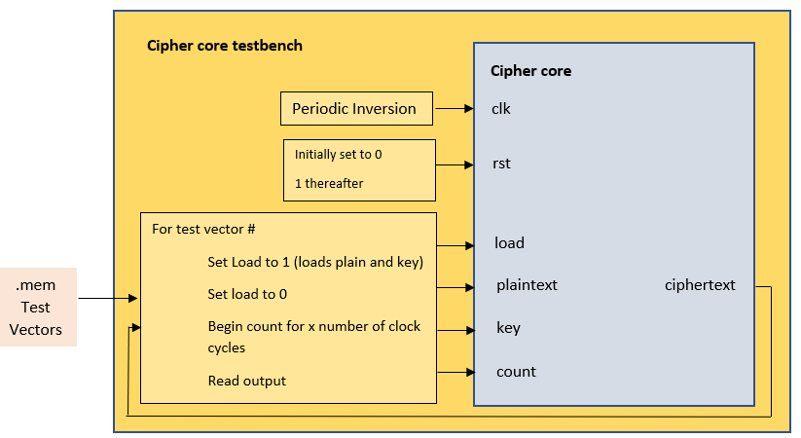

Figure ‑ Testbench structure with input controllers

## Testbench Controller Logic

To create a test bench simulation source, refer to the process steps described in the first practise project in section 5.2.1. The first section of the testbenches declares variables corresponding to the ciher_core I/O ports. The variable definitions are shown in Figure 7‑2.

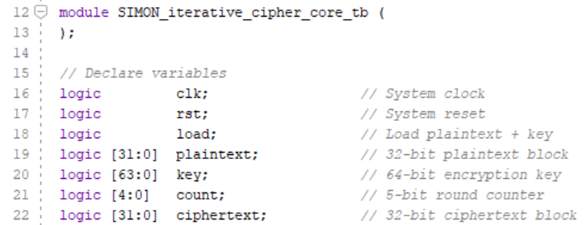

Figure ‑ Cipher core testbench variables

### Test Vectors

A set of plaintext, key and ciphertext vectors is required to verify the cipher is working as expected. A choice of random and verified test vectors is required. The national security agency provided a test vector for each configuration of SIMON that is used as the first test, as shown in Figure 7‑3.

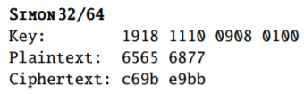

Figure ‑ Verified test vectors

Despite extensive online research, no adequate source was found to provide any additional test vectors. As a result, a set of plaintext and key were created using a random 32 and 64 bit online hex generator. The corresponding ciphertext was encrypted using a verified online SIMON32/64 encryptor. These test vectors were recorded and copied into the three files:

* *plaintext_testvectors.mem*
* *key_testvectors.mem*
* *ciphertext_testvectors.mem.*

*.mem* files use Foxpro software to store variables and arrays. The test vectors can be added, line by line, similar to a *.txt* file. A totally of twenty plaintext, key and ciphertext test vectors are chosen in total to provide sufficient confidence of verification. To create test vector simulation source, select *add source* from the flow navigator. Choose *add or create simulation source* as normal. Select a *.mem* file from the dropdown instead of a SystemVerilog file and complete the setup as normal. The test vectors are read into the predefined plaintext, key and ciphertext registers from memory using the  command as seen from the SystemVerilog code given in Figure 7‑4.

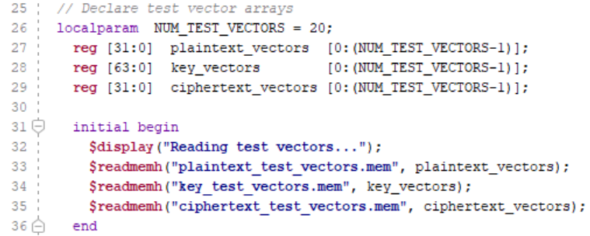

Figure ‑ Reading test vectors from memory into registers

The next step is to create an instance of the core module of the model to be verified. The ports of the module are assigned to the corresponding variables as seen in Figure 7‑5.

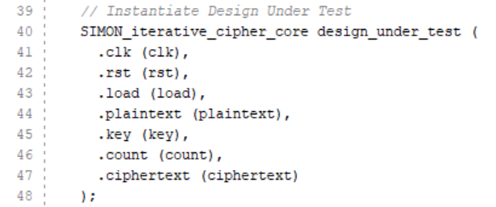

Figure ‑ Core module instantiation

As discussed previously, the clock and reset signals need to be driven by the standard practice; the clock will invert periodically. The SystemVerilog driving this along with the corresponding waveform is given in

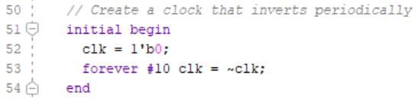



Figure ‑ Clock driver and waveform

The reset value is initialised with a value of 0 and driven to 1 after a delay to clear the register values and set load and count to 0 as seen in Figure 7‑7

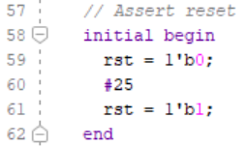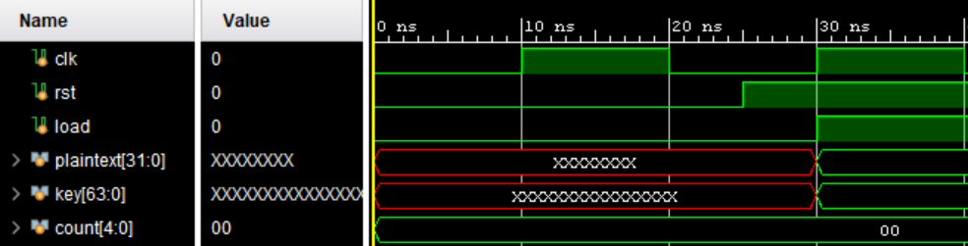

Figure ‑ Reset driver and corresponding waveforms

The main stimulus waits for the posedge reset that was created in the initial begin. It then loops through all 20 test vectors in a for loop. For every test vector, it asserts a 1 value to the load signal to load the plaintext and key vectors as seen in Figure 7‑8.

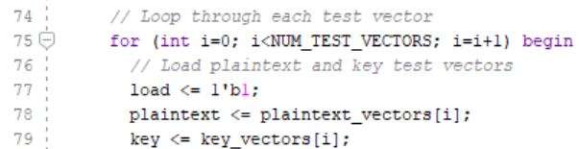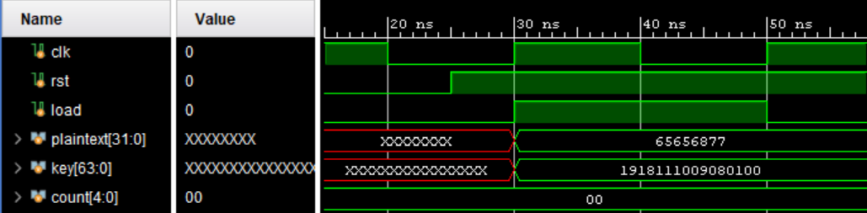

Figure ‑ Loading test vectors

The load value is then driven to 0 which begins the count. This is where the main difference occurs between the different models. The iterative model requires 32 clock cycles to complete, the pipelined model 2 (1 to complete load and 1 to encrypt) and the mixed model 32/*mixed_size* where *mixed_size* is the size of the unrolling.The SystemVerilog for the three models is shown in Figure 7-9 (a), (b) and (c) respectively.

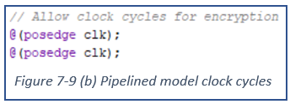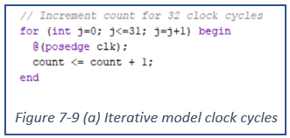

Figure 7‑9

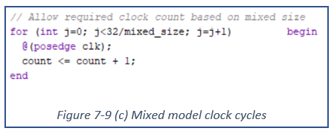

The hardware can be verified using the print and assert statements. An assert statement is used to check that the produced ciphertext matches the expected ciphertext and the expected output is shown in Figure 7‑10. Any mismatch is flagged. This is repeated for all 20 test vectors

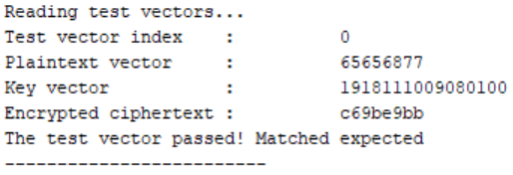

Figure ‑ Expected output

**Decrypt_mode**

The decrypt mode behaves test bench drives the signals in the same way as the mixed model test bench. There is an additional variable that determines whether the core is in encrypt/ decrypt mode:

* 0: Encrypt mode
* 1: Decrypt mode

This value is driven after the reset and can be changed by the user. To verify the results, read the ciphertext test vectors into the plaintext registers and vice versa to swap the plaintext and ciphertext vectors as shown in Figure 7‑11.

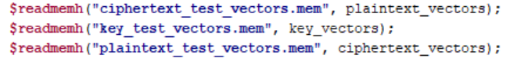

Figure 7‑11 Swapping plaintext and ciphertext test vectors

The keys can remain the same. The print statement is customised to display results depending on the mode.

## Debugging

The waveform simulation can be viewed to analyse I/O and register values at every clock cycle. The waveform is produced by selecting *Run Simulation* -> *Run Behavioural Simulation* in the flow navigator. This a useful place to begin debugging. Figure 7‑12 shows the waveform simulation for the iterative model. Both the expanded keys and text value after after round can be viewed and verified to ensure correct functionality. Unless intentional, red signals representing X (unknown) values, can be an immediate sign of error and can propigate through the simulation.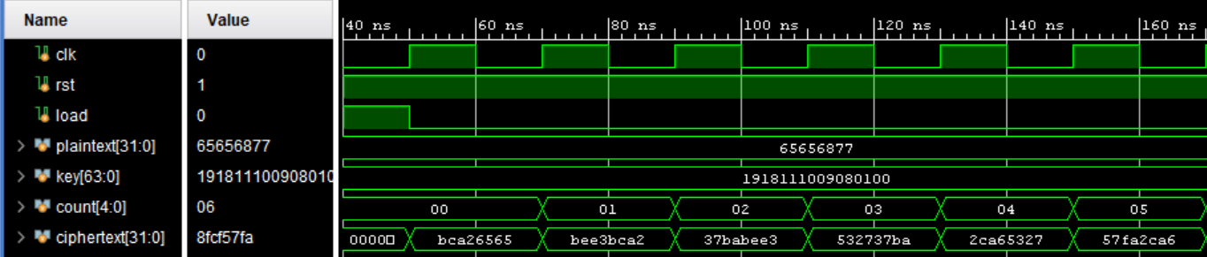

Figure ‑ Waveform Simulation showing I/O and register values for iterative model

Vivado only include top-level ports and testbench variables in the simulation by default. Internal signals from the core, round function or key schedule modules can be added to the waveform by opening the *Scope* window after the waveform has been simulated, expanding the design to the required signal, right clicking, and selecting *Add to Wave Window* as seen in Figure 7‑13*.*

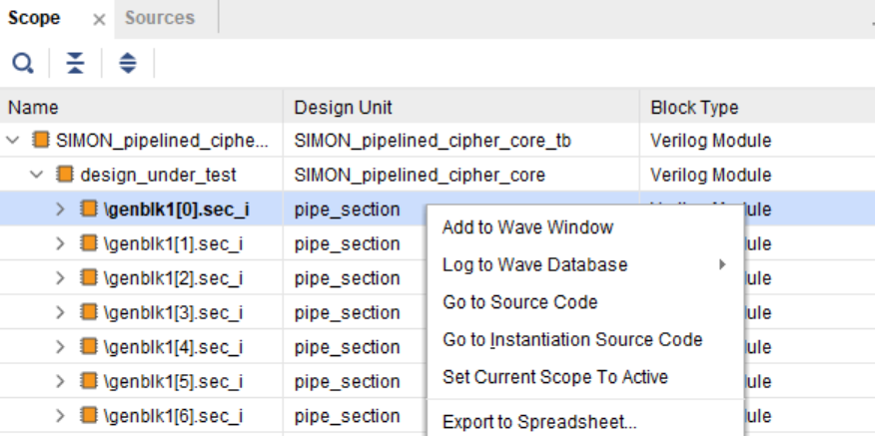

Figure ‑ Adding internal signals to Wave Simulation

The default run time in Vivado is 1000ns. This may need to be extended. The Vivado command *$finish* is called after the last test vector has been encrypted and verified. It exits the simulation and gives control back to the operating system. To allow the testbench to run until finish, select *Tools -> Settings -> Simulation,* open the *Simulation* tab and change 1000ns to *“-all”* in *xsim.simulate.runtime.* Markers can be placed in the simulation to quickly return to specific points in the simulation. Right click on the waveform at the required position and select *Markers -> Add Marker*. This can also be useful in timing calculations

A suggested approach for debugging is to verify the submodules for functionality first before working up to the core and then the testbench. Very simple testbenches can be created for the submodules, without any timing requirements such as the clock, reset, or load signals. After these have been verified, it is useful to verify that the core module is working correctly for one round of encryption to verify that the core module is working without timing requirements. Any errors beyond this point will be timing errors and are due to how the signals are driven in the testbench. This iterative approach is a standard procedure for debugging.

## Conclusion

The hardware implementations of the different models of SIMON32/64 are validated and ready to be packaged as a peripheral and integrated into a block design in the next stage. This chapter has demonstrated all of tools needed to create suitable testbenches for validation for all models. The approach taken for signal driving was explained in a theoretical sense with architectural diagrams before the SystemVerilog code was created for the iterative, pipelined, mixed and decrypt models. The process for deciding the test vectors used in the *.mem* was also outlined. Finally, useful guidance for efficient debugging were given.

# Cipher Core Custom IP Development

## Introduction and Review

The next primary goal of the project is to create a custom IP from the previously developed cipher core and access it via the processor and AXI peripherals. It is important to develop a full understanding of the Zynq architecture and how the custom IP will be integrated. This subsection begins with a brief review of the Zynq-7000 SoC. Detailed steps of how a custom IP is created and packaged using the Vivado design suite follows this, analysis of the AXI Interconnect for data transfer between the PL and the PS, Out of Context Runs to configure place and route and, access from SDK will all be reviewed. The remainder and focus of this chapter will analyse how the IP’s will be developed and integrated into the Zynq architecture and interfaced with one another.

### Zynq-7000

The Zynq-7000 architecture was briefly introduced in section 3.2 and once again in section 5.2.2 when the processing system IP was re-configured. The Zynq-7000 is the first AP SoC in the industry to amalgamate the ARM Cortex A9 Processing System (PS) and the Programmable logic (PL) on the same SoC, increasing overall system performance and reducing latency. The main features of the PS are the dual core processor, DDR memory controller and configuration. The core processor contains a dual-core ARM Cortex-A9 processor through which, all the software programmability can be fulfilled. A fully programmable FPGA located adjacent to the processing system provides the reconfigurability for streamlined digital circuit development. The FPGA is a semiconductor device composed of interconnected logic blocks called slices. These slices are comprised of gates, look-up tables (LUTs) and flip flops. The slices can be configured using a bitstream file that details how the gates, LUTSs and flip flops are interconnected. Block RAMs (BRAM) are used for storing large amounts of data inside the FPGA. They have a customisable width and depth and will be used to store plaintext and ciphertext data for this project.

### IP Creation, Packaging, and Integration

As discussed in the design flow section of 5.1, the cipher core must be packaged in a newly created, custom IP. This will be the first step in the AXI IP development and a brief run through of the required steps are detailed in this subsection. To begin, select *tools -> Create and Package new IP..* from inside the project to be packaged. The introductory window that pops up details the tasks that can be accomplished with the wizard. Select *Next* to proceed to the next window where the option to create a peripheral or package IP appears. Select *Create a new AXI4 peripheral* and enter the peripheral’s details and location. The next window displays the interface options for the peripheral as shown in Figure 8‑1. This window configures the number of interfaces, their names, interface type, interface mode (master or slave), data width and number of control and status registers (CSRs).

Figure ‑ Peripheral's AXI Interfaces

For this project, a single AXI slave interface is needed to interface the single cipher core. The interface type is detailed in the following subsection. The interface type, data width and number of registers should be decided ahead of creation, as will be shown throughout this chapter. Select *Edit IP* and finish to begin editing.

The block design will provide the mapping between the programmable logic and the processing system. Vivado provides a large amount of automation to assist with this. It also automates a large amount of the IP packaging process that wraps up the design, constraints and I/Os into a block that is easily customised, modified, and integrated. Figure 8‑2 shows the project manager interface for custom IP editing. Two design source files are auto-generated – a top-level RTL file and an AXI slave. These Verilog files can be opened and edited as normal with Vivado providing spacing for custom parameters, ports, and user logic for both the top level and slave files. Additional design sources can be added in the normal way. The usual hardware development flow tools are available such as simulation, synthesis, and implementation for verification purposes. The package IP user interface is also shown in Figure 8‑2 which is used to assist in packaging, such as customizing the packaging of ports and interfaces which will be used in this project.

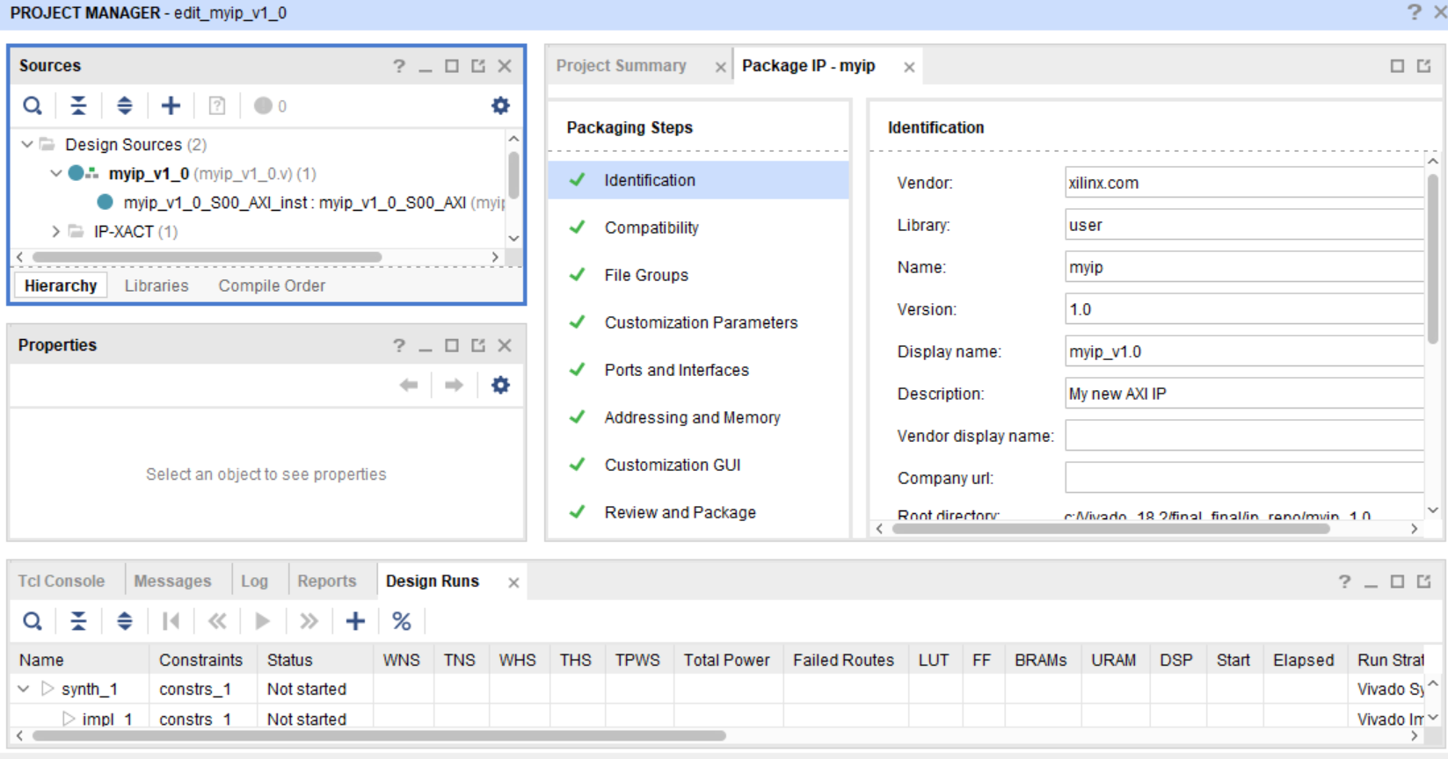

Figure ‑ Custom IP Packager Project Manager Interface

The IP is ready to be added to the IP repository and added into the block design. Once integrated, the block must be appropriately connected to the other blocks and the design validated. Refer to Figure 5‑3 for a summary of the IP creation design flow.

### AXI Interconnect

The AXI Interconnect provides an essential communication link between the PS and PL for two-way data transfer. The Zynq SoC contains 9 PS to PL AXI Interconnect Interfaces allowing for rapid data transfer. The AXI interconnect is part of the ARM AMBA microcontroller bus family. The latest AXI4 model is used in the Zynq SoC and comes in three different interface types:

**Lite:** Subset of the AXI4 protocol aimed for simple data transfer through the CSR’s. All transactions have a burst length (amount of data transferred in each transmission) of one and data access is always the same width as the bus.

**Full:** Fully operational, high bandwidth with burst lengths of up to 256, suitable for bulk transfers

**Stream:** Designed for one-way communication from the master to the slave, reducing signal routing. Used for implementations in FPGAs

For this project, the Lite model is used. This requires less area resources. The project does not require large bandwidth and thus the significantly reduced area realisations are more beneficial. The stream interface is not an option as it does not support the memory mapping needed to access data via software.

### Out-of-Context Runs

Running synthesis and implementation were introduced in section 4.3. These operations attempt to place and route the ports of the top-level module in the RTL design with a device pin. Counting the number of ports in the basic core module (32-bit plaintext, 64-bit key, 5-bit count, 32-bit ciphertext, clock, reset and load signals), there are a minimum of 136 ports declared. Synthesis and implantation will result in an error stating, ‘I/O placement is infeasible.’ The system tries to place and route the 136 ports to physical pins, of which there are only 100 on the Zybo board. The synthesis and implementation tools need to be configured to prevent the routing of the core module ports to the pins of the FPGA so that Synthesis and Implementation are only run at an IP level. This is achieved by enabling “*Out-of-Context”* mode. Select *Tools* -> *Settings* and open *Synthesis* under *Project Settings*. Scroll to *More Options* in the *Options* section. Type “*-mode out_of_context”* and apply the settings to the project as shown in Figure 8‑4. Repeat the steps for *Implementation*, found underneath *Synthesis* in *Project Settings.*

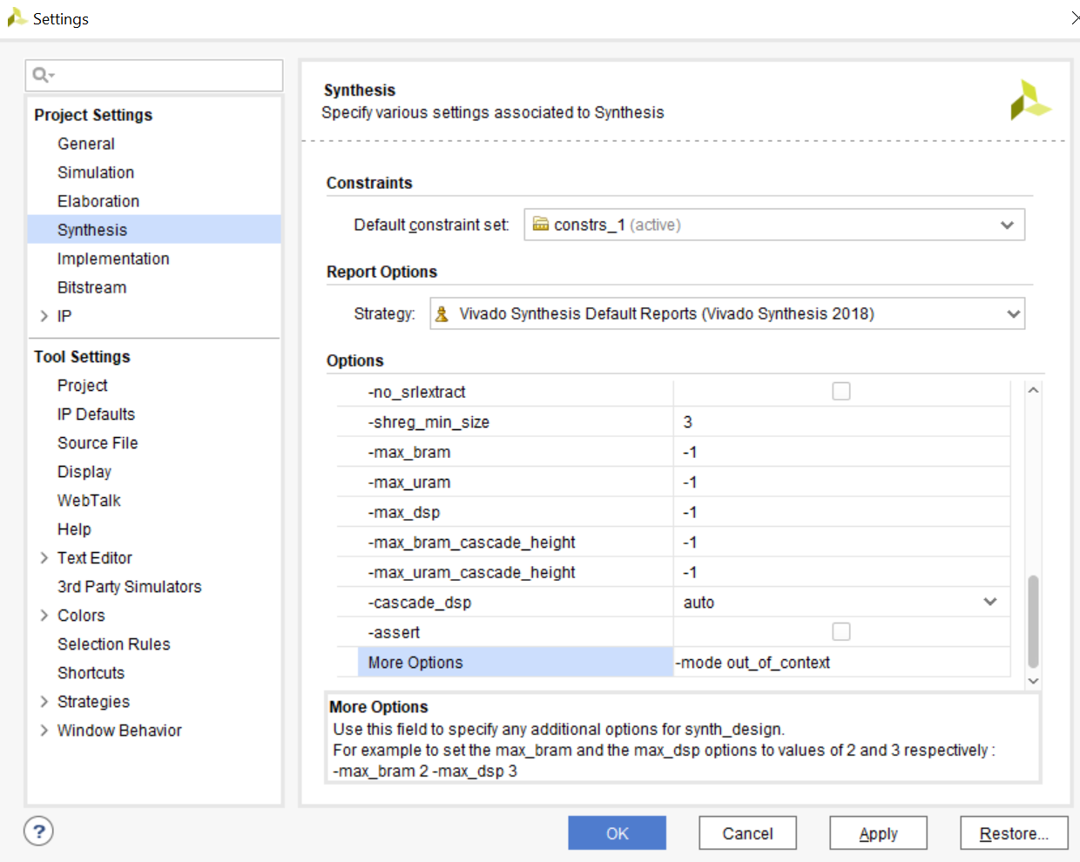

Figure ‑ Out-of-Context Mode

### 

### Access From SDK

Don’t need?

## AXI IP system Architecture

The iterative, pipelined, and mixed model cipher cores developed in Section 6 can now further be developed into a custom IP using some of the details previously outlined in this chapter. **The first goal is to package the IP as to provide a suitable interface for the hardware peripherals to be accessed by the processor. The interface design will include the plaintext and ciphertext data buffers, an interrupt to notify the processor of complete encryption and the control and status registers used to supply the key, length of test vectors and to control the flow of data. Next, the RTL implementation of the created IP needs to be edited and driven by a controller. Finally, a block design is created to visually integrate the cire IP, processor, plaintext, and cipher BRAMs, and AXI GPIO to allow for the encryption to be triggered using a switch. The full architecture of the system is shown in Figure 8‑3.**

Figure 8‑4 Processing System and Programmable Logic with AXI interconnects

The AXI BRAM Controllers, the Block Memory generators used to store the plaintext and ciphertext and the AXI GPIO are all fully supported IPs created by Xilinx and supported by the Zynq-7000 Soc. Chapter 9will deal with the software required to driver cipher encryption the processing system.

## AXI BRAM & AXI GPIO

Xilinx provides a flexible Block Memory Generator to use as high-performance memory that will be used to store plaintext and ciphertext. These will be interfaced using AXI protocols and controlled from the processor via Xilinx’s AXI BRAM control. Two true Dual-Port are used, one port providing the plaintext or ciphertext and the other used for control via the AXI BRAM control. The write/read data width required is 32 bits in accordance with SIMON32/64 allowing for a depth of 2048. To see the BRAM physical ports that will be interfaced with the cipher core, in an empty block design, add a *Block Memory Generator* and double click on it to re-customize. Expanding the BRAM port shows the block diagram in Figure 8‑9.

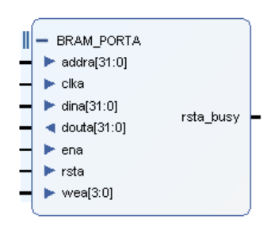

Figure ‑ Block Memory Generator

There are a total of seven physical ports used for reading and writing that need to be interfaced with the cipher core. The details of these ports are given in Figure 8‑6.

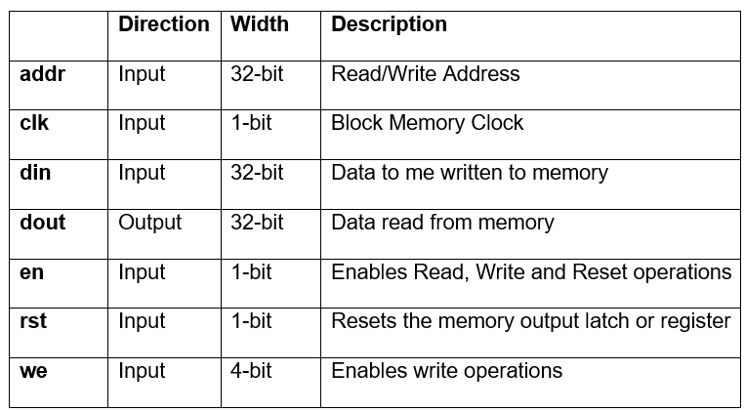

Figure ‑ BRAM port descriptions

Rst_busy is a safety circuit feature used to minimise data corruption. When asserted, it indicates that the BRAM should not permit access. It is not needed for the purposes of this project and can be left untouched.

The AXI GPIO provides a general purpose I/O core to the AXI interface that will be used to trigger the start of encryption. The block will be added to the block design in the PL section of the device. When the switch is triggered, it informs the processing system and allows it to begin encryption.

## Control & Status Registers

As discussed in section 8.1.2, when creating a new IP, the number of CSRs must be defined during creation. It is possible to create between 4 and 512 CSRs and the figure should be worked out pre-definition. These 32-bit registers can be accessed through the AXI-Interface. The 64-bit key value will be programmed into these registers, requiring two in total. Defining the key in the peripheral removes the need for a key buffer. It means that one key will be used to encrypt many blocks of plaintext and is more fitting with real-world applications. A load value, whose functionality is analogous to the load value in the testbench is used to begin encryption and uses one bit. The number of plaintext blocks for encryption is specified in the registers. The BRAMs used to hold the ciphertext can store 36000 bits. Dividing 36000 by 32 gives a total of 1125 blocks available to be loaded into BRAM. To provide the maximum number of plaintext vectors, 11 bits are required to define the number of plaintext vectors that will be loaded into memory. A total of 66 bits are required for the control and status registers and so only 4 32-bit registers are needed. The table in Figure 8‑4. As can be seen from the table, part of register 0 and all of register are not required.

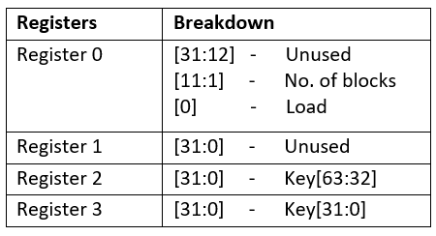

Figure ‑ Register Breakdown for custom IP

NOTE: CHANGE

uint32_t cfg_val = ((length << 1) & 0xFFE) | 0x1;

Xil_Out32(XPAR_P128_RB_IP_0_S00_AXI_BASEADDR + P128_RB_IP_S00_AXI_SLV_REG0_OFFSET, cfg_val);

JUST WRITE TWO SEPARATE FUNCTIONS TO WRITE THE NUMBER OF TEST VECTORS2^20 = 1048576

ALSO CHANGE current_block <= 11'b0;

NEEDS TO BE 20

## Interrupt

An interrupt is used to notify the processor that the cipher has finished encryption so that it can continue its flow of operation. An output port from the top-lever RTL of the IP is routed to the processor. As will be discussed in the block design creation, the processor can be customised to take in an interrupt. On receiving this interrupt, the software will continue running the programme and will be discussed in the following chapter during software driver development. To send this trigger, a rising edge will need to be produced. This will be triggered by the controller, that will also be developed later. Figure 8‑5 shows a visual representation of the block design and how the done interrupt of the cipher IP is connected to processor.

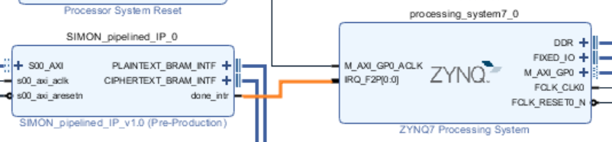

Figure ‑ Interrupt signalling end of encryption

## Controller, Slave & Top Module RTL

After creating the new IP packaged, as discussed in section.., a new skeleton AXI IP is formed for editing. There are two ways to edit the cipher core IP. Select *Edit IP* on the final window in the creation process. Alternatively, select *Add IP to the Repository* in the final window off the creation process, create a new block diagram, add the custom IP by searching for it in the IP repository, right click on the newly added block and selecting *Edit in IP Packager.* A new Vivado project will open with the skeleton AXI IP. The IP contains two auto-generated designs sources, as shown in Figure 8‑6.

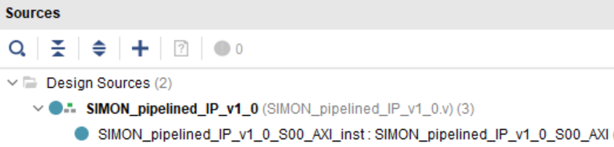

Figure ‑ IP autogenerated source files

The IP contains a top-level RTL file and an AXI slave. These files are used for instantiating modules, adding parameters, ports, and user logic. Data will be received by the AXI slave, passed to the top-level interface where the core, controller are instantiated and plaintext and ciphertext BRAM, and done interrupt ports are defined.

### AXI Slave Interface

The AXI Slave interface will be used to interface with the 4 newly created CSRs as discussed in 8.4. These values will then be passed on to the top-level RTL file for use in the cipher core and control modules. The key, number of blocks and load data are therefore included as output ports in the slave interface. The autogenerated source code provides space to include user ports as shown in Figure 8‑7. The values will be used as input for the control module and are so named appropriately.

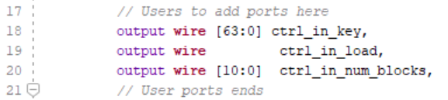

Figure ‑ AXI Slave Interface Ports

These ports are assigned values from the slave registers. The 0th bit of slave reg 0 is assigned to load, the 10th to 1st bits of slave reg 0 are assigned to the number of blocks and the key is the concatenation of slave reg 2 and slave reg 3. The source code provides space for including user logic.

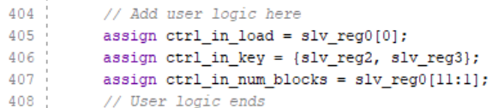

Figure ‑ AXI Slave Interface User Logic

### AXI IP Top Module

**Slave Instantiation**

The top-level module creates an instantiation of the AXI slave interface. The first task for editing the top-level module is to edit this instantiation to include the key, load and block number output ports of the slave and assign them to wires that will be used in the control module as shown in Figure 8‑12.

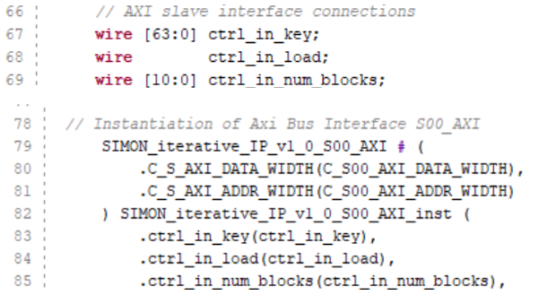

Figure ‑ Slave Instantiation

**Core Module**

The next step is to instantiate the core module used for cipher encryption. Add the cipher_*core, round_function* and *key_schedule* module for the chosen model. These design sources can be added in the usual way, selecting *Add File* and adding the source files from the chosen model’s source code directory. The load, plaintext, key, count and ciphertext ports are routed to newly created wires. The clock and reset ports are assigned to the global clock signal and global reset signal (Active Low) defined by the IP. The other signals will be driven by the controller. Load, plaintext, key, and count will be outputs of the controller and fed into the core, the ciphertext is encrypted and its value returned to the controller to be written into memory.

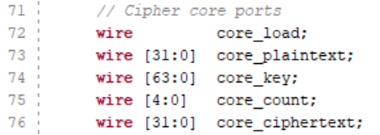

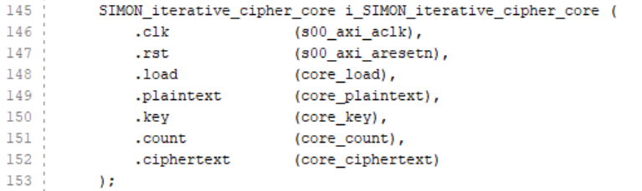

**I/O Ports**

Vivado auto generates the top-level ports AXI ports to be interfaced with the slave and logically groups them into a single *S00_AXI* interface as shown in *Ports and Interfaces* tab seen in Figure 8‑13. These ports are used for communication with the slave

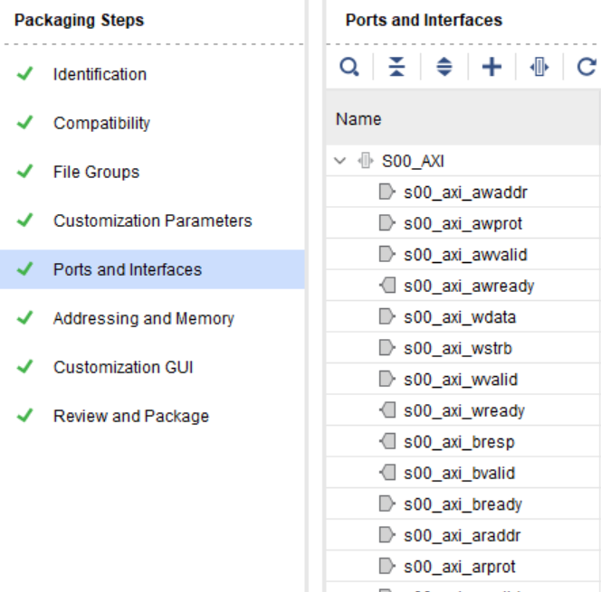

Figure ‑ AXI-lite Interface connection

The slave clock and reset ports are also logically grouped as shown in

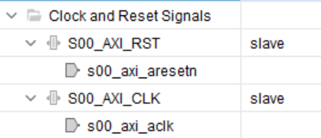

In addition to the auto-generated ports, additional user defined ports are required. These are logically grouped into three categories:

* Plaintext BRAM interface to read from the plaintext BRAM
* Ciphertext BRAM interface to write to the ciphertext BRAM
* Interrupt to signal completion to the Processing System

The BRAM physical ports were described in 8.3 and are copied into the top-RTL file (in the opposite direction). The 1-bit done interrupt output signal is also included. These additional user ports are shown in Figure 8‑14.

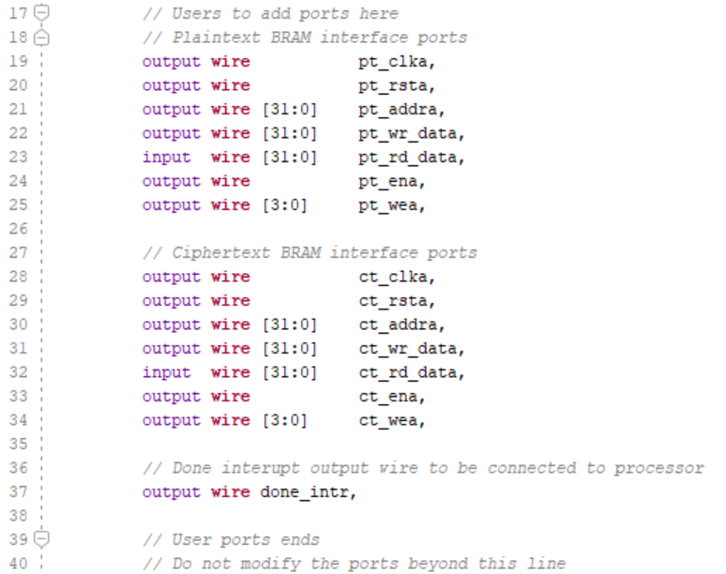

Figure ‑ User ports

It is useful to logically package the BRAM into one interface for simplicity when making connections in the block design. Open *Ports and Interfaces* in the *Package IP* window. The BRAM physical ports to be interfaces are listed. To add an interface, select the *+* icon. Give the interface an appropriate name. To define what the interface will be mapping to, open *Interface Definition* to search for the BRAM. Expand *Advanced* and scroll down to *bram_rtl* as shown in Figure 8‑15. Shown in the figure is the ports that need mapping. Select *OK.*

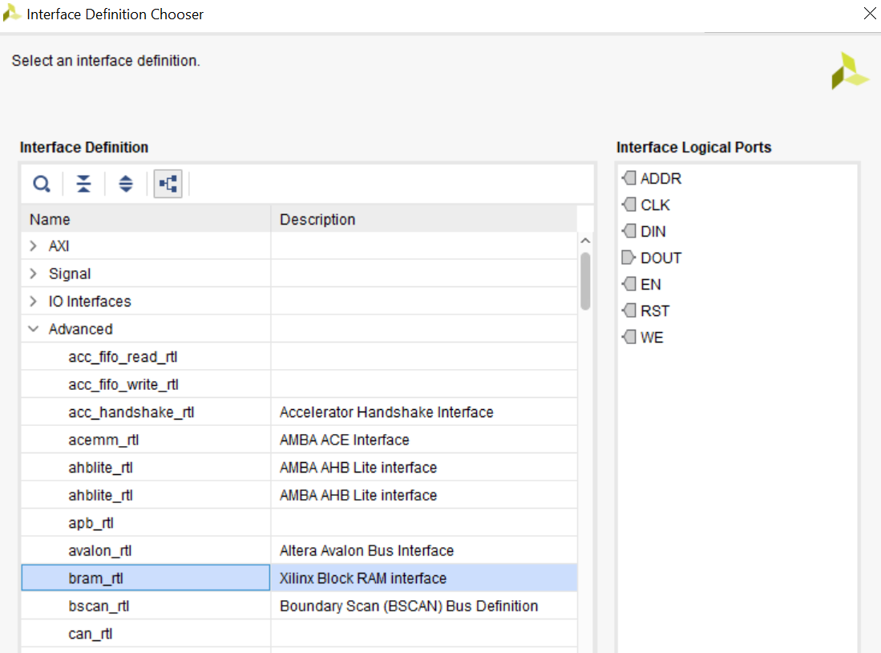

Figure ‑ Interface Definition

Open the *Port Mapping* tab. Map the logical and physical ports as shown in Figure 8‑16.

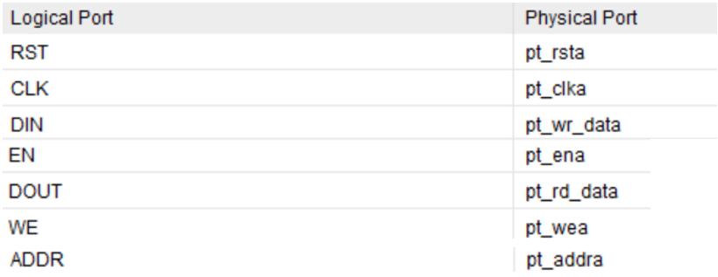

Figure ‑ Mapping logical and physical ports

Finally, to override the master type parameter open the *Parameters* tab. Move he *MASTER_TYPE* parameter to the override section. Change the *Value* of *MASTER_TYPE* to *BRAM_CTRL.* Repeat this process to interface the ciphertext BRAM.

**Control**

The final step of the process is to create the controller logic that ties the plaintext and ciphertext BRAMs, cipher core and the interrupt together. A new SystemVerilog file *Simon_modelname_cipher_core_ctrl.sv* design source is created for each core model. The controller will form the logic to drive the signals for the cipher core, like the testbench. The following pseudocode describes the control functionality:

@ reset

initialise states

Current address = 0

Current block = 0

plaintext = 0

ciphertext = 0

@ begin

for(i from 0 to no. of blocks){

Read plaintext from BRAM at address i

plaintext = BRAM_plaintext[i];

Set cipher core load

load = 1

begin Count for required number of clock cycles

while(count < required cycles)

count++

write encrypted ciphertext to ciphertext BRAM at address i

BRAM_ciphertext[i] = ciphertext

Increment address

address ++

}

Enable interrupt

done_interrupt = 1

A Finite State Machine (FSM) model is used to provide the abstraction needed to drive the logic. First, a decision on the set of states needed for the FSM based on the above pseudocode is needed. The SystemVerilog code in shows six distinct states that were chosen for the FSM

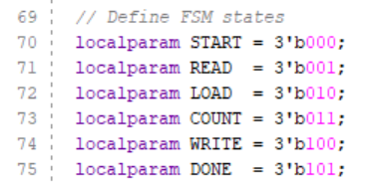

Figure ‑ Finite State Machine States

Next, the variables that are included in the finites state machines truth table need to be decided on. Once again, referencing the pseudocode, the truth table shown in Figure 8‑18 is produced.

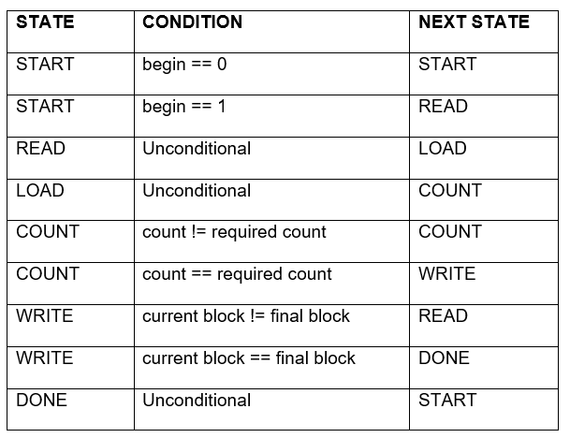

Figure ‑ Finite State Machine Truth Table

This is translated to the following SystemVerilog Code

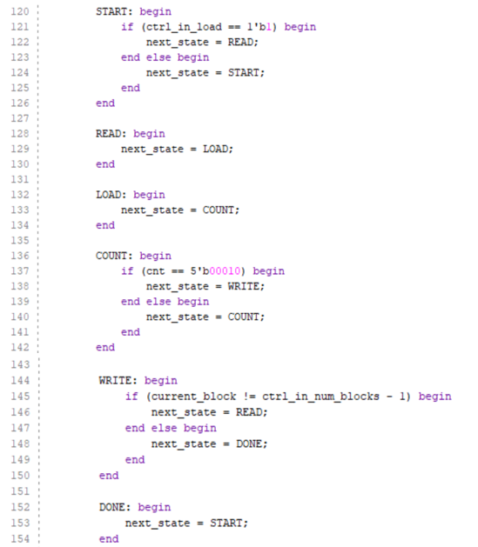

**BRAM Control**

The signals needed for plaintext and ciphertext BRAM control and driven by the control. They are therefore declared as ports in the control module and updated depending on the state. The following details how the BRAM signals are driven

**Clk**: The plaintext and ciphertext BRAM clocks are synchronised with the custom IP’s clock which is in turn driven by the processing system.

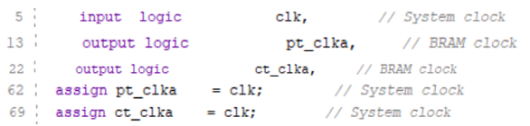

**Rst:**  Like the clock, the BRAM resets are assigned to the custom IP’s. The Processors System Reset (and therefore the custom IP’s) is active HIGH and the BRAM’s reset is active low. The BRAM is therefore assigned the inverse of the IP’ reset.

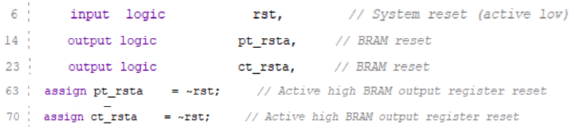

**Addr:** The data bit bus is 32 bits wide as can be seen from the IP details. This can be reconfigured but is the desired width for SIMON32/64. The address width for read and write operations is 32.



A current address register is used to store the current address for read and write operations. The same address will be used for the plaintext read operations and ciphertext write operations to provide synchronisation and therefore the same address register can be used. On a reset or in the start state, the current address is assigned a value of ‘0. The BRAMs are by default byte addressable. When encrypting a new block, the current address is incremented by 32 bits, corresponding to 4 bytes.

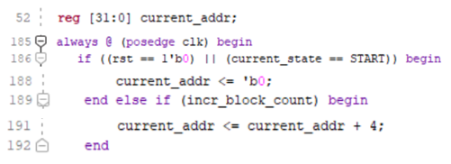

The plaintext and ciphertext address need to be updated in the correct states. When in the read state, the plaintext address is assigned to the current address value. When in the write state, the ciphertext is assigned the current address location and write is enabled.

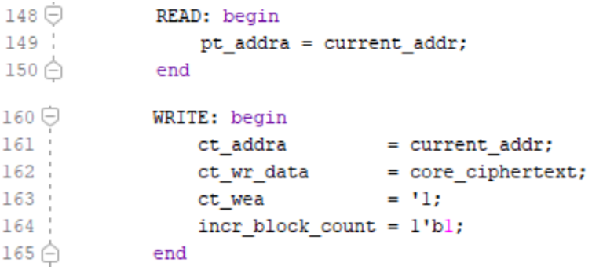

**Din:** The plaintext test vectors will be written to the BRAM by software. It will then be read from memory through the control and assigned to an output port to be used in the cipher core.

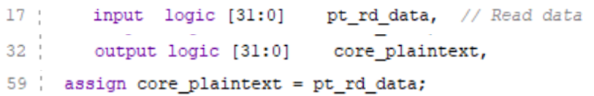

The ciphertext read data does not need to be accessed at this point and will instead be accessed through software by the processor in the next section

**Dout:** No data should be written to the plaintext BRAM by the cipher core IP. Instead, it’s values are written through software via the processor. Therefore, the write enable should be disabled to avoid data corruption, as seen in the subsequent section. The plaintext write data is assigned a default value of ‘0.



The data to be written to the ciphertext BRAM is assigned the core ciphertext value when in the WRITE state.

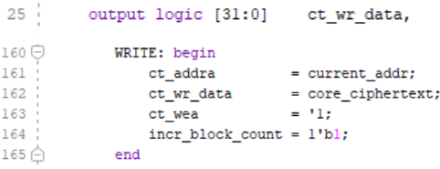

**En:** The enable signal is set to high for both BRAMs to allow for read, write and reset



**Wen:** As previously discussed in **dout**, the plaintext write enable is disabled to avoid data corruption.



Write enable to ciphertext memory is enabled in the write state:

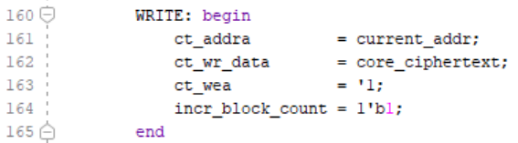

There are four other values that need to be updated depending on the state:

* *core_load*: This sets the cipher core load to high when in state LOAD and low otherwise

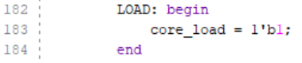

* *enable_counter*: This register is created in the control module. It is set to hight when in the COUNT state and low otherwise.

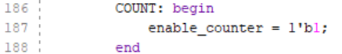

When *enable_counter* is set, the count is incremented every clock cycle. Otherwise, count is set to ‘0

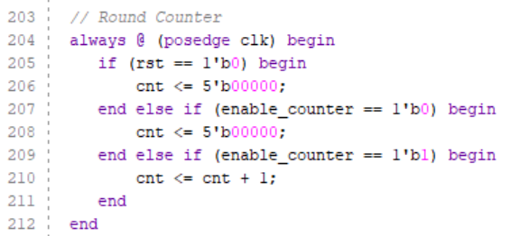

* incr_block_count: When in the WRITE state, *incr_block_count* is set to high and is otherwise low.

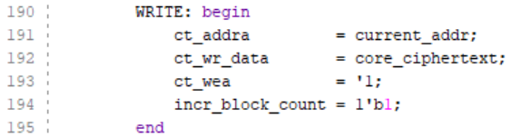

Setting the value to high triggers the block number and current address to be updated

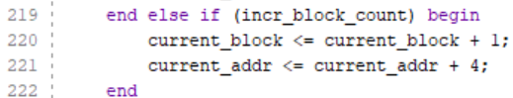

* done_intr: When in the state DONE, the done interrupt is set to high and is otherwise 0. This is ultimately sent back to the processing system where it is handled by the interrupt handler.

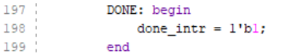

This completes the creation of the controller module to drive signals for the cipher core and BRAMs. It can now be instantiated in the top-level RTL and connected to the appropriate ports. The final step is to package the modified IP. First Run synthesis in out-of-context. Errors in the code can be reported here. Vivado provides a tool to automatically merge any changes that were made. In the package IP, use the merge changes tool that appear after a change has been detected as seen in , until all of the packaging files have a green tick beside them.

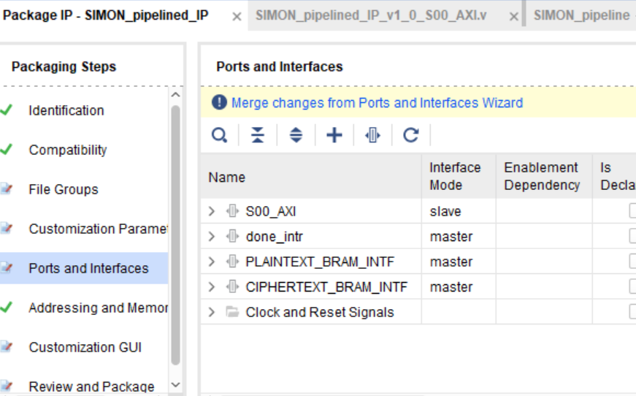

In the *Review and Package* section select *Re-Package IP* to finalise the creation and packaging of the cipher core custom IP.

**Iterative, Pipelined and Mixed Models Cipher Control**

As discussed in Section 7, the difference between the iterative, pipelined, and mixed model testbenches were the number of clock cycles required to complete encryption. This is also applied to the iterative, pipelined, and mixed model controllers. The iterative model requires 32 clock cycles, the pipelined model requires 2 and the mixed model *32/x* clock cycles, where x is the degree of unrolling. The FSM will stay in state COUNT until the counter has reached the number of clock cycles required for that model, before it moves onto state WRITE. The differences in the three models are shown in ..

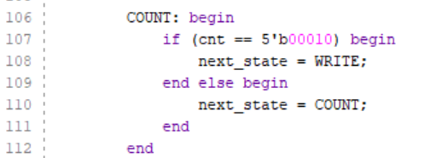

## Block Design and Integration

**Add the new IP to the repository**

The custom cipher AXI IP has been created and ready to be integrated with the processor and memory. The core IP has been created and edited but has yet to be added to the IP repository. This can be achieved by ..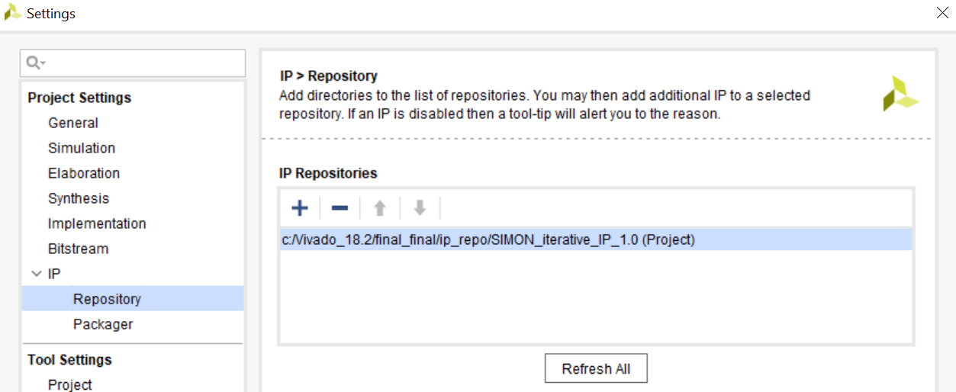

**Add the processing system**

Create a new block design using the normal steps. First, add the Zynq7 processing system and run block automation as normal.

**Add custom IP**

Add the custom IP by searching for it in the repository.

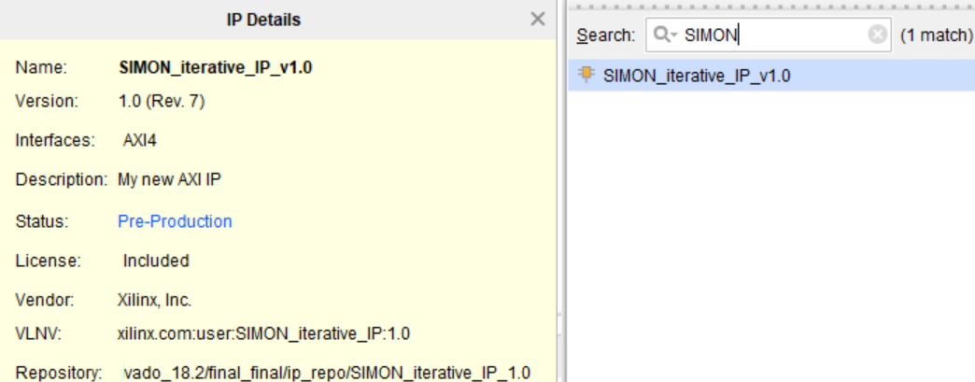

Select *Run Connection Automation* allowing the AXI Slave interface to be automatically connected to the processing system. This automatically creates and connects an “AXI Interconnect” and “Processor System Reset” Ips.

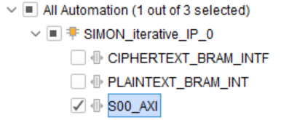

Next, the memory to store the plaintext and ciphertext vectors are added. A physical BRAM block and an AXI BRAM controller for access management via the proceesor core are required.

**Add the AXI BRAM Controllers**

The AXI BRAM Controllers are added to the Block Design by searching for *AXI BRAM Controller*. Add two controllers to the repository. Run the connection automational tool once more, selecting the controller’s AXI interfaces to auto-connect it to the central AXI interconnect.

**Add the block RAMs**

The plaintext and ciphertext BRAMs are added by searching for the *Block Memory Generator* IP. The initial configuration of the BRAM has a single Port memory type. Single port memory has only one data/address port allowing either read or write operations at a time. Dual Port RAM has distinct data/address ports to allow read/write operations through the two ports at the same time. Two independent clocks are used to allow for the asynchronous operations. This is the preferred memory type to allow. This allows the plaintext vectors to be written to memory by the processor and read from cipher core independently (similarly for the ciphertext but in the opposite direction). To reconfigure the memory type, double click on the block and under *Memory Type* select *True Dual Port RAM*. Repeat this for the ciphertet.

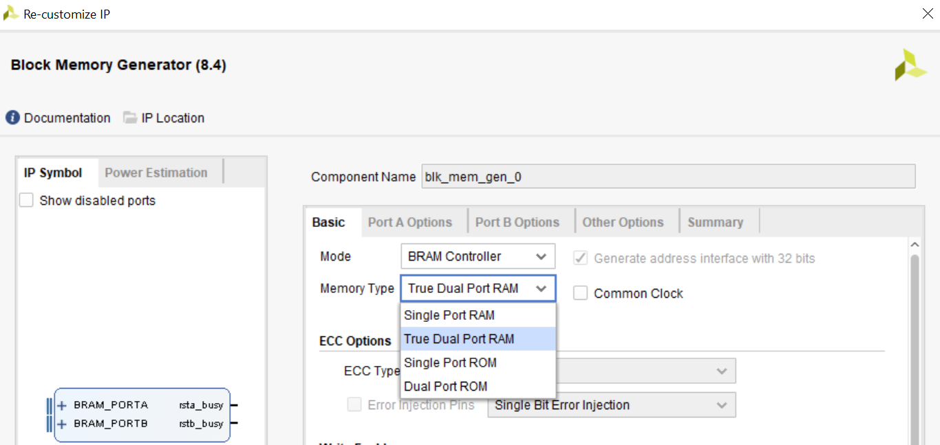

**AXI GPIO**

TO DO

**Connection**

The logical connections between the core, controller block memory need to be manually established. Hover over the *BRAM_PORTA* interface of the first controller. Click and drag the port to the *BRAM_PORTA* of the first block memory generator. Repeat the process for the second controller and memory generator. To connect the cipher core, click and drag the *PLAINTEXT_BRAM_INTF* to *BRAM_PORTB* of the first memory generator. Repeat for the *CIPHERTEXT_BRAM_INTF* and *BRAM_PORTB* of the second memory generator. The last unconnected port is the cipher core done interrupt. The default configurations of the Processing System does not include an interrupt and so needs to be reconfigured. Double click on the *Zynq7 Processing System.* Under the page navigator, open the *Interrupt* configuration handler. Check and expand the *Fabric Interrupts* port. Available interrupts are PL to PS or PS to PL. As the cipher core invokes the interrupt, a PL to PS interrupt interface is needed. PL to PS interrupts are either private (for interrupts to one of the processors cores), fast (same as private with higher latency), or shared (for interrupts to both of the cores). As the there is only a single interrupt signal, the choice of PL to PS interrupt is not critical. For this project, the 16-bit shared interrupt is used. Check the *PL-PS Interrupt Ports* followed by *IRQ_F2P[15:0]* to enable the port. To make the connection with the core, click and drag the *done_intr* from the cipher core to the newly created interrupted port in the Zynq7 Processing System. The completed block design for the pipelined model is shown in Figure 8‑19 Finalised Block Design

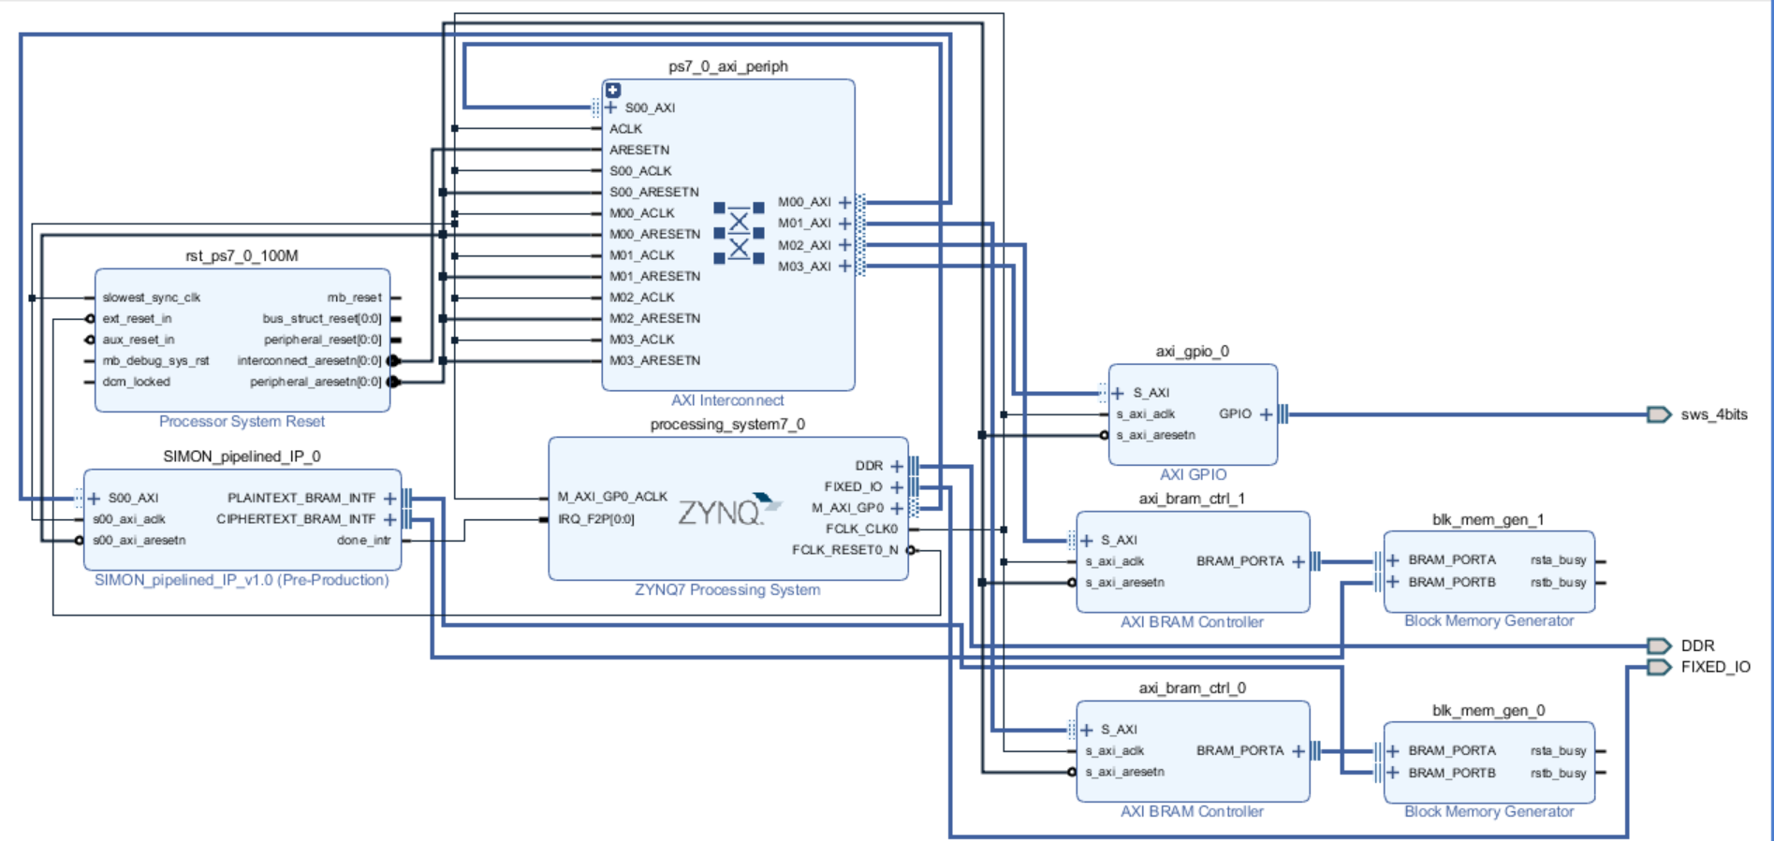

Figure ‑ Finalised Block Design

The usual steps are taking to complete the block design to be exported to hardware. Export the hardware, ensuring the bitstream is includes and launch the SDK to begin software development.

## Conclusion

# Software Driver Development

## Overview

The exported block design that integrated the fully developed SIMON cipher core peripheral, block RAM memory and Processing System in the previous chapter is now ready to be accessed through software. The software driver targets the embedded processor to provide a user-friendly application to perform encryption of the SIMON32/64 cipher in hardware. This chapter analyses how the software is developed to provide the cipher and block memory controller with the required logic.

## Header Files

As with any standard Application Project, header files are included to import useful libraries of code. Xilinx provides many useful header files that can be run through the Cortex A9 processor and included in the source code. These files are designed specifically for the Zynq platform that has more constraints that traditional software that targets very powerful computers, with powerful processors and large main and secondary memory components. These resources are not as extensive when targeting an embedded system and Xilinx has created functions accordingly. These functions often provide similar functionality to traditional C. For example, Xilinx provides the routine *Xil_printf* to output data the same as the standard *printf* function but with reduced overhead. The list of Xilinx provided header files available for import that can be run through the Cortex A9 processor is found in the board support package as shown in Figure 9‑1.

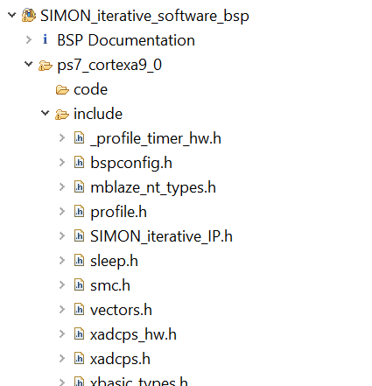

Figure ‑ Xilinx Header Files

These header files are important for robust programming development. Not only do they provide useful function declarations but also the macro definitions required for modular programming such as addresses and offset widths. The following are a list of the imported header files used as well as a description of their functionality:

* **xil_printf.h** Outputs data the same as the standard printf function
* **xscugic.h** Used for General Interrupt Controller functionality
* **xstatus.h** Contains Xilinx software codes that will be used to verify functionality and for debugging
* **xparameters.h** Contains base addresses for the custom and imported peripherals from the hardware design
* **SIMON_*modelname*_IP.h**  Contains AXI Slave Register offset values for each register in the cipher core peripheral as well as function declarations for reading and writing to these registers and a self-test.
* **xil_io.h**  Contains function declarations
* **Xgpio.h** Contains the interface for general I/O operations to the processor. This will be used to read and write to memory locations form specific addresses.

## Interfaces & Methods

The first task for creating software is to understand the flow of operation required to create the algorithm needed for implementation. The following pseudocode describes how the algorithm should operate.

> Initialise plaintext, key, ciphertext, expected ciphertext, and number of block variables

> Initialise the interrupt

> Write the key to slave registers

> Write the plaintext blocks to BRAM

> Wait for switch to be flipped

> Write no. of blocks to and Assert begin through slave register

> Read ciphertext blocks from BRAM

> Trigger Interrupt

> Verify ciphertext is as expected

A main source file will be used to provide a user-friendly interface to perform encryption. Upon launching the SDK, the exported hardware is automatically included in the newly created project. Create a new, appropriately named application project, as described in 5.2.2. A *hello_world.c* template or a blank project is sufficient. Rename the file that contains the main function to *main.c*.

***Main.c***

***main()***

The main file in the application project will contain the function *main()* which carries out the initial set up, as in the first line of the pseudocode. The number of blocks is declared, plaintext and ciphertext arrays instantiated with length equal to the number of blocks. As was discussed in the previous chapter, only one key will be used. The 64-bit key is assigned to the key array. As a new key is used for every plaintext, the test vectors used in hardware verification are not sufficient for the cipher core created IP. Therefore, a new set of plaintext and ciphertext test vector pairs are created using a single key: 1918111009080100. This is the key provided by the creators of SIMON32/64 for testing. These plaintext-ciphertext pairs are chosen and verified using the same method as in 7.3.1. An encrypted ciphertext array is also declared that will contain the encrypted ciphertext and compared with the expected ciphertext for verification.

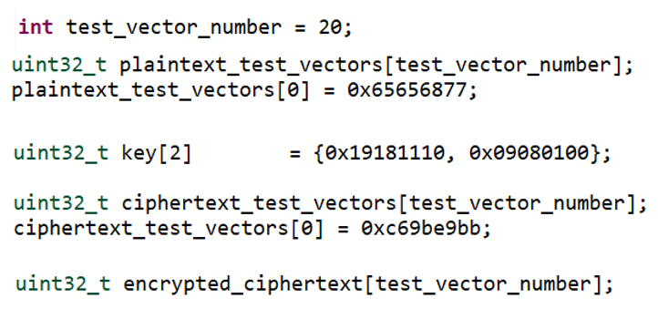

The main function then calls the function *simon_encrypt,* passing the previously defined values as arguments.

***simon_encrypt***

This method is responsible for calling all the functions needed for encryption. It begins by calling *hw_init* which will create the interrupt. It then calls *hw_key_write* which writes the keys to slave registers 2 and 3 followed by *plaintext_bram_write* which writes the plaintext test vectors to BRAM. Finally, *initate_encryption* waits for the switch 0 to toggle before it drives the signals required to begin encryption. These functions are declared in the header file *simon_hw.h* and defined in the associated source file *simon_hw.c* and will be discussed in further detail in the subsequent section. It then waits for an interrupt signal. Verification is complete by checking that encrypted ciphertext matches the expected ciphertext, similar to the testbench

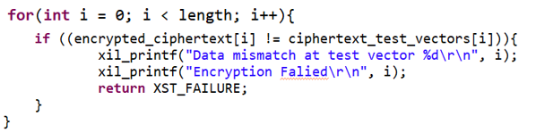

This code includes the *xstatus* macro *XST_FAILURE.* This, as well as *XST_SUCCESS* are used throughout the code for verification purposes and to assist with debugging.

To allow for modular programming, a header file will be used to declare the functions required for encryption and their methods defined in the corresponding source code.

> Initialise plaintext, key, ciphertext, expected ciphertext, and number of block variables

> Initialise the interrupt

> Write the key to slave registers

> Write the plaintext blocks to BRAM

> Wait for switch to be flipped

> Write no. of blocks to and Assert begin through slave register

> Read ciphertext blocks from BRAM

> Trigger Interrupt

> Verify ciphertext is as expected

The software driver will deal with accessing BRAM to write the plaintext and ciphertext test vectors, writing the key, no. of blocks, and the begin signal to the cipher core CSRs and sensing an interrupt trigger. An additional source file and header file called *simon_hw.c* and *simon_hw.h* are added. This will create the ins..

## Data Transfer

The variables declared to define the plaintext, key, expected ciphertext etc. are stored in the DDR3 RAM. The plaintext needs to be transferred to the PL Block RAM and the ciphertext, in turn, read from Block RAM and assigned to the ciphertext in DDR3. The function Xil_Out32 and Xil_In32 from the xgpio.h header file are used for these operations..

## Interrupt

## Conclusion

# Hardware Metric Testing

## Overview

All implementations of SIMON 32/64 in hardware have successfully been developed and validated. An accompanying software driver has been designed to access the embedded hardware and drive the encryption. The next part of the project workflow is to carry out performance analysis. This chapter analyses the performance of hardware metrics for the different models of SIMON32/64 that were designed in previous chapters. The hardware is analysed on three key metrics:

* **Area:** The area utilisation metric can be calculated in different ways. The percentage area of the die utilised is ultimately the metric required. There are multiple ways to measure this including slice percentage utilisation and slice LUT utilisation.
* **Timing:** The measurement to be ultimately calculated is called the maximum operational clock frequency. This measures the highest clock frequency for that system, while maintaining proper operation and will be used for throughput and latency calculations in the subsequent section.
* **Power:** There are two different power types, static and dynamic, to be measured to analyse power consumption.

Vivado provides feature-rich tools and extensive reports to measure these metrics that will be discussed throughout this section.

## Area

Running synthesis and implementation in the Vivado Design suite produces extensive area utilisation reports of the design. Selected *Open Implemented Design* after the implementation has been run. As can be seen in the device view of the iterative cipher core model shown in Figure 10‑1 there are different logic resources available.

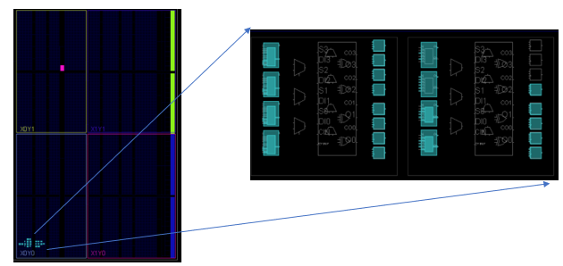

Figure ‑ Iteravite Cipher Core Device View with Expanded View of fully (left) and partially (right) filled slices

To understand the report, it is important to understand the different resource types. Each resource type has its own measure of utilisation that should be monitored. When utilisation is too high, it can negatively impact Vivado’s ability to fit the design into the device and meet performance requirements. The following is a list of the types of resources utilised in hardware:

* **Slices** The device is primarily composed of Zynq slices. Each slice contains four LUTs and eight flip-flops. Some slices can also utilise the LUTs as distributed memory. The zoomed in section of the device in Figure 10‑1 shows two such slices, with the left slice fully filled and the right slice only partially filled. The slices implement the logic functions of the synthesiser, RTL, and IP
* **I/O and GT** The I/O pads and GT (gunning transceiver- a high speed bus) are used for external data transmission. In the planning stages the IO resources need to be compared with what is available.
* **Block Memory Tile** Can hold Block RAM and / or FIFO depending on the device
* **Digital Signal Processing Tile (DSP)**
* **Clocking Resource** These include global clock buffers, Mixed-Mode Clock Managers (MMCMs), Phased-Locked Loops (PLLs), and regional clock buffers

As the cipher core modules, cipher AXI IP and the complete top-level design wrapper (including PS, BRAM, AXI GPIO and AXI Interconnect) do not use DSPs, they will have zero utilisations and will not be discussed hereafter.

In the flow navigator select *Implementation -> Open Implemented Design -> Report Utilisation*. Alternatively, in the *Reports* console, scroll to the *Place Design* reports and open *impl_1_place_report_utilization_0* to view a complete breakdown. This report included measurements in terms of total resources used and as a percentage of the resources available.

**Slice Logic**

Slice logic will form a central part in the cipher core, cipher AXI IP, and complete top-level design wrapper (including PS, BRAM, AXI GPIO and AXI Interconnect). Figure 10‑1 shows a breakdown of the slice logic used for the SIMON32/4 iterative model. The first category gives a breakdown of LUT usage, the number used for logic and memory (as distributed RAM or shift registers). A breakdown of registers in terms of flip flops and latches is given next. Finally, the slice Muxes for signal control are detailed. As seen from the breakdown, only 80 logic LUTs (.45% utilisation) and 96 flip-flops (0.27% utilisation) are used.

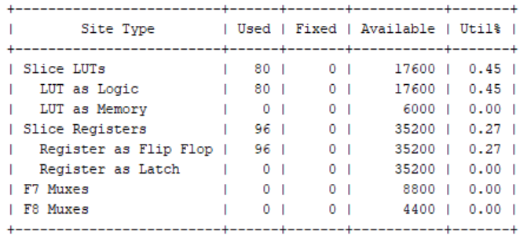

Figure ‑ Cipher Core Iterative Model Slice Logic

**Slice Distribution Logic**

The slice distribution logic provides information as to how the slices are used. Of the utilised slices in the device, not all slices are made total use of, as is seen in the partially filled slice in Figure 10‑1. This is because the placer will not tightly pack logic unless it must do so to avoid congestion. Therefore, the slice percentage utilisation is typically higher than the LUT percentage utilisation, as seen in Figure 10‑3. This will become more emphasised for bigger designs. The next section shows the logic LUT breakdown. A slice LUT can implement a single logic LUT with the output using either the O5 or the O6 pad or a combination. LUTs used as memory can either be distributed RAM or as shift registers. LUT Flip Flop pairs count structures that are easier for the placer to pack into a pair. Finally, the control set that control the shared control signals including clock, clock enable and set or reset. Only registers with the same control signal can be placed in the same slice.

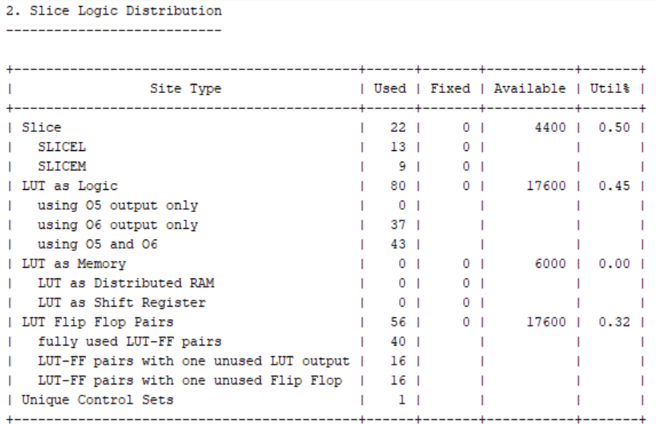

Figure ‑ Cipher Iterative Core Slice Logic Distribution

**Memory, IO and GT, and Clocking**

The cipher core and AXI IP are not connected to and I/O or GT or use any additional clocking, or block memory and therefore their values will all be 0. The complete top-level design wrapper contains some IO and GT, memory, and clocking resources, as expected. Figure 10‑4 shows the clocking resources used. As expected, the design contains a single global clock buffer. Similar expected reports are found for memory and IO and GT.

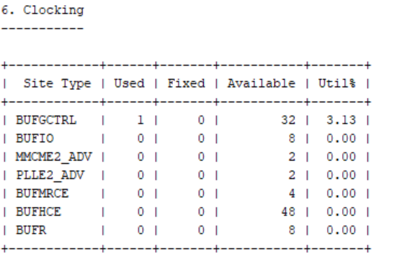

Figure ‑ Complete Top-Level Design Wrapper Clocking Resources

**Results**

The following table details the area utilisations for the different implemented architectures. Note that for the reprogrammable logic contains 4400 slices (4 LUTs and 8 Flip Flops)

|  |  |  |  |  |
| --- | --- | --- | --- | --- |
|  | **Slice Usage (%)** | **Slice LUTs (%)** | **Slice Registers (%)** | **BRAM Tiles** |
| **Iterative Core** | 0.5 | 0.45 | 0.27 | 0 |
| **Mixed - 2 Core** | 0.52 | 0.46 | 0.27 | 0 |
| **Mixed - 4 Core** | 0.82 | 0.59 | 0.27 | 0 |
| **Mixed - 8 Core** | 1.64 | 1.38 | 0.27 | 0 |
| **Mixed - 16 Core** | 2.81 | 2.81 | 0.27 | 0 |
| **Pipelined Core** | 5.98 | 5.51 | 0.27 | 0 |
|  |  |  |  |  |
| **Iterative IP** | 2 | 1.18 | 0.9 | 0 |
| **Mixed - 2 IP** | 2.12 | 1.31 | 0.9 | 0 |
| **Mixed - 4 IP** | 2.35 | 1.59 | 0.9 | 0 |
| **Mixed - 8 IP** | 2.95 | 2.07 | 0.9 | 0 |
| **Mixed - 16 IP** | 4.34 | 3.49 | 0.9 | 0 |
| **Pipelined IP** | 7.27 | 6.13 | 0.9 | 0 |
|  |  |  |  |  |
| **Iterative Full** | 22.3 | 12.76 | 8.11 | 6.67 |
| **Mixed - 2 Full** | 22.57 | 13.05 | 8.11 | 6.67 |
| **Mixed - 4 Full** | 22.85 | 13.68 | 8.11 | 6.67 |
| **Mixed - 8 Full** | 23.42 | 14.21 | 8.11 | 6.67 |
| **Mixed - 16 Full** | 24.43 | 15.06 | 8.11 | 6.67 |
| **Pipelined Full** | 26.2 | 17.76 | 8.11 | 6.67 |

**Analysis**

Figure ‑ Area Utilisation Report

Figure 10‑5 shows a visual representation of area utilisation for the cipher cores, AXI IPs and top-level designs. The graph confirms that results follow predicted trends. As anticipated, the iterative model possesses the lowest slice utilization. The pipelined model sacrifices an approximate 12x increase in slice utilization for increased throughput and latency.

As expected, the mixed model provides a flexible trade-off dependent on the number of rounds unrolled. For the core, AXI IP and full systems the increase in area utilisation approximately doubles with the number of rounds unrolled. The models, therefore, contain similar area utilisations for set-up and configuration before the rounds are unrolled, as expected.

Packaging the cipher cores into a custom IP requires minimal area increases. Only an additional 4 CSRs are used in the AXI-Lite slave, requiring minimal resources. The AXI-Lite interface is also streamlined for simple, resource-friendly data transfer. As expected, the controller used to drive signal control, while complex in design, does not require extensive additional resources.

The fully completed top-level design, as expected requires large additional area requirements. The Block Memory Generators, associated AXI BRAM Controllers, AXI GPIO, and the logic between them need to be fitted on the device. 4 BRAM tiles (6.7% utilisation) were used to store memory. The disparity between the iterative, pipelined, and mixed models become relatively reduced. The iterative model requires an additional 893 slices to package the full system (981) than the cipher IP (88). The pipelined model (833) and the mixed model (778) required approximately the same number of additional slices. These additional slices could be reduced by removing the AXI GPIO interrupt.

Finally, it should be noted that the resource utilisation can be affected by how severely the frequency is drive, for the design. Utilisations are therefore recorded at the respective maximum operational frequencies, as discussed in the next section.

## Timing

As highlighted in the overview, the main timing metric to be calculated is the maximum operational frequency. This metric is calculated to determine if the hardware can reach the required throughput and constraints. User defined clock constraints are added in the Xilinx Design Constraints (.xdc) file, as discussed in 5.2.1. Only timing constraints are required and therefore an empty *.xdc* file can be created. As has been discussed throughout the project, a single shared clock is used to control all parts of this system. Using a single clock is a simpler way to provide synchronisation. Introducing more clocks makes the design and control more complex but can provide better performance realisations but is out of the scope of this project. The following line of code is added to the empty *.xdc* file to define what frequency the clock should run at. The frequency cannot be defined directly and instead the period is specified. The default timing is in nanoseconds and therefore the 4ns period will correspond to a 250MHz clock cycle.



This frequency is confirmed in the timing report as seen below

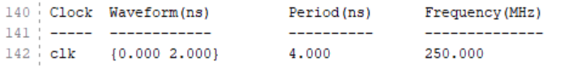

It is required that implementation and synthesis are run out of context mode as usual to avoid place-and-route errors. As there are no I/O pins in out-of-context runs, there is no requirement for I/O delays, simplifying timing analysis. This is confirmed in the timing report:

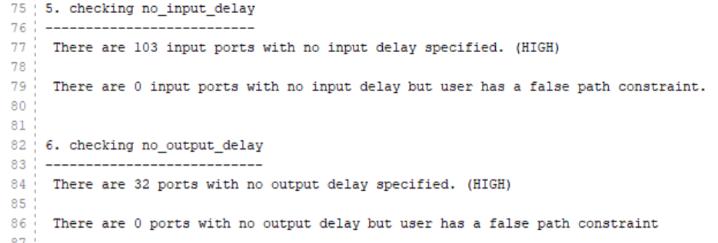

In the flow navigator select *Implementation -> Open Implemented Design -> Report Timing Summary*. Alternatively, in the *Reports* console, scroll to the *Place Design* reports and open *impl_1_route_report_timing_summary_0* to view a complete breakdown. The *Design Timing Summary* report includes information including:

* Whether the user specified timing constraints are met
* Worst Negative Slack (WNS)
* Worst Hold Slack (WHS)
* Worst Pulse Width Slack (WPWS)
* Clock checks such as number of register/latch pins with no clock or a constant clock
* Delay checks

The main information to be analysed is shown in

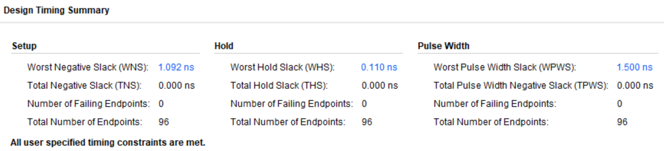

Figure ‑ Iterative Cipher Core Design Timing Summary

It can be seen from the timing summary that the clock period provided met the timing constraints. The maximum operational frequency is not explicitly given and must be derived from the above values. The WNS is the longest path in the hardware to complete propagation of the signal. By subtracting the WNS from the originally supplied clock period, a period corresponding to the maximum operational frequency. In this case, the clock period in the *.xdc* file should be updated to 2.908ns (4ns – 1.092ns). The synthesiser and implementer do not attempt to optimise timing unless the constraints force it to in order to pass. Therefore, it may take some repetition of this process to find the maximum frequency. The WNS must be positive and effectively zero.

**Results**

**SIMON32/64 Iterative Model**

|  |  |  |
| --- | --- | --- |
|  | **Clock Period (*ns*)** | **Maximum Operational Frequency (*MHz*)** |
| **Cipher Core** | 1.959 | 510.5 |
| **Cipher IP** | 3.565 | 280.5 |
| **Top-Level Design Wrapper** | 7.055 | 141.4 |

**SIMON32/64 Pipelined Model**

|  |  |  |
| --- | --- | --- |
|  | **Clock Period (*ns*)** | **Maximum Operational Frequency (*MHz*)** |
| **Cipher Core** | 2.811 | 355.7 |
| **Cipher IP** | 5.168 | 193.5 |
| **Top-Level Design Wrapper** | 9.88 | 101.21 |

**SIMON32/64 Mixed -8 Model**

|  |  |  |
| --- | --- | --- |
|  | **Clock Period (*ns*)** | **Maximum Operational Frequency (*MHz*)** |
| **Cipher Core** | 7.952 | 125.75 |
| **Cipher IP** | 12.004 | 83.3 |
| **Top-Level Design Wrapper** | 18.801 | 53.2 |

**Analysis**

The maximum operational frequency follows a trend that correlates with logic. As the logic paths increase in the design, the critical path length will intuitively increase also. The minimal complexity of the round-based cipher core gives it the highest maximum operational frequencies. The iterative model has the capability to operate at 1.44x the frequency of the pipelined model Upon analysis, the critical path of the pipelined core is located on a path between pipe stages. Like the area analysis, further optimisation on the mixed model is required to get results closer to anticipated. It is expected that the mixed model results should be between the iterative and pipelined models.

There cipher core IPs and the complete systems must operate at a lower frequency than the standalone cores, as expected, due to their increase in logic. The additional communication paths required for reading and writing text from the processor to the BRAM via controllers and to the cipher cores requires additional data paths. The top-level models are clocked using the AXI fabric clock which operates at 100MHz. The iterative and pipelined systems can safely operate above this frequency. The mixed model cannot operate at the AXI fabric clock safely and so the clock should be reconfigured to below 50MHz to ensure data integrity.

## Power

Vivado offers two modes of power estimation: Vector-based power estimation and vector-less power estimation. The vector-based method requires users to provide a simulation activity file that represents the real-world operation of the design. Vivado’s vector-less mode provides the best possible assumption for the signal switching probability and is the chosen mode for this project to avoid any unnecessary change of variables and provide a fair comparison. In the flow navigator select *Implementation -> Open Implemented Design -> Report Power*. This will open a window containing the power report as shown in Figure 10‑7. The set-up dialogue provides commonly used options that users require to achieve accurate power estimation. For example, the *environment* tab of the report deals with device settings such as *temperature grade* and environment settings such as *ambient temperature.* For the purpose of this project, the default settings are used.

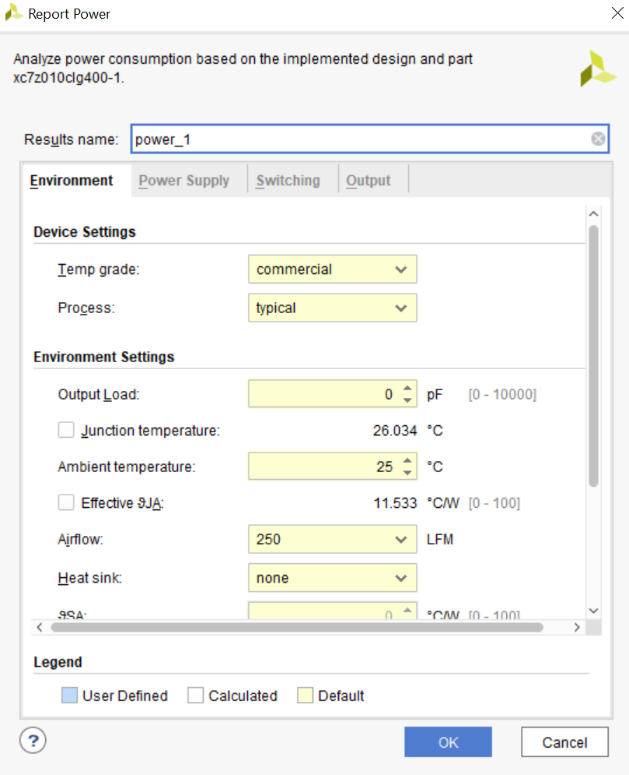

Figure ‑ Power Report Configurations

Selecting *OK* provides the following interface for power estimation

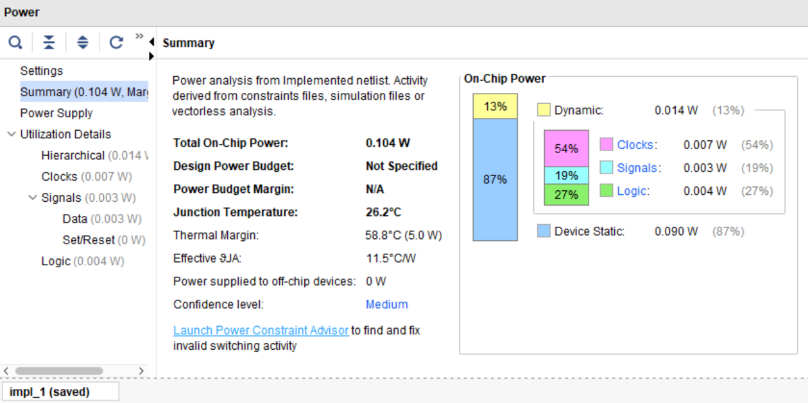

The report includes information on:

* The total power consumed
* Thermal characteristics
* Confidence level of estimation
* Breakdown of power consumption by component

Alternatively, in the *Reports* console, scroll to the *Place Design* reports and open *impl_1_route_report_timing_power_0* to view a complete breakdown under the following sections.

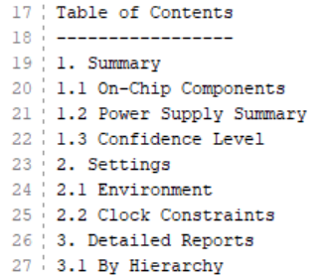

The main components to take away from the report are the dynamic power, static power, total on chip-power. The static power is the power consumed when the circuit is inactive. Dynamic power is the power consumed while the circuit is active and signals are switching.

**Results**

|  |  |  |  |
| --- | --- | --- | --- |
|  | **Static (*W)*** | **Dynamic (*W*)** | **Total (*W*)** |
| **Iterative Core** | 0.09 | 0.013 | 0.103 |
| **Iterative IP** | 0.14 | 2.709 | 2.849 |
| **Iterative Full** | 0.121 | 1.588 | 1.709 |
|  |  |  |  |
| **Mixed-8 Core** | 0.09 | 0.054 | 0.144 |
| **Mixed-8 IP** | 0.173 | 3.134 | 3.307 |
| **Mixed-8 Full** | 0.123 | 1.678 | 1.801 |
|  |  |  |  |
| **Pipelined Core** | 0.09 | 0.015 | 0.105 |
| **Pipelined IP** | 0.173 | 3.376 | 3.549 |
| **Pipelined Full** | 0.13 | 1.988 | 2.118 |

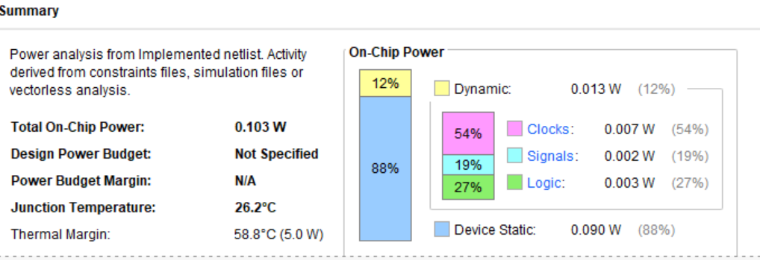

**Analysis**

Once more, the power usage follows general expected trends. The iterative cipher core requires the least power (0.102W). The pipelined model requires a 1.03x increase (0.105W), indicating that the significantly increased area usage in the pipelined model does not transfer to power consumption. The mixed model core requires an insignificant increase in power that is not translated to the IP and full systems.

An evident take-away from the results is that the power usage in the cipher IPs is greater than the full system. This result is counter-intuitive given that the IPs are contained within the top-level designs. Analysing the power estimation report of the standalone IP, it is found that a large amount of power is consumed driving logic. More specifically, the LUT used to source the current key and current registers. This power consumption is not transferred to the top-level design. Running a vector-less analysis results in a large number of internal nodes not specified giving a low confidence level to the estimation. Another potential cause for the jump, could be caused by running synthesis and implementation out of context.

Another obvious result is the large jumps in static/dynamic power ratio from the cores to the IP and top-level design while the static power consumption remains approximately consistent. This indicates that the extra hardware does not consume additional static power. The dynamic power becomes that predominant consumption source in the more complex models due to increased signal switching activity.

## Conclusion

The performance analysis of the cipher cores, standalone IPs and the top-level design wrappers carried out in this chapter provided metrics for area utilisation, timing, and power usage. The results generally followed expected trend with the iterative core achieving the best performance. The complexity associated with the mixed model meant that is requires additional optimising to achieve the expected results. It should be noted that the power and timing results achieved do not provide complete accuracy. The power usage was carried out using vector-less approach. While this provides consisting in testing, it can leave the confidence levels of estimations low. Furthermore, Out-of-Context runs synthesis and implementation can affect the results that take I/O into account, such as I/O delays when carrying out timing analysis.

# Performance Analysis

## Overview

Following the hardware metric testing on the cipher core, standalone IP and top-level design wrappers in the last chapter, performance analysis is carried in this chapter to evaluate throughput and latency. The iterative, pipelined, and mixed hardware accelerated models are measured using Zynq-7000 onboard timers in the processing system. To benchmark the results, a software model of SIMON is written and run through the processor. The throughput of each model is calculated by appropriately manipulating the latency results.

## Software Implementation

A software-only implementation of SIMON32/64 is used to provide a benchmark to compare the latency and throughput values with the hardware accelerated models. In keeping with the flexibility desired, the creators of SIMON note that the cipher performs well in software as well as hardware. The only differences between SIMON and it’s sister algorithm SPECK occur due to a design decision that would optimise SIMON in hardware and SPECK in software. An example of such as operation is the circular shift, that is resource friendly in hardware but not as much in software.

The software implementation is created in the file *simon_sw.c.* Like the hardware implementations, functions *round_function* and *key_expansion* to perform their respective operations. The key is pre-expanded in this implementation and a single ciphertext variable is updated for 32 rounds until encryption is complete. As there is no clocking there is no option to implement different models of the cipher. It is possible to synchronise the key expansion and the round functions. As the latency is to be calculated, many blocks will be encrypted to provide the best average. The same key will be used, in keeping with the hardware accelerated approach. Therefore, key pre-expansion will produce higher rates and will form a better comparison.

## Onboard Timer

The Zynq-7000 contains many on board timers. The 64-bit Global timer is used to provide a general clocking tool. The global timer runs at half the ARM processor clock frequency, which by default runs at a frequency of 650MHz. The ARM Cortex-A9’s Performance Monitoring Unit contains the global clock. The functions and macros needed to invoke the timer and perform timings tests are found in *xtime_l.h* header file. This is provided by Xilinx and located in the included Board Support Package. The *XTime_GetTime()* function is used to get the start and end times of the encryptions. The macro *COUNTS_PER_SECOND* converts the clock frequency into seconds. The functionality needed to measure the time in microseconds is given in the following code:

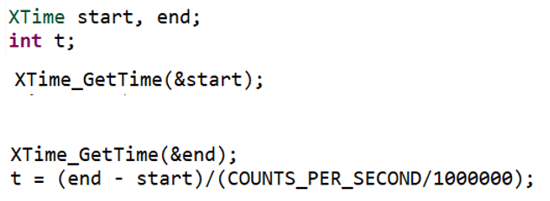

The segment of code that needs to be times is place between the two *XTime_GetTime* functions.

## Latency

Single block latency is an important characteristic of a block cipher. As the name suggests, this is the time taken to encrypt one block. By appropriately starting and ending the global timer, the latency of the models can be measured. To record an accurate measure, all unnecessary inclusions such as print statements are commented out. The placement of the timer is important. For encryption only, reading and writing of the test vectors to BRAM, the key to the CSR and the interrupt set-up is not included in the measurement. The timer is therefore started between where the plaintext and key are written to hardware and before the begin signal is triggered. The timer ends after the done interrupt is triggered and before the encrypted ciphertext is read from memory. Similarly, in the software implementation, the timer does not include any key or text instantiation or reading.

To evaluate how the read and write operations affect latency, a second measurement is recorded to include these operations.

Note: There is a bug in the pipelined and mixed models that occurs when a single block is encrypted in hardware. The bug causes the cipher interrupt to trigger repeatedly. The issue was not resolved in time to meet project deadlines. The timing issue occurred due to a broken development board that had to be replaced. As a result, the time taken to encrypt two blocks was used to provide a latency figure that could be compared across all models.

The time taken to encrypt 1000 blocks was divided by 1000 to get the average time to encrypt one block. This figure was taken away from the time taken to encrypt two blocks to get an estimated latency result.

**Results**

|  |  |  |
| --- | --- | --- |
| **Model** | **Latency (*us)*** | **Latency with R/W & interrupt setup (*us)*** |
| Iterative | 1.689 | 3.642 |
| Mixed – 2 | 0.771 | 3.191 |
| Mixed – 4 | 0.775 | 3.208 |
| Mixed - 8 | 0.772 | 3.202 |
| Mixed – 16 | 0.76 | 3.137 |
| Pipelined | 0.732 | 3.083 |
| Software | 11.123 |  |

**Analysis**

The latency results produced follow anticipated trends. It is observed that the latency decreases with the increase of the number of rounds functions performed in parallel. The fully unrolled, pipelined model achieves the greatest latency results (0.732 *us*), approximately 2.3x the latency of the iterative model. The area, timing and power inefficiencies that were observed in the mixed models did not translate to latency results. The mixed model latency results achieved were approximately 2x greater than the iterative model. The mixed model achieved latency results very close to that of the pipelined model. Figure 11‑1 clearly shows the trend downward trend in latency as the mixed model is unrolled. Furthermore, the trend is logarithmic, as the number of rounds processed in parallel doubles, the difference in latency times approximately doubles also. There is a small discrepancy in the mixed-2 model. Its latency is less than the mixed-4 model. This is by a very unsubstantial amount (0.004 *us*) and can be put down to slight differences in place and route. The implementation of the mixed and pipelined model followed a similar design of generated pipe sections, explaining their closely related results. The pre-expanded key implemented in the mixed model does not provide the significant performance improvements for latency that it achieves in bulk encryption. The iterative model, on the other hand, implemented a design that produced better hardware results. It is evident from these results is the trade-off achievable from the different architectural implementations.

Figure ‑

Another observation that can be made from the results is the difference in latency between the hardware accelerated and the software only models. The research into SIMON shows that it has competitive realisations when implemented in software. It was expected that for single block latency (in this case two blocks), the time taken for initial set-up between the processor and the programmable logic would offset the hardware core encryption efficiencies that would cause it to perform similar to software only implementation at best. It is observed that by utilising encryption hardware and freeing the processor produces a substantial increase in latency. It should be noted that the large disparity in latency times can be put down to the lack of optimisation for the software-only implementation.

Finally, from the graph in Figure 11‑2, it can be seen that the read/write operations of the key into the CSR and the text to and from BRAM and the initial interrupt setup cause a significant bottleneck in the overall system. These operations take almost constant time for all models (between 1.953 and 2.433 microseconds). It was anticipated that such a result would occur, and it is out of the scope of this project to investigate potential solutions but could be open for investigation in future work.

Figure ‑ Latency Report

## Throughput

Throughput is a performance analysis measurement used to evaluate the rate at which encryption can be performed per unit of time. The global timer is once again for this performance analysis. A large number of blocks (1000) are encrypted. The macro *COUNTS_PER_SECOND* is used once more to convert the number of cycles taken to complete encryption at ARM processor frequency (650MHz) into seconds. From this, the rate of blocks encrypted per second is calculated. Dividing by the block size produces the throughput in bits per second.

**Results**

|  |  |  |  |  |
| --- | --- | --- | --- | --- |
| **Model** | **1000 Block Latency (*us)*** | **1000 Block Latency (us) with R/W & Interrupt Setup** | **Throughput (*Mb/s)*** | **Throughput (*Mb/s)* with R/W & Interrupt Setup** |
| Iterative | 340.963 | 746.24 | 93.85 | 42.882 |
| Mixed – 2 | 121.089 | 525.36 | 264.27 | 60.911 |
| Mixed – 4 | 101.049 | 506.45 | 316.55 | 63.185 |
| Mixed - 8 | 70.996 | 471.72 | 450.73 | 67.837 |
| Mixed – 16 | 63.043 | 465.11 | 507.59 | 68.801 |
| Pipelined | 61.028 | 466.31 | 524.35 | 68.624 |
| Software | 3258.477 |  | 9.822 |  |

**Analysis**

The average throughput follows similar trends to latency. Figure 11‑2 depicts a line graph of the throughput in megabytes per second for each model of the graph. It is clear from the graph the throughput increases with round unrolling. As expected, the software only implementation lags behind the hardware accelerated models. The larger workspace results in the loss of any head start that the software only implementation model had from initial hardware configurations and PL to PS data transfers. The software only implementation processes 9.5x slower than the iterative model. Once again this can somewhat be put down the model not being fully optimised. The algorithm is relatively straightforward to implement, and optimisations are limited to hardware friendly operations such as shifts and logical operations on bits of predefined length. Furthermore, as a single key is used to encrypt all blocks, it is pre-expanded to avoid any additional timing overheads. It is therefore anticipated that such optimisations would not significantly increase the throughput.

Another obvious result from the graph is the step jump of approximately 2.8x the throughput from the iterative model (93.85 *Mb/s*) to the mixed model with 2 rounds unrolled (264.27 *Mb/s*). Furthermore, the jump between the mixed-16 model (507.59 *Mb/s)* and the pipelined model (524.35 *Mb/s)* is not as significant as anticipated. This can be attributed once again to the key being pre-expanded in the mixed model. The iterative cipher core will synchronise the key expansion and the round function. This traditional method is more efficient when encryption uses different keys for successive blocks. However, in keeping with practical applications using pre-expansion provides a significant improvement in throughput for bulk encryptions using the same key. This architecture should be considered in such scenarios, provided the trade of in hardware metrics meets the criteria.

A final observation is that the average latency for bulk encryption is significantly greater than the latency of one block (in this case 2) encryption. It took 201x longer to encrypt 1000 blocks than the 2 blocks for the iterative model and only 83.3x longer for the pipelined model. The mixed models lay somewhere in the middle of these figures. These results show the efficiency of bulk encryption after the initial set-up has been configured.

Figure ‑

Like latency, the data transfer from the Cortex-A9 to BRAM via AXI interconnect causes significant time delay. From Figure 11‑4, the throughput trade-off achieved are notably less exaggerated when read/write operations are considered. Once more the 1000-block latency increase is approximately constant (400-406 *us)*. Converting this to throughput cause a large damping factor. Writing the key into the CSR and the initial interrupt setup are insignificant when dealing with bulk encryption. Once again, it is out of the scope of this project to investigate potential solutions to read/write bottlenecks.

Figure ‑ Throughput Report

Throughput

Pipe: 61.027692 u

Soft 3258.476923

It: 340.963077

Mixed 8 Time to encrypt 1000 blocks in hardware: 70.996 us

Mixed 4 Time to encrypt 1000 blocks in hardware: 101.049 us

# Source Code

The projects source code is made open sourced on GitHub via the following link:

<https://github.com/bazzza95/SIMON32-64_Masters_Project>

The following links provide quick access to specific parts of the project

## Iterative Model

**Design Sources:**

<https://github.com/bazzza95/SIMON32-64_Masters_Project/tree/main/Iterative_model/source_code/design_sources>

**Simulation Sources:**

<https://github.com/bazzza95/SIMON32-64_Masters_Project/tree/main/Iterative_model/source_code/simulation_sources>

**AXI IP RTL:**

<https://github.com/bazzza95/SIMON32-64_Masters_Project/tree/main/Iterative_model/source_code/AXI_IP_RTL>

**Software:**

<https://github.com/bazzza95/SIMON32-64_Masters_Project/tree/main/Iterative_model/source_code/SDK>

## Pipelined Model

<https://github.com/bazzza95/SIMON32-64_Masters_Project/tree/main/Pipelined_model/source_code/design_sources>

**Simulation Sources:**

<https://github.com/bazzza95/SIMON32-64_Masters_Project/tree/main/Pipelined_model/source_code/simulation_sources>

**AXI IP RTL:**

<https://github.com/bazzza95/SIMON32-64_Masters_Project/tree/main/Pipelined_model/source_code/AXI_IP_RTL>

**Software:**

<https://github.com/bazzza95/SIMON32-64_Masters_Project/tree/main/Pipelined_model/source_code/SDK>

## Mixed Models

<https://github.com/bazzza95/SIMON32-64_Masters_Project/tree/main/Mixed_model/source_code/design_sources>

**Simulation Sources:**

<https://github.com/bazzza95/SIMON32-64_Masters_Project/tree/main/Mixed_model/source_code/simulation_sources>

**AXI IP RTL:**

<https://github.com/bazzza95/SIMON32-64_Masters_Project/tree/main/Mixed_model/source_code/AXI_IP_RTL>

**Software:**

<https://github.com/bazzza95/SIMON32-64_Masters_Project/tree/main/Mixed_model/source_code/SDK>

*Mian.c*

The main file in the application project will contain the main function and an encrypt fuction. The main function carries out the initial set up. The number of blocks is declared, plaintext and ciphertext arrays instantiated with length equal to the number of blocks. As was discussed in the previous chapter, only one key will be used. The 64-bit key is assigned to the key array. As a new key is used for every plaintext, the test vectors used in hardware verification are not sufficient for the cipher core created IP. Therefore, a new set of plaintext and ciphertext test vector pairs were created using a single key: 1918111009080100. This is the key provided by the creators of SIMON32/64 for testing. An encrypted ciphertext array is also declared that will contain the encrypted ciphertext and compared with the expected iphertext for verification.

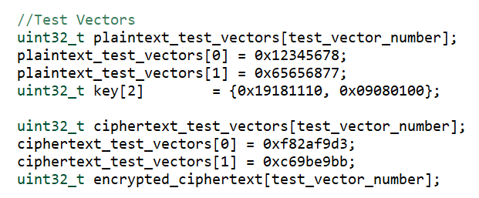

The plaintext, key and ciphertext test vectors and the number of vecotrs are passed to the function simon_encrypt which forms the interface to perform encryotion. Th

POSSIBLY MOVE XS.. to encr

An interrupt controller is required to set up and handle General Interrupt Controller (GIC) operations. This will be further discussed in the remainder of the chapter. The *simon_encrypt* function creates A new XScuGic object that will be used to set up interrupts. It then calls the function hw_init which performs hardware initialisation

The functions used to access the hardware registers for encryption are defined in a the source file *simon_hw.c*.

**Interrupt Controller**

A

**Functions**

**Header Files**

Xscugic.h

Xstatus.h –

Xil_printf.h

Xparameters.h

SIMON_modelname_IP.h

Xil_io.h

Xgpio.h

Xil_exception.h

%https://store.digilentinc.com/zybo-z7-zynq-7000-arm-fpga-soc-development-board/

% <https://www.element14.com/community/roadTestReviews/3090/l/digilent-zybo-z7-pcam-5c-review>

**Final Versions C:\Vivado_18.2\final_versions\SIMON_30_2_block\SIMON_30_2_block.xpr**

**C:\Vivado_18.2\final_versions\ip_repo\edit_SIMON_30_2_v1_0.xpr**

**Research Style Paper** (6 pages ~3500 words) 16th to 20th

Abstract, Intro, Prior Work, Technical Description, Results Obtained, Analysis, Conclusion

**Appendix A - Literature Review**

**Appendix B- Project Plan**

**Appendix C - Research Log**

**Appendix D - Project Design & Implementation**

**Appendix E - Testing & Results (highly recommended)**

**Appendix F - Source Code Listing (if appropriate)**

**Appendix D - Project Design & Implementation**

1. Introduction
2. SIMON Cipher

Development S

Create Test Benches

Validate Waveforms

Develop RTL design sources

Create new Vivado Project

Create new IP for Packaging



IP Creation

Define AXI interface type

Package IP

Develop Custom HDL

Connect Interfaces

Validate Design

Add IP to Block Design

“Console and Tool Info The lower pane of the Vivado window contains useful information on the status of design runs, as well as a TCL console interface as shown in Figure 6.4. Figure 6.4: Bottom pane of Vivado window providing tool information and TCL console. Each tab of this pane can be used in the hardware development flow as follows: TCL Console Most EDA tools (including those present in the Vivado suite) are typically command-line based. As such, they provide a TCL interface whereby commands/options can be specified manually or from a script. This is useful for design automation or when working in teams larger than one person, allowing version 6 Cipher Core Development 34 control to track changes to scripts and/or kick off regression testing automatically. Messages This provides status messages output from tools, sorted by severity. The messages pane is useful in diagnosing issues in the design, such as syntax errors or unsynthesizable RTL. Log Each tool produces a text-based log as an alternative to the Messages view above - again useful for parsing as part of an automated flow. Reports Some tools, such as the synthesis or implementation tools, output reports on design utilization (area) or clock information. These are useful to locate bottlenecks/critical paths in the design - as well as gauge whether the design requirements are being met. Design Runs Finally, this tab provides information on which tools are currently running and progress status.”

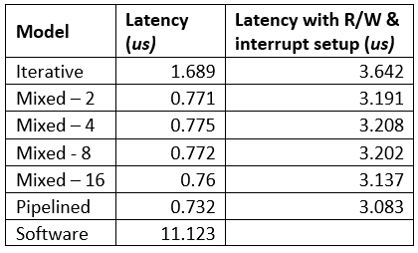

Processing System

Programmable Logic

AXI BRAM Controller

Cortex-A9 Core

AXI BRAM Controller

AXI Interconnect

Ciphertext BRAM

Plaintext BRAM

Interrupt

SIMON AXI IP Controller

Control and Status Registers

Key & Done

AXI GPIO

SIMON Cipher Core

Cipher Core Controller

Intermediate Register

Key Expansion

Round Key

Round Function

Ciphertext

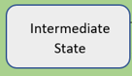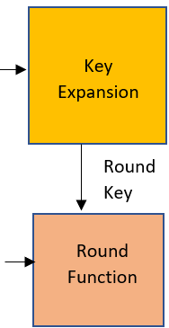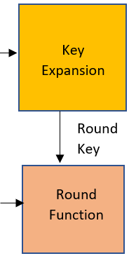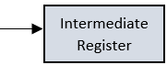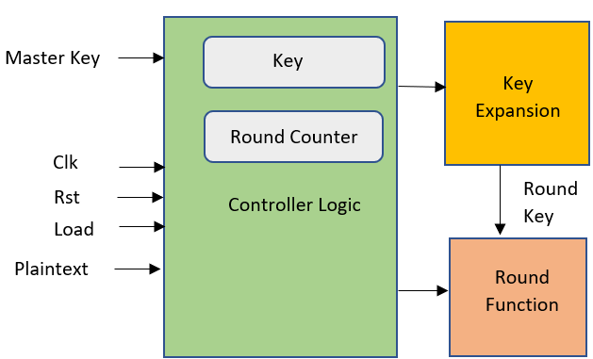

.. x rounds per stage

Master Key

Key

Key Expansion

Clk

Round Counter

Round Key

Rst

Load

Controller Logic

Round Function

Plaintext

**Cipher core testbench**

clk

**Cipher core**

Periodic Inversion

rst

Initially set to 0

1 thereafter

For test vector #

Set Load to 1 (loads plain and key)

Set load to 0

Begin count for x number of clock cycles

Read output

.mem Test Vectors

load

plaintext

ciphertext

key

count

Finally, understanding the addressing scheme for Block RAMs in Vivado is critical. By default, all Block RAMs are byte-addressable (as opposed to word-addressable). This means that a value of 0x0 placed on the address bus will access the 64-bit word with it’s least significant byte at byte location 0. Address value 0x08 will access the next 64-bit word, and so on. Block RAMs by default have a single cycle delay (as the outputs are registered for timing), and contain a bytewrite enable input to allow masked writes. Both of these features are configurable. In the context of this project, BRAM addressing was one of the major challenges faced during IP development. Limited information available online suggested a default word-addressable interface for the BRAMs, hence the IP was developed to increment the address by one for each block. The issue manifested as encryption only working for the first block (as address 0x0 is valid in both byte- and word-addressable schemes). After a length debug process, the issue was discovered and resolve

|  |  |  |  |
| --- | --- | --- | --- |
|  | **Direction** | **Width** | **Description** |
| **addr** | Input | 32-bit | Read/Write Address |
| **clk** | Input | 1-bit | Block Memory Clock |
| **din** | Input | 32-bit | Data to me written to memory |
| **dout** | Output | 32-bit | Data read from memory |
| **en** | Input | 1-bit | Enables Read, Write and Reset operations |
| **rst** | Input | 1-bit | Resets the memory output latch or register |
| **we** | Input | 4-bit | Enables write operations |

|  |  |  |  |
| --- | --- | --- | --- |
| **STATE** | **CONDITION** | **NEXT STATE** | **Register/ Signal Update** |
| **START** | begin == 0 | **START** | No update required |
|  | begin == 1 | **READ** |
| **READ** | Unconditional | **LOAD** | Plaintext address updated |
| **LOAD** | Unconditional | **COUNT** | Cipher core load enabled |
| **COUNT** | count != required count | **COUNT** | Counter stared |
|  | count == required count | **WRITE** |
| **WRITE** | current block != final block | **READ** | Ciphertext address updated, write enabled and data assigned. Current block no. incremented |
|  | current block == final block | **DONE** |
| **DONE** | Unconditional | **START** | Done interrupt triggered |

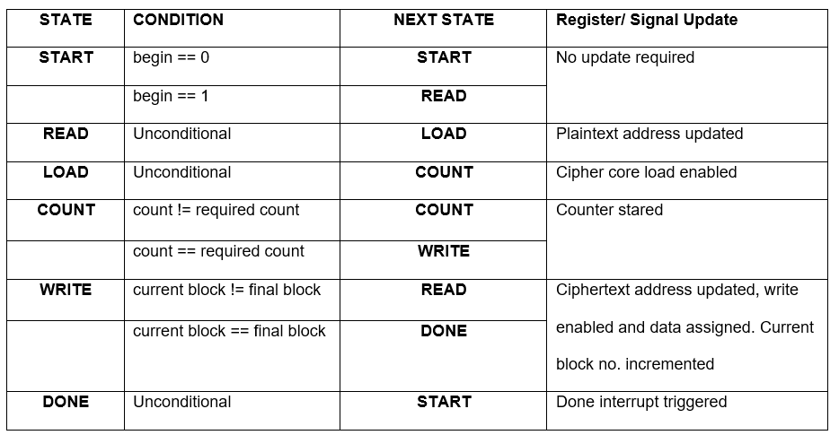



**BRAM**

The custom IP provides an interface to the BRAM blocks. There will be a memory generator for the plaintext vectors and ciphertext vectors. The top-level RTL therefore includes two sets of interface ports corresponding to the BRAM interface, but in the opposite directions.

* Disable write to ciphertext BRAM
* *address* = 0

For(no. of blocks){

plaintext read = 1

plaintext vector = plaintext[address]

Feed to core,

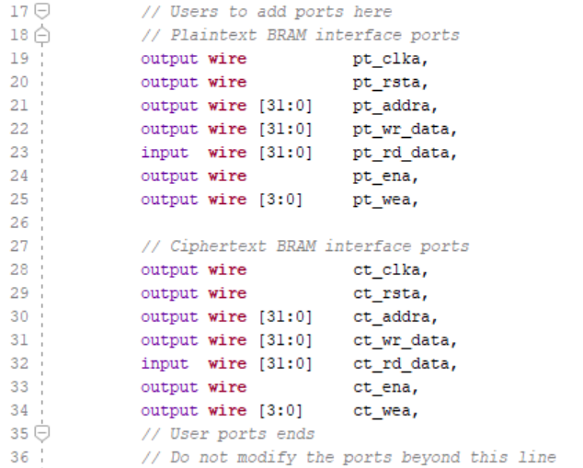

WEA CAN BE CHANGED TO SMALLER WIDTH IN VIVADO

These ports must be packaged to group the ports into a user-friendly interface for connection in the block diagram. The Port Mapping tab provides functionality to map the logical ports of the interface and the physical ports of the custom IP. Mapping steps..

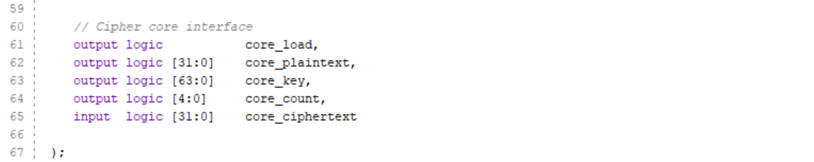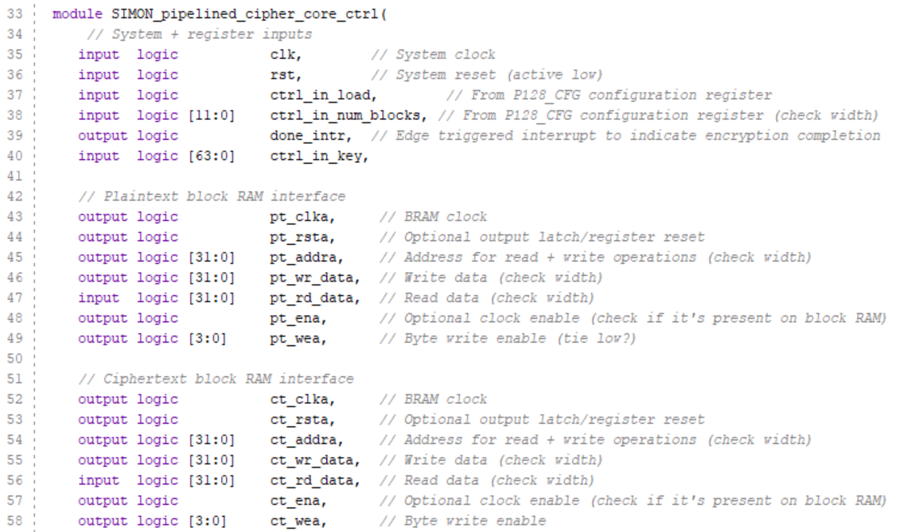

The FSM in .. shows the truth tavle

INIT

The signals are instantiated to initial values, the plaintext vectors are read from memory, the load signal is set, count is incremented for the required number of clock cycles dependent on the model, the encrypted ciphertext is written to memory. This design flow is repeated for the number of blocks to be encrypted. An additional step is included at the end of the process. The testbench used the function $finish to indicate the end of encryption. For this, as discussed previously , an interrupt will be used. These steps can be broken down into the following states:

START

READ

LOAD

COUNT

WRITE

DONE

These are

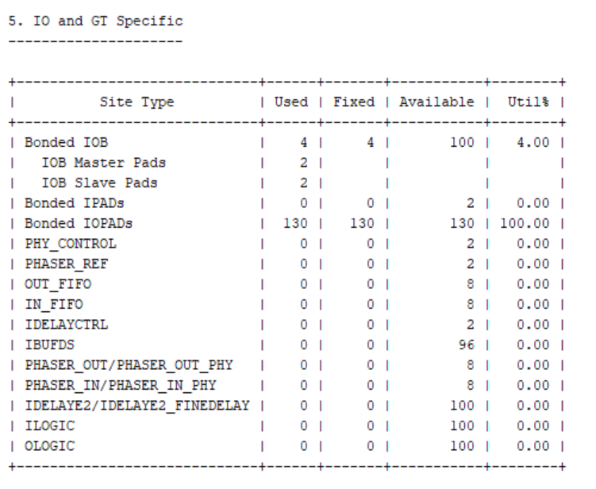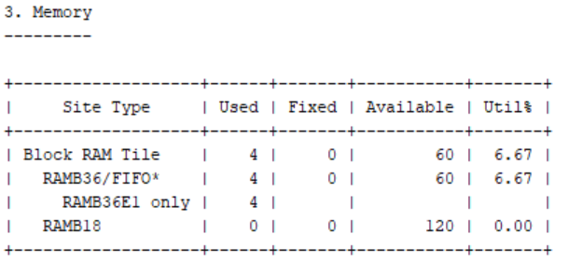

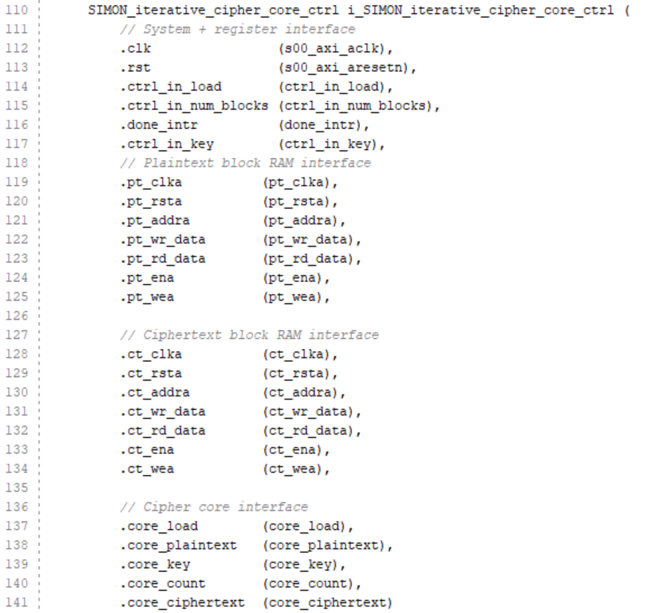

I/O ports

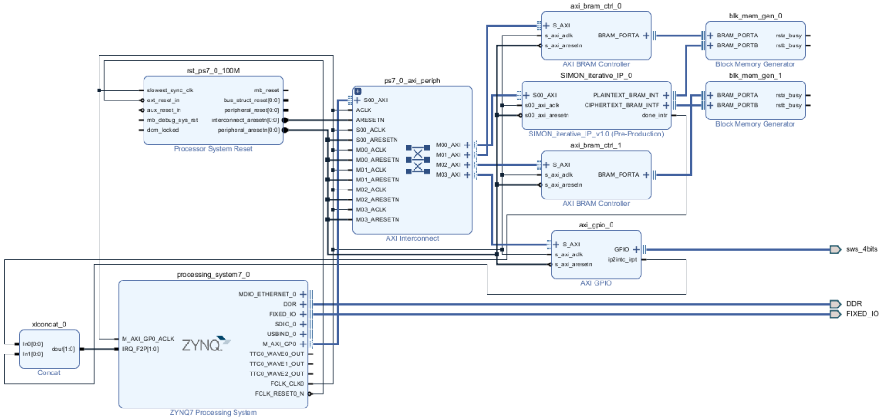

**Controller**

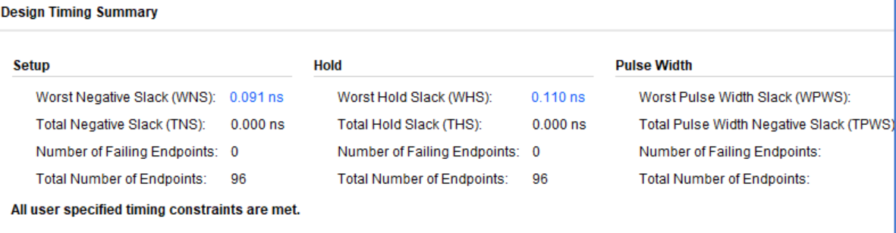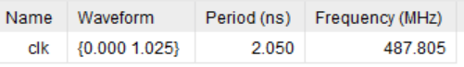

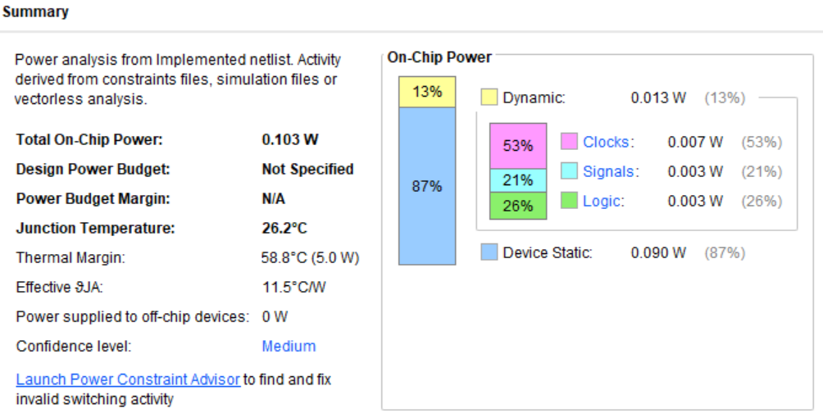

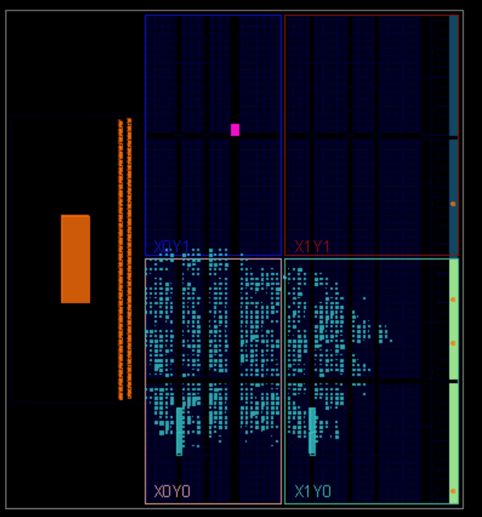

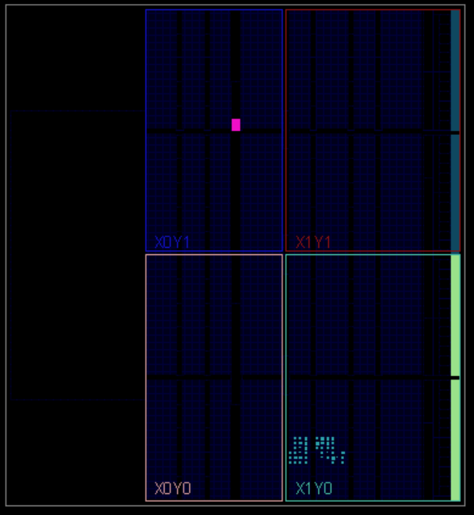

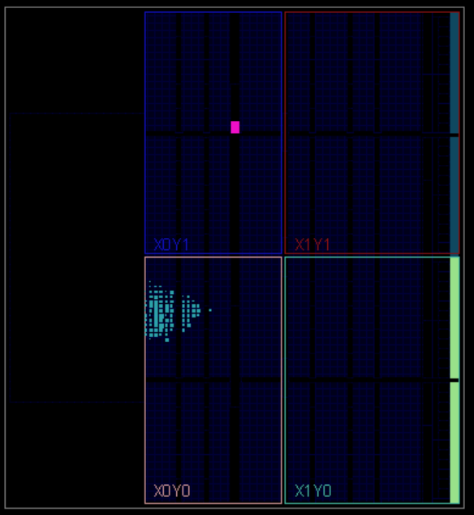

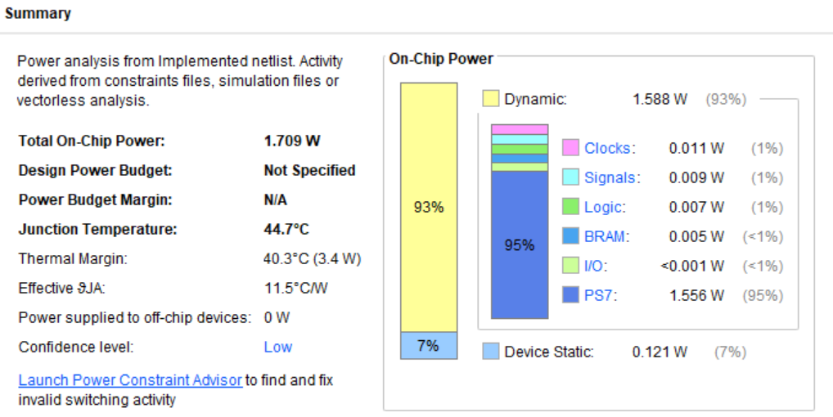

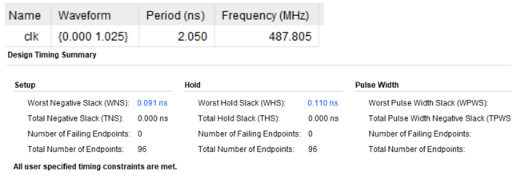

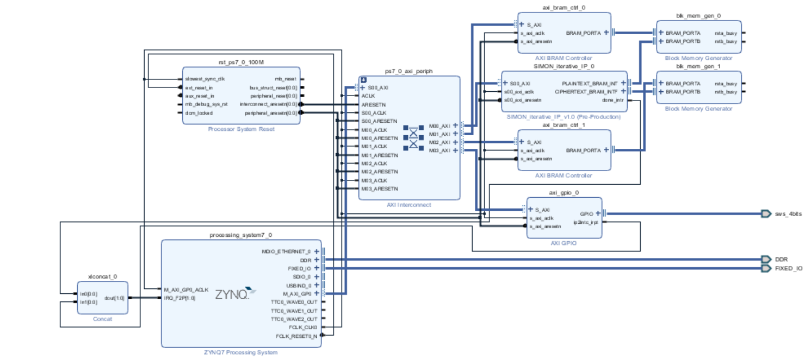

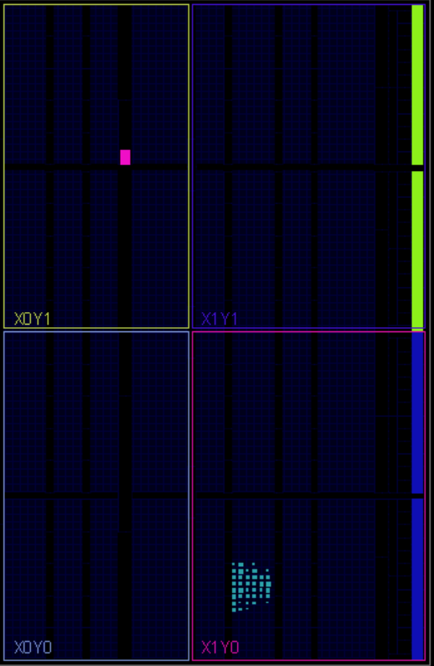

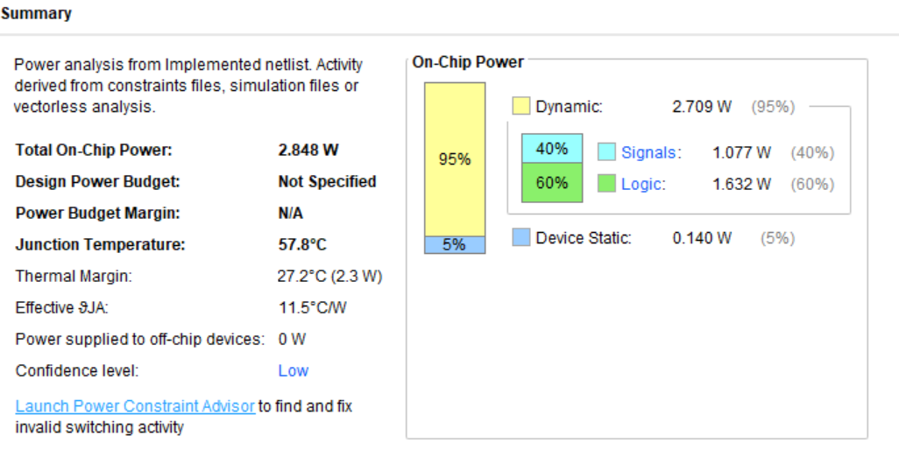

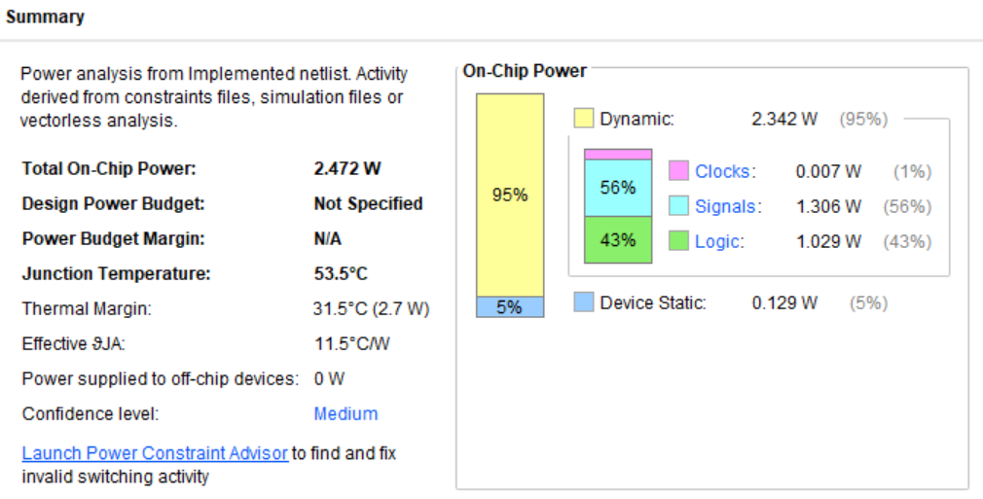

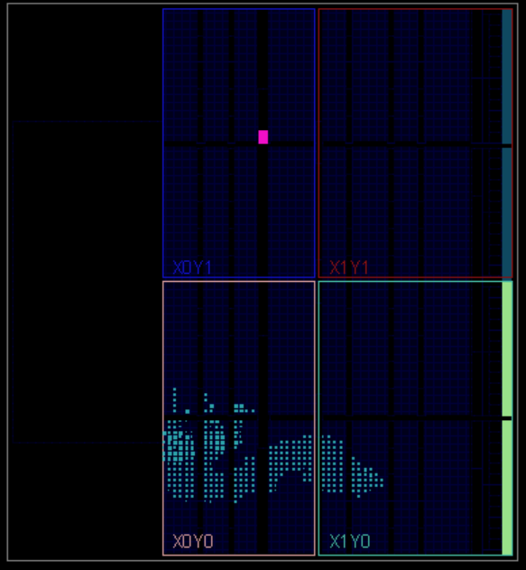

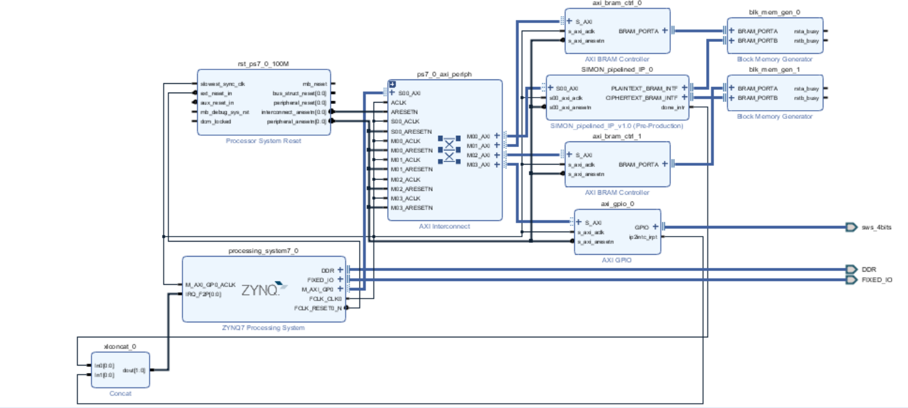

**SIMON32/64 Iterative Model**

|  |  |  |  |  |
| --- | --- | --- | --- | --- |
|  | **Slices** | **Slice LUTs** | **Slice Registers** | **BRAM Tiles** |
| **Cipher Core** | 22  (0.5%) | 80  (0.45%) | 96  (0.27%) | 0 |
| **Cipher IP** | 88  (2%) | 207  (1.18%) | 318  (0.9%) | 0 |
| **Top-Level Design Wrapper** | 981  (22.3%) | 2245  (12.76%) | 2856  (8.11%) |  |

**SIMON32/64 Pipelined Model**

|  |  |  |  |  |  |
| --- | --- | --- | --- | --- | --- |
|  | **Slices** | **Slice LUTs** | **Slice Registers** | **BRAM Tiles** | **IO** |
| **Cipher Core** | 263  (5.98%) | 969  (5.51%) | 96  (0.27%) | 0 | 0 |
| **Cipher IP** | 320  (7.27%) | 1078  (6.13%) | 318  (0.9%) | 0 | 0 |
| **Top-Level Design Wrapper** | 1153  (26.2%) | 3126  (17.76%) | 2856  (8.11%) | 4 |  |

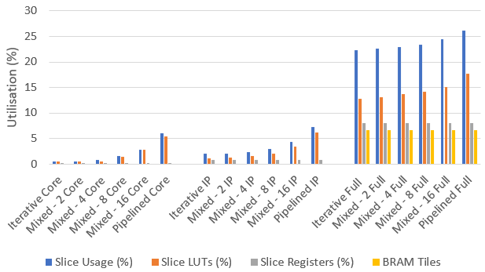

**SIMON32/64 Mixed Model**

|  |  |  |  |  |  |
| --- | --- | --- | --- | --- | --- |
|  | **Slices** | **Slice LUTs** | **Slice Registers** | **BRAM Tiles** | **IO** |
|  | 390 | 1475 | 96 |  |  |
| **Cipher Core (2)** | 404 | 1537 | 96 |  |  |
|  | 410 | 1574 | 96 |  |  |
| **Cipher Core**  **(8)** | 311  (26.2%) | 1147 | 96 | 0 | 0 |
|  |  |  |  |  |  |
| **Cipher Core**  **(32)** | 169 | 537 | 96 |  |  |
| **Cipher IP** | 568  (12.91%) | 1963  (11.15%) | 320  (0.91%) | 0 | 0 |
| **Top-Level Design Wrapper** | 1346  (30.59%) | 3973  (22.57%) | 2817  (8.00%) |  |  |

**SIMON32/64 Decrypt Model**

|  |  |  |  |  |  |
| --- | --- | --- | --- | --- | --- |
|  | **Slices** | **Slice LUTs** | **Slice Registers** | **BRAM Tiles** | **IO** |
| **Cipher Core** | 22  (0.5%) | 80  (0.45%) | 96  (0.27%) | 0 | 0 |

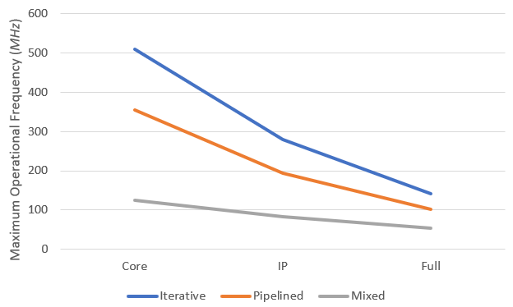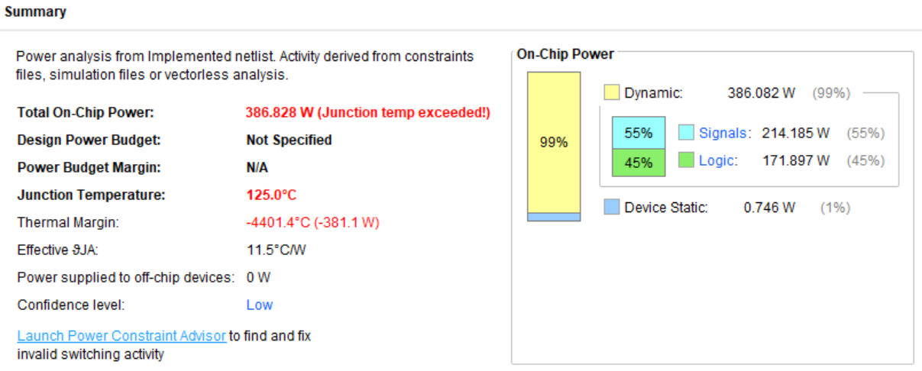

Run and Debug

Develop Software

Program FPGA

Create new Application

Launch SDK

Generate Bitstream

Run Implementation

Run Synthesis

Create Block Design

Create new IP for Packaging